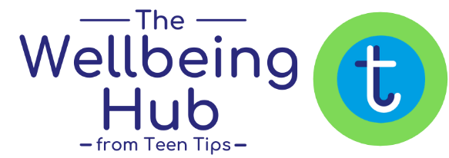
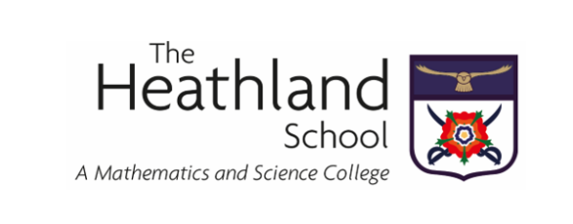

Creating an environment that nurtures pupil mental health and wellbeing is a key priority for us at The Heathland School.

To help us do this, we have gained access to The Wellbeing Hub, developed by child and adolescent mental health and wellbeing experts, Teen Tips. We are delighted to let you know that, as a Heathland School parent, you are entitled to free access, and we highly recommend you take the opportunity to register and start using these resources. All students have been encouraged to do the same.

The Wellbeing Hub is an interactive online portal, designed to help you understand and meet your child’s social and emotional needs. We believe it will be an invaluable source of information and support for our whole school community.

As a member, you benefit from:

- Complete Parenting Teens and Parenting 2-12’s Audio & Video Courses
- Weekly Updated Resources - podcasts, articles, tips and more
- Weekly Live Q&A with a Child & Adolescent Psychotherapist
- Careers Advice Articles and Webinars, as well as Inspiring Futures Mini-Podcasts - insiders’ perspectives on different industries, roles and career paths
- Q&A Library
- Self-Care - an area to find positivity, inspiration, good news and more
- Member Offers
- Parenting One-to-Ones (paid service)
- Access to Specialist help and support
- Monthly Webinars from in-house and guest, expert-level speakers on a range of topics

You can find a Guided Video Tour of The Wellbeing Hub for Parents (2-12) here and for Parents (13+) here. You will also find a Visual Guide linked here.

Our agreement with The Wellbeing Hub from Teen Tips covers our whole school community, and also delivers a wealth of support and resources for staff – including a 10-part course to help them to understand and support your child here at school.

The Wellbeing Hub for Pupils

Our pupils are being given access to The Wellbeing Hub via two different platforms, one for those aged 10-13 and one for those aged 13+, with resources tailored specifically to support them with their mental health and wellbeing. The Wellbeing Hub for pupils includes:
- Answers - a huge bank of Q&As on a wide range of topics
- Top Tips - short films, blogs, and tip sheets on all manner of themes
- Self-Care - an area to find positivity, inspiration, good news and more. Self-care is also available in The Wellbeing Hub for Parents so you can access it too
- Futures - Careers Advice and Inspiring Futures Podcasts
- Help Zone - with links to specialist organisations if they need extra support or advice
- Access to our Wellbeing Ambassadors Programme for Pupils, encouraging them to champion their own and their peer’s wellbeing

You can find a Guided Video Tour of The Wellbeing Hub for Pupils here and a Visual Guide here.

You can find a Visual Guide to the Junior Pupil Hub here.

Emails have been sent to all parents/guardians with the details for accessing The Wellbeing Hub, if you have not received this email, please contact admin@heathland.hounslow.sch.uk

We are so pleased to be able to provide this enhanced level of pastoral support. We hope you find The Wellbeing Hub beneficial for your family and we welcome your feedback.

