
Useful Websites and Helplines to support your Wellbeing
Creating an environment that helps you to understand and manage your own mental health and wellbeing is a key priority for us at The Heathland School.


To help us do this, we are able to give you access to The Wellbeing Hub developed by child and adolescent mental health and wellbeing experts, Teen Tips. We are delighted to let you know that, as a pupils The Heathland School, you are entitled to free access to The Wellbeing Hub, and we really encourage you to register and start using these resources. Your login was sent to you via your school email.
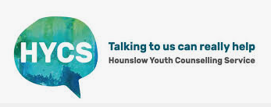

HYCS offer a free, 1-2-1 counselling service for young people. Their service is confidential and anyone aged 11-25 who lives, works or studies in the Borough of Hounslow can self-refer to the service. HYCS 020 8568 1818 https://www.hycscounselling.co.uk

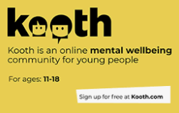
Kooth is an online mental wellbeing community for young people. Helpful articles, personal experiences and tips from young people and their Kooth team. Chat to their helpful team about anything that’s on your mind. Message them or have a live chat.


Youngminds.org.uk
Young Minds provides information about mental health conditions and support available. They offer some useful online guides.


mind.org.uk info@mind.org.uk 0300 123 3393 Text 86463
MIND offer information and advice for a huge range of mental health issues. You can contact MIND’s info line for information about types of mental health problems, where to get help, medication, and advocacy.


samaritans.org jo@samaritans.org 116 123
Samaritans provide round the clock support by phone, email, or through letters. They are there to listen to any problem that you’re facing. No matter who you are, or how big or small the issue may seem.


Childline.org.uk 0800 1111
Childline provide confidential help and advice about a wide range of issues. Young people can talk to a counsellor online or over the phone, as well as post on message boards.
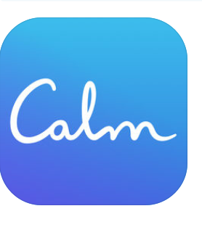

Calm offers guided meditations, sleep stories, breathing programs and relaxing music. (4+)
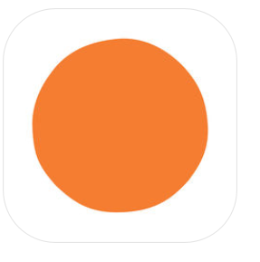

Headspace is a guided meditation app made simple. It tracks your stats and gives you reminders to help you with your practice. Its goals include supporting people to manage stress, anxiety and panic attacks, as well as promoting relaxation and wellbeing. (4+)
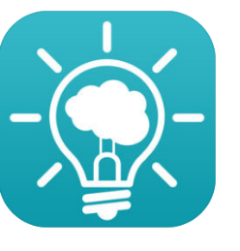
MindShift is an app designed to help teens and young adults cope with anxiety. It can help you change how you think about anxiety.
MindShift aims to help you learn how to relax, develop more helpful ways of thinking, and identify active steps that will help you take charge of your anxiety. (4+)

Winston's Wish is the UK's childhood bereavement charity. We support children and their families after the death of a parent or sibling.
https://www.winstonswish.org/ 08088 020 021



Cruse helpline is run by trained bereavement volunteers, who offer emotional support to anyone affected by grief. They will give you space to talk about your feelings and how you’ve been coping.
08088081677.
https://www.cruse.org.uk/get-support/helpline/

