
NHS NW London Vaccination Team
15 Marylebone Road
London NW1 5JD
Email: nhsnwlccg.c-19.vac.group@nhs.net
Rise in measles cases in North West London
Dear Parents and Guardians,
In the last few weeks there’s been an increase in the number of measles cases in North West London. Measles spreads easily and can cause serious illnesses including pneumonia and meningitis.
Check your child’s red book and, if they need to, update their vaccinations. To do this, contact your GP and book an appointment. If your child is not currently registered with a GP, then you can contact your local GP Practice and ask to be registered and at the same time request for your child to be vaccinated.

If you have any concerns or questions relating to the MMR vaccine or any other childhood vaccinations and would like to discuss further before getting your child vaccinated, then do please contact your local GP who will be able to help.
Look out for symptoms of measles in your child, which include:
- a high temperature;
- a runny or blocked nose, sneezing or a cough;
- red, sore, watery eyes;
- a rash with spots of the measles sometimes raised and join together to form blotchy patches; and / or
- white spots in the mouth.

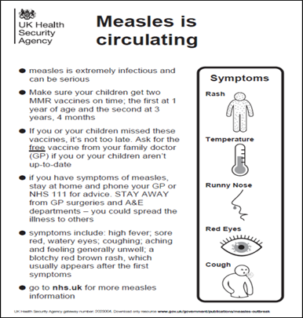

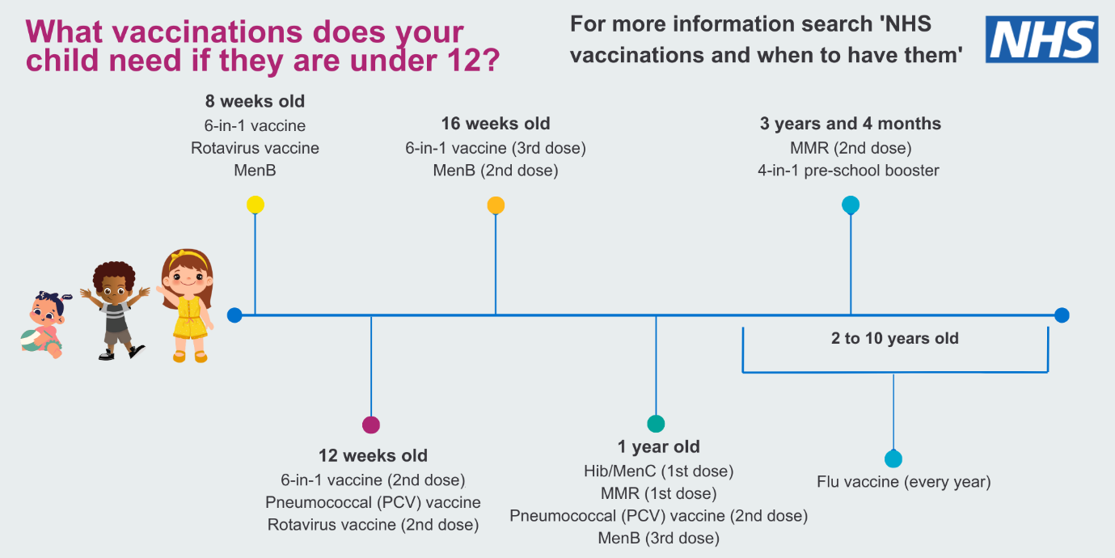
This graphic illustrates the vaccinations your child should be having, according to their age.

Contact NHS 111 or telephone your GP if any of the below list applies:
- you think you or your child may have measles;
- you've been in close contact with someone who has measles and you've not had measles before or you've not had 2 doses of the MMR vaccine;
- you've been in close contact with someone who has measles and you're pregnant – measles can be serious in pregnancy; or
- you have a weakened immune system and think you have measles or have been in close contact with someone with measles.
Important Note: Wherever possible please do not attend GP Practice or A&E in person if you or your child have symptoms as this may spread the infection to others.
How can we stop infections from spreading?
Measles is spread when an infected person coughs or sneezes. There are things you can do to reduce the risk of spreading or catching it.
Do:
- wash your hands often with soap and warm water;
- use tissues when you cough or sneeze; and
- throw used tissues in the bin straight away.
Don’t:
- share cutlery, cups, towels, clothes, or bedding.

