
Home Learning Expectations:
- All work is written by yourself, in your own words.
- All work is completed by the due date.
- All work is finished to the best of your ability.
- All instructions are read and followed closely, before starting.
- All work is green-penned and improved when needed.
- All work that is marked and/or peer-assessed when asked to.
- All work is presented clearly and all writing is legible.
- All work is proofread to ensure spelling, punctuation and grammar is to the best of your ability.

Name:
Set:
Teacher:
Q1. Define Ethics
Ethics are st______ of b__________________ that are acceptable within our _______.
They are the moral principles and v___________________ that make society operate effectively
Q2. Define Law
The law is described as the_______________________________________________________

_______________________________________________________________________________________

The law is created by the_________________________________________________________

Q3. What is the difference between Ethics and Law?
Law is created by the ___________________________ and Ethics are
_____________________

Q4. What law governs the storage of data on computers? Describe what the law covers.
Data P__________________________________ A__________

Q5. What law governs the illegal use of computers? Describe what the law covers.
C__________________________ M_____________________________ A____________
Due Date:

Peer Assessed Work
What went well:

Even better if:

Taking control of personal data is about your rights, not owning it
Due Date:

By Jeni Tennison, CEO of the Open Data Institute

The new General Data Protection Regulation (GDPR) gives us more control over personal data. The Open Data Institute believes that this control will come from our rights over this data, not our ownership of it.

Personal data is information about us such as where we study or work, what we like and who we spend our time with. Data is collected, shared and used a lot in our day-to-day lives.
When we go to a shop and use a contactless card to pay, the shop collects and can use data about us, such as what we bought and how much we spent. It’s the same for online services we use too, including shopping and social media sites.
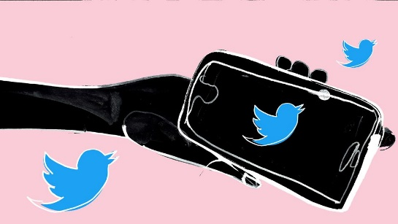
Lots of people are currently talking about personal data and how it’s used and shared.
People feel uncomfortable when it’s used in ways that can cause us harm or affect us in ways we’re not happy about. For example, the recent Cambridge Analytica scandal, or the sharing of data from the National Pupil Database.
Some people say we need to own ‘our’ data to take more control over how data about us is used.
This feels instinctively right. It's data about me, therefore surely it's my data?
At the Open Data Institute, however, we believe that data does not belong to any one person. We think this for a few reasons.

Data is often about multiple people
Data can also be created by multiple people.
Your school or college record could describe your friends and other pupils, as well as members of your family and the teachers or lecturers that you’ve come into contact with. Therefore the choices you make about how personal data is used or shared can have an impact on other people too. What does ‘owning’ data really mean if the data about you is also about multiple people? Isn’t it important that we consider their opinions about how that data is used too?
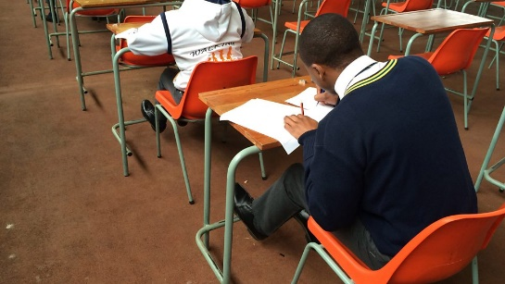
Your school record could contain information on others, not just yourself.

Our rights are fundamental
While privacy is a fundamental human right, and we need to find a way to fairly share the benefits created by data, giving individuals exclusive control of data about them also means that wider society can’t benefit from it.
Data gathered through national censuses help governments keep us healthy and safe, and future gathering of data could help us to tackle challenges like climate change through scientific research.

Data can be permanent
Data about us now can also be about us forever.
When someone sells or gives away something they have owned, like a mobile phone, it no longer belongs to them. The new owner can do anything they want with it and it won’t affect the person that had it before. Personal data isn’t like that. It’s always going to be about someone and the way it’s used could always affect them. This doesn’t mean that we shouldn’t make data about us available for good purposes.

We should have the power to donate data about us to charities and researchers if we want to, so they can do things with it to benefit our communities and societies.
It does mean that we should be careful about who we trust with data about us and our friends, and what they are going to use it for.
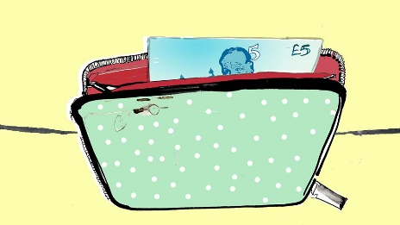
Data is unlike most personal property. We should also be careful of words related to ownership like “my data” or “your data”, as they don’t really do a good job of describing the complexity of the rights and controls we and others have over data about us.

The new General Data Protection Regulation (GDPR) gives us more control over personal data.
It strengthens the rights we have to control how data about us is used. This includes the right to share data with - or donate data to - organisations we trust.

Questions (Circle or highlight the correct answers):
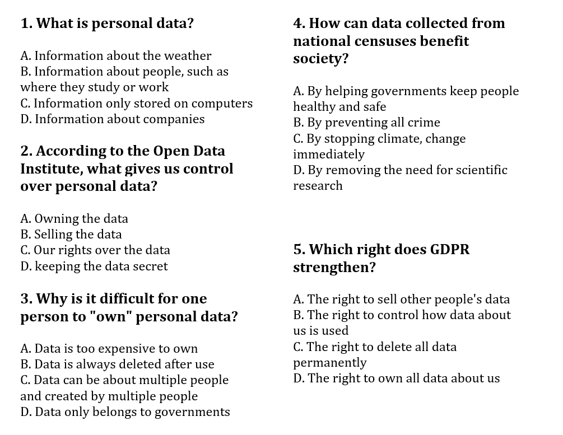

Peer Assessed Work
What went well:

Even better if:

The video talks about the effects of ____________________ on our ___________________
I agree/disagree that social media is ______________________ because
Due Date:

Teacher Assessed Work
What went well:

Even better if:

Computer ethics govern the behaviour of users online, and dates back to 1992. These ethics govern social, financial and legal uses of computers worldwide. Legal and ethical questions affect many areas of computing including privacy, sharing, hacking and the environment.
Due Date:

Privacy
What information can we consider to be private and who owns data? For example, photographs that are uploaded to social networks often legally become the property of the website. At what stage can private information like this be used and for what purposes?
Sharing
There are piracy laws protecting the distribution of films and other media. It is illegal to rip a copyrighted DVD or CD and distribute it online. However, peer-to-peer (P2P) file-sharing networks and hosting websites mean it is easy to share files with anyone in the world. At which point does sharing a film with others become piracy?
Hacking
The term 'hacking' can have a positive or negative meaning. It refers to any activity which makes unusual use of, or attempts to break, a computer system. Hacking can be used for negative purposes such as looking for weaknesses in systems to access and steal private data, but it can also be used for positive purposes such as:
- creatively exploring new ways of using a program or computer
- working around bugs in code
- exposing security risks in software and websites, and warning the general public
- testing the security of a system
- a 'hack day' - where people get together to explore new technologies
The code of computer ethics, also called the Ten Commandments, instructs users to not harass other users, use computers to spy or use computers to gain access to private information.
Examples of computer ethics include not using a computer to steal or to harm others, especially by avoiding the spread of computer viruses and shunning plagiarism of computer software.
https://www.reference.com/world-view/importance-computer-ethics-ec81d2b2a4e8dc79

Q1.What is Computer Ethics?
Computer Ethics govern_________________________________________________________

Q2.The code of computer ethics is also referred to as…?
T__________ C________________________________

Q3. When did the article say Computer Ethics dated back to?
Q4. Give at least three examples of ethical behaviour when using computers?
- Not using the computer to ___________

- _______________________________________________________

- _______________________________________________________

Q5.Explain the term hacking? Identify at least one positive and one negative purpose of hacking?
Hacking refers to any activity which __________________________________________________
One positive example of hacking is:___________________________________________________________________________________________
One negative example of hacking is: _____________________________________________________________________________________________

Peer Assessed Work
What went well:

Even better if:

(Q1)
Due Date:

Keywords:
Digital Divide, Law, Cyber Bullying, Copyright, Illegal, Privacy
Definition | Key word
- The moral ideas that govern a person's behaviour or the conducting of an activity. | Ethics
- A system of rules created and enforced through social or governmental institutions to regulate behavior
- An Act to make provision for securing a computer
- Bullying that takes place over digital devices like cell phones, computers and tablets
- Difference between people who have easy access to the internet and those who do not
- Legal rights that protects the use of your work once your idea has been physically expressed

(Q2)
- Give at least 3 pieces of advice on how to protect your privacy online.
Explain why you should follow each piece of advice.
_____________________________________________________________________________________

_____________________________________________________________________________________

_____________________________________________________________________________________

_____________________________________________________________________________________

_____________________________________________________________________________________

_____________________________________________________________________________________

Peer Assessed Work
What went well:

Even better if:

Using the link below to help you, complete the sentences regarding the Data Protection Act,
Due Date:

https://www.bbc.co.uk/bitesize/guides/z9nk87h/revision/4
Data Protection Act governs how p___________________ d_________________ has to be stored by companies.
Data Protection Act is built around eight p___________________, some examples include:
- ___________________________________________________________________________________
- ___________________________________________________________________________________
Any organisation that breaks the act, can receive a ____________________________.
Read the article below and finish the sentences.
https://www.bbc.co.uk/news/technology-40366823
Two men were arrested for their part in a plan to ___________________.

They were charged under the C_________________ M_________________ A____________, which makes it illegal to ____________________________________________

They did not gain a_________________ to any c________________________________ i__________________________________________
Teacher Assessed Work
What went well:

Even better if:

