Name:__________________________ Class:_______

  - Year 8
  - Français
  - Cahier de devoirs
  - Topic 1 : Mon portrait
  - Autumn Term 1
  - Aspiration


Home Learning expectations
-Written by yourself, in your own words.
-Completed by the due date.
-Finished to the best of your ability.
-Instructions to be read carefully.
-Green pen and improve when needed.
-Peer or self-assess when asked to.
-Presented so your work is clear and neat
-Proof read your work to ensure spelling, punctuation and grammar is to the best of your ability.

Use your Knowledge Organisers to support with your Home Learning Tasks

Contents
Topic 1
Topic 1 Task 1: Grammar_Adjectival agreement 2
Topic 1 Task 2: Vocabulary 3
Topic 1 Task 3: Reading Aloud (LSA) 4
Topic 1 Task 4: Vocabulary 5
Topic 1 task 5: Linguascope 6
Topic 1 task 6: Linguascope 7

Topic 1 Task 1: Grammar_Adjectival agreement
Due: ______________________

Put the words in the correct order so the sentence makes sense in French

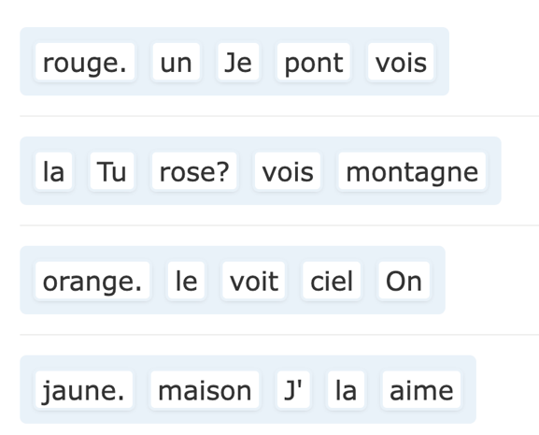 | Je vois

Tip: In French, adjectives describing colour come after the noun.

Change the underlined adjective in each sentence into the correct form.

- Tu vois la mer? Elle est vert. - verte
- Je vois la montagne. Elle est gris.
- Vous voyez le pont? Il est blanche.
- On voit le ciel. Il est bleue.
- Nous voyons une maison. Elle est noir.
- Je vois une fleur. Elle est violet.

EXT: Translate the sentences into English

________________________________________________________________________________________________________________________________________________________________________________________________________________________________________________________________________________________________________________________________________________________________________________________________________________________________________________________________________________________________________________________________________________________________
Self-Assessed
Self-Reflection:


Topic 1 Task 2: Vocabulary
Due: ______________________
Use the Knowledge Organiser 1 (Mon Portrait) at the back of your booklet.
Choose 15 words from the box ‘Le monde à travers mes yeux’ and practice using the grid below.

French Vocabulary | English Translation | Look and Say (tick) | Look, Say and Write in French | Look, Say and Write in French | Look, Say and Write in French
Extension: Write three sentences using the vocabulary that you’ve learned
- __________________________________________________________
- __________________________________________________________
- __________________________________________________________
Peer-assessed
Write with your green pen
-How confident do you feel about it from 1 to 5 (1 is not confident at all, and 5 is very confident)? _____
-How to improve further:

Topic 1 Task 3: Reading Aloud (LSA)
Due: ______________________

Prepare and practice the text below.

Je suis jeune et je suis très travailleur. Je suis aussi intelligent et je suis assez sérieux.
Être travailleur, c’est important pour moi.
Je ne suis pas paresseux.

Teacher Assessed
Teacher’s Feedback:

Topic 1 Task 4: Vocabulary
Due: ______________________
Use the Knowledge Organiser 1 (Mon Portrait) at the back of your booklet.
Choose 15 words from the box ‘C’est quoi, un modèle?’ and practice using the vocab grid.
French Vocabulary | English Translation | Look and Say (tick) | Look, Say and Write in French | Look, Say and Write in French | Look, Say and Write in French

EXT: Write three sentences using the vocab that you’ve learned
- __________________________________________________________
- __________________________________________________________
- __________________________________________________________
Peer-assessed
Write with your green pen
-How confident do you feel about it from 1 to 5 (1 is not confident at all, and 5 is very confident)? _____
-How to improve further:

Topic 1 task 5: Linguascope
Due: ______________________
Login into Linguascope

Username: Heathland
Password: _________________________________

Instruction:
- Click on the French flag and select ‘Beginner’ section
- On the right side select ‘Moi et ma famille’ from the list of topic
- Select ‘Les traits de personnalité’
- Spend 20 minutes practising the new vocab in the following sections



EXT: Practise two more sections of your choice

Write your score here for the Contrôle Final: ________
Do you think you can do it better? Try again and write your best score _____

Self-Assessed
Write with your green pen
-How confident do you feel about it from 1 to 5 (1 is not confident at all, and 5 is very confident)? _____
-How to improve further:

Peer assessed
Positive points:
How to improve further:

Topic 1 task 6: Linguascope
Due: ______________________
Login into Linguascope
Username: Heathland
Password: _________________________________

Instruction:
- Click on the French flag and select ‘Beginner’ section
- On the right side select ‘Les loisirs’ from the list of topic
- Select ‘Les passe-temps’
- Spend 20 minutes practicsing the new vocab in the following sections
EXT: Practise two more sections of your choice
Write your score here for the Contrôle Final: ________
Do you think you can do it better? Try again and write your best score _____

Self-Assessed
Write with your green pen
-How confident do you feel about it from 1 to 5 (1 is not confident at all, and 5 is very confident)? _____
-How to improve further:

Peer assessed
Positive points:
How to improve further:

