Year 8 Home Learning Project
Autumn term 1: The Wars of the Roses

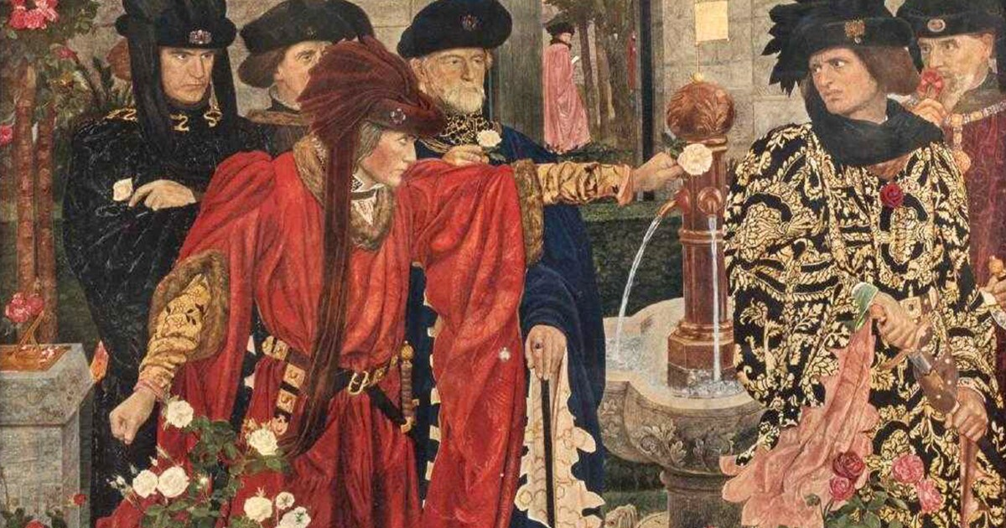

Homework expectations
-Written by yourself, in your own words.
-Completed by the due date.
-Finished to the best of your ability.
-Closely followed the instructions.
-Green penned and improved when needed.
-Peer or self-assessed when asked to.
-Presented so it is clear and neat
-Proof read the work to ensure spelling, punctuation and grammar is to the best of your ability.

Task one- The start of the Wars of the Roses
Due Date:

In the 1400s, there was a serious fight between two parts of the royal Plantagenet family: the House of Lancaster and the House of York. Both families were related to King Edward III and believed they had the right to be king of England.
The Lancasters were descended from John of Gaunt, who was Edward III’s third son to survive into adulthood. The Yorks were descended from Edmund of Langley, Edward III’s fourth surviving son. The conflict started because Henry VI from the House of Lancaster and Richard, Duke of York, disagreed about who should rule England.

At the time, these fights were called civil wars because they were fought between people from the same country. The Lancasters were linked with a red rose, while the Yorks were linked with a white rose. After the fighting ended, the conflict became known as the Wars of the Roses.
Instructions: Refer to the power point in teams for support. Create two top trump cards for the leader of each side when the Wars of the Roses began. You must include:
- An image
- Their name
- Their house
- Their claim to the throne
- One fun fact
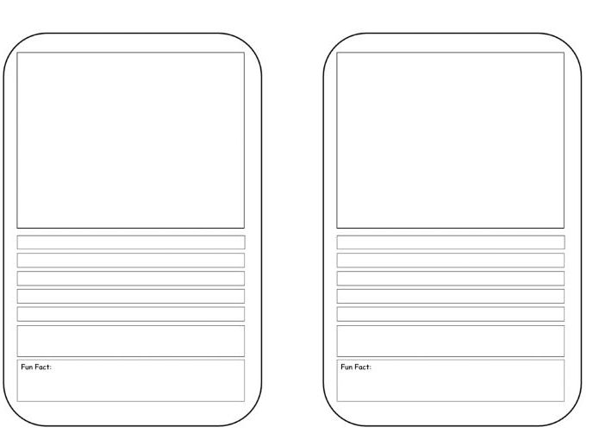
Self assessed
Positive points:
How to improve further:

Task two- Henry VIII and the Reformation Retrieval
Due Date:

Instructions: answer the questions below

1 – In which year did Henry VIII become king of England?
______________________________________________________________________________________________________________________________________________________________________________
2 – Why did Henry VIII want to end his marriage to Catherine of Aragon and why was he unable to get a divorce?
_________________________________________________________________________________________________________________________________________________________________________
3 – What was the name of the new church Henry VIII established in England?
______________________________________________________________________________________________________________________________________________________________________________
4- The establishment of a new Protestant church in England was known as the Reformation. What can you infer (learn) from the image below about what Henry VIII treated Catholic monks during the Reformation?

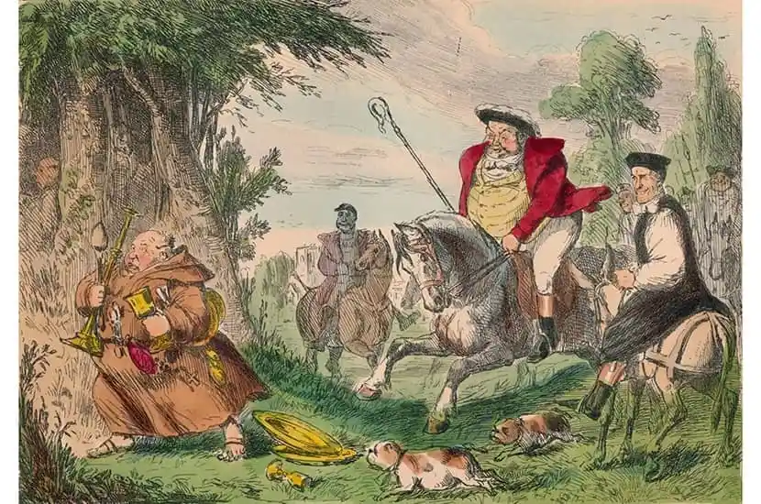
A catholic monk
Henry VIII
______________________________________________________________________________________________________________________________________________________________________________
Teacher assessed
Positive points:
How to improve further:

Task Three – Battles during the Wars of the Roses
Due Date:

- 1455 – The Wars of the Roses begin when Richard of York defeats King Henry VI at the First Battle of St Albans.
- 1460 – Richard of York is killed at the Battle of Wakefield after a Lancastrian victory.
- 1461 – Edward IV, Richard's son, defeats the Lancastrians at the Battle of Towton and becomes king.
- 1471 – Edward IV defeats the Lancastrians again, and Henry VI dies in the Tower of London.
- 1485 – Henry Tudor defeats Richard III at the Battle of Bosworth and becomes King Henry VII.
- 1487 – Henry VII defeats the remaining Yorkists at the Battle of Stoke Field, ending the Wars of the Roses.

Instructions: Use the information above to create a timeline of the battle of the Wars of the Roses.
You must include: The date, the name of the battle, who won (colour coded)

Peer assessed
Positive points:
How to improve further:

Task Four – The Reformation Retrieva
Task four- Elizabeth I Retrieval
Due Date:

Instructions: answer the questions below

1 – What year did Elizabeth I become Queen and how old was she?
______________________________________________________________________________________________________________________________________________________________________________
2 – Why did some Catholics see Elizabeth I as an illegitimate ruler?
_________________________________________________________________________________________________________________________________________________________________________
3 - What was the name of Elizabeth’s religious policy in England and why did she create it?
_____________________________________________________________________________________________________________________________________________________________________________________________________________________________________________________________________
4 – Which country was England’s enemy during Elizabeths reign and why?
_________________________________________________________________________________________________________________________________________________________________________
5 – Give three reasons why England was able to defeated the Spanish Armada
_________________________________________________________________________________________________________________________________________________________________________________________________________________________________________________________________________________________________________________________________________________________________________________________________________________________________________________
Self assessed
Positive points:
How to improve further:

Task Five- The end of the Wars of the Roses
Due Date:

Instructions: using the power point in teams for support, create a storyboard on how Henry VII ended the Wars of the Roses.

Teacher assessed
Positive points:
How to improve further:

Task Six – English Civil War retrieval
Due Date:

1 – What was the ‘Divine right of Kings’?
______________________________________________________________________________________________________________________________________________________________________________
2 – What was Ship money?
_________________________________________________________________________________________________________________________________________________________________________
3 – What were the two sides of the English Civil War?
______________________________________________________________________________________________________________________________________________________________________________
4 – Why were the New Model Army significant for the outcome of the English Civil War?
_________________________________________________________________________________________________________________________________________________________________________
5 – What happened to Charles I after the English Civil War?
______________________________________________________________________________________________________________________________________________________________________________
6 – How did the English Civil War change who held power in England?
______________________________________________________________________________________________________________________________________________________________________________

