Mathematics Home Learning
Autumn TERM 1 – Year 8
Aspiration
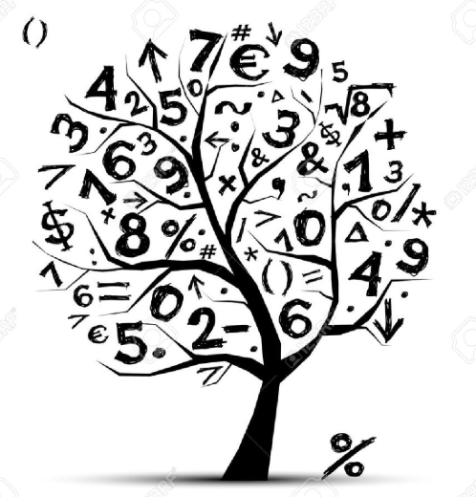
Home Learning Expectations

SPARX Login Details

All students can access SPARX from home by going to https://sparxmaths.com and using their school Microsoft login details.

SPARX expectations:
- All students must complete Home Learning work in the BLUE exercise book provided
- Divide your page in half
- Draw margins using a ruler and a pencil
- Use blue or black ink
- The title should be the date the homework is due
- Write SPARX question codes for all questions
- Show working out for each question where applicable
- Once you have completed a question, mark you answer with a green pen
- When all questions have been completed write down the percentage you achieved
- If you get a question wrong, reattempt the question using a green pen
- Make sure all your working out is neat and legible.

EXAMINATION questions expectations:
- Use blue or black ink
- If the question is 2 or more marks you must show working out in the spaces provided
- Make sure all your working out is neat and legible
- Write final answer on the dotted line

HOME LEARNING SCHEDULE – Autumn Term1

Homework is set on: | Date completed
TASK 1: Week beginning 7th Sept 26 – Complete SPARX in BLUE homework books
TASK 2: Week beginning 14th Sept 26 – Complete SPARX in BLUE homework books
TASK 3: Week beginning 21st Sept 26 – Complete SPARX in BLUE homework books
TASK 4: Week beginning 28th Sept 26 – Complete EXAM questions on Ratio on page 3
TASK 5: Week beginning 5th Oct 26 – Complete SPARX in BLUE homework books
TASK 6: Week beginning 12th Oct 26 – Complete SPARX in BLUE homework books
TASK 7: Week beginning 19th Oct 26 – Complete EXAM questions on Proportion and Scale on pages 4 and 5
HALF TERM

Task 8: Week beginning 2nd November – Complete SPARX in BLUE homework books

Task 9: Week beginning 9th November – Complete SPARX in BLUE homework books
Task 10: Week beginning 16th November – Complete EXAM questions on Algebraic Manipulation on pages 6 and 7

Task 11: Week beginning 23rd November – Complete SPARX in BLUE homework books

Task 12: Week beginning 30th November - Complete SPARX in BLUE homework books

Task 13: Week beginning 7th December – Complete EXAM questions on Coordinates and Graphs on pages 8 and 9

Week beginning 14th December - No home learning this week

CHRISTMAS HOLIDAYS

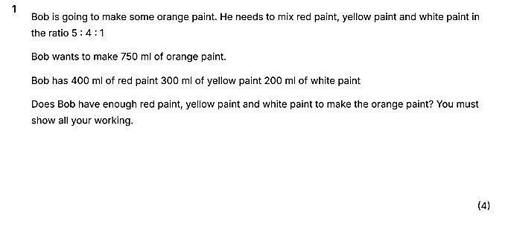
Ratio - Aspiration

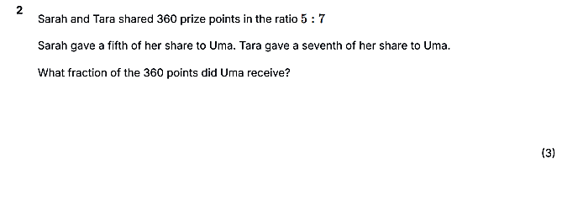

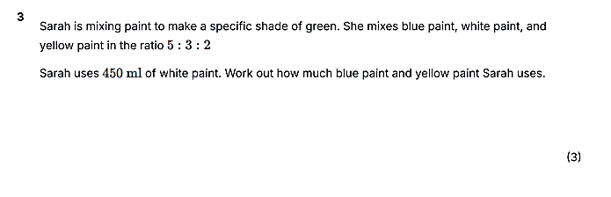

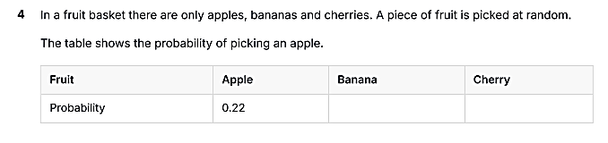

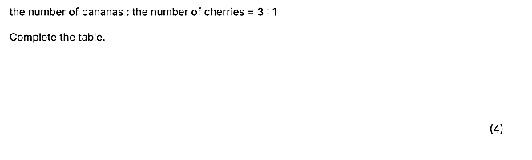

Proportion and Scale - Aspiration

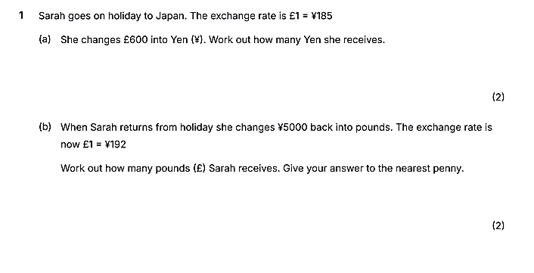
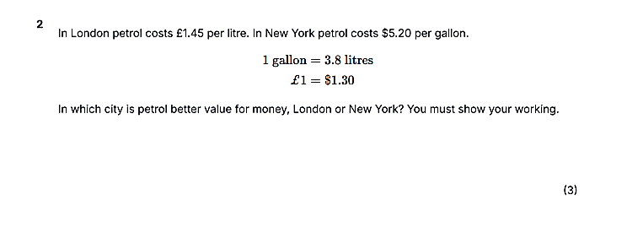
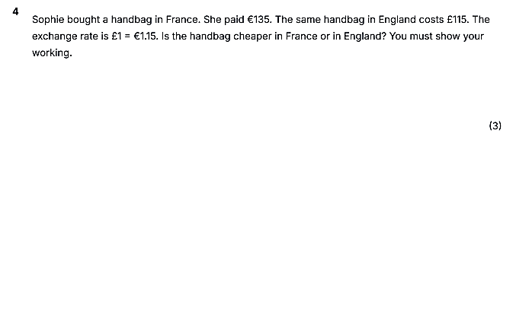
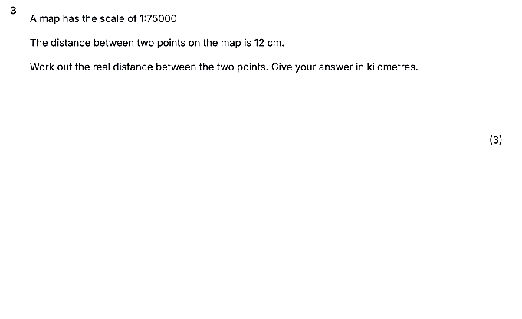

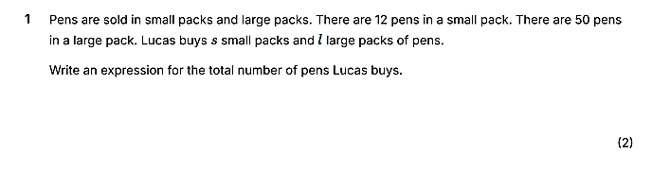
Algebraic Manipulation

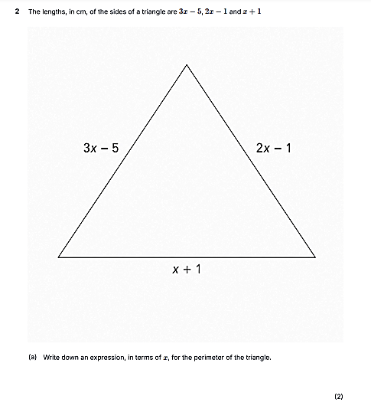

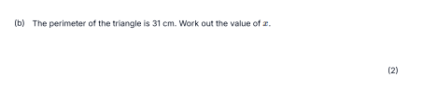
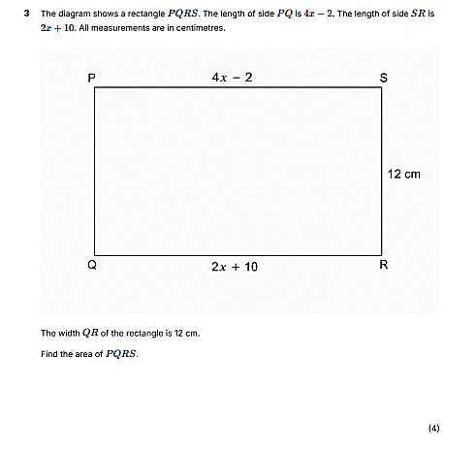

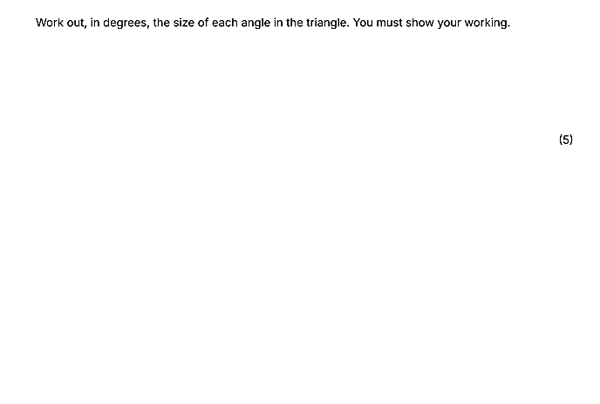
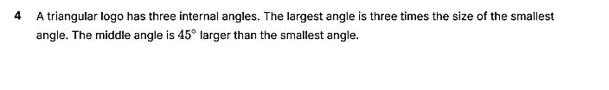

Co-ordinates and Graphs - Aspiration


