Mathematics Home Learning
Autumn TERM 1 – Year 8
Dedication
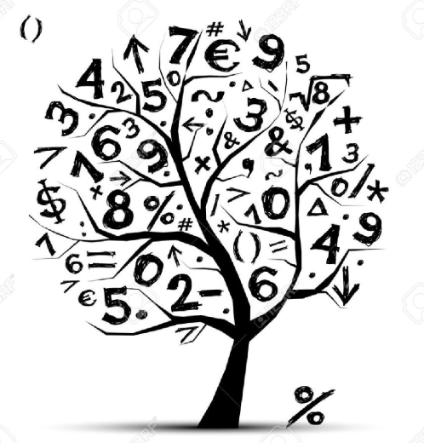
Home Learning Expectations

SPARX Login Details

All students can access SPARX from home by going to https://sparxmaths.com and using their school Microsoft login details.

SPARX expectations:
- All students must complete Home Learning work in the BLUE exercise book provided
- Divide your page in half
- Draw margins using a ruler and a pencil
- Use blue or black ink
- The title should be the date the homework is due
- Write SPARX question codes for all questions
- Show working out for each question where applicable
- Once you have completed a question, mark you answer with a green pen
- When all questions have been completed write down the percentage you achieved
- If you get a question wrong, reattempt the question using a green pen
- Make sure all your working out is neat and legible.

EXAMINATION questions expectations:
- Use blue or black ink
- If the question is 2 or more marks you must show working out in the spaces provided
- Make sure all your working out is neat and legible
- Write final answer on the dotted line

HOME LEARNING SCHEDULE – Autumn Term1

Homework is set on: | Date completed
TASK 1: Week beginning 7th Sept 26 – Complete SPARX in BLUE homework books
TASK 2: Week beginning 14th Sept 26 – Complete SPARX in BLUE homework books
TASK 3: Week beginning 21st Sept 26 – Complete SPARX in BLUE homework books
TASK 4: Week beginning 28th Sept 26 – Complete EXAM questions on Ratio on pages 3 and 4
TASK 5: Week beginning 5th Oct 26 – Complete SPARX in BLUE homework books
TASK 6: Week beginning 12th Oct 26 – Complete SPARX in BLUE homework books
TASK 7: Week beginning 19th Oct 26 – Complete EXAM questions on Proportion and Scale on page 5
HALF TERM

Task 8: Week beginning 2nd November – Complete SPARX in BLUE homework books

Task 9: Week beginning 9th November – Complete SPARX in BLUE homework books
Task 10: Week beginning 16th November – Complete EXAM questions on Algebraic Manipulation on pages 6 and 7

Task 11: Week beginning 23rd November – Complete SPARX in BLUE homework books

Task 12: Week beginning 30th November - Complete SPARX in BLUE homework books

Task 13: Week beginning 7th December – Complete EXAM questions on Coordinates and Graphs on pages 8 and 9

Week beginning 14th December - No home learning this week

CHRISTMAS HOLIDAYS

Ratio - Dedication
Question 1
​A bag contains some coloured counters.
Some are red, some are yellow, some are orange and the rest are green.
One counter is selected at random from the bag.
The probability of selecting:
• a yellow counter is twice the probability of selecting an orange counter
• a green counter is three times the probability of selecting a yellow counter.
Write down the ratio of the number of yellow counters to the number of orange counters to the number of green counters.

....... : ....... : .......
(2 marks)
Question 2
​There are ​$90$ red counters and ​$150$ yellow counters in a bag.
Write down the ratio of the number of red counters to the number of yellow counters.
Give your ratio in its simplest form.

....... : .......
(2 marks)

Question 3
​Ali and Beth divide £280 in the ratio ​$2:5$
Work out how much each person gets.

​Ali: £ …………………………
​Beth: £ …………………………
(2 marks)

Question 4
Giles and Sarah share some bales of hay in the ratio ​$11:4$
Sarah receives ​$20$ bales of hay.
Work out how many bales of hay are shared in total.

…………………………
(3 marks)
Question 5
​​$100$ students vote in a school election.
​$1$ vote is spoiled and is not counted.
The remaining votes are for Jamal or Layla and are in the ratio ​$3 : 8$.
How many more votes does Layla have than Jamal?

…………………………
(3 marks)

Question 6
​A sauce is made from cream and stock in the ratio
cream ​$:$ stock ​$=1:6$
How much sauce can be made using ​$80$ millilitres of cream?

………………………… ​ml
(2 marks)
Proportion and Scale - Dedication
Question 1
​The cost of ​$3$ calendars is ​$£18$
Work out the cost of ​$5$ calendars.

​​$£$ …………………………
(2 marks)
Question 2
​​$6$ cakes cost ​$£10.74$
Work out the cost of ​$11$ of these cakes.

​​$£$ …………………………
(2 marks)
Question 3
​The cost of ​$5$ kg of potatoes is ​$£3.20$
The cost of ​$\frac{1}{2}$ kg of carrots is ​$29$p
Work out the total cost of ​$12$ kg of potatoes and ​$1\frac{1}{2}$ kg of carrots.

​​$£$ …………………………
(3 marks)
Question 4
​Sophia spends a total of ​$£6.30$ on cheese.
She buys ​$500$ g of Cheddar cheese and ​$200$ g of Stilton cheese.
The cost of the Cheddar cheese is ​$£9.20$ for ​$1$ kg
Work out the cost of ​$1$ kg of the Stilton cheese.

​£ …………………………
(4 marks)
Algebraic Manipulation - Dedication
Question 1 ​
Expand ​$5\left(9-13y\right)$
…………………………
(1 mark)

Question 2
​Factorise ​$6a+15$

…………………………
(1 mark)

Question 3
​Multiply out ​$3d(d-2)$

…………………………
(2 marks)

Question 4
​Expand ​${ 3c}^{3}\left(c + 4\right)$
…………………………
(2 marks)

Question 5
​Simplify ​$8j+4k-10j+7k$
…………………………
(2 marks)

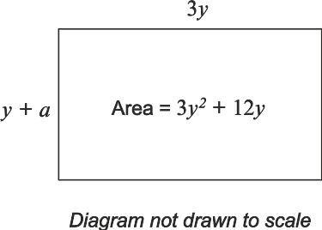
Question 6
The rectangle below has:
• a length of ​$3y$
• a width of ​$y+a$
• an area of ​${3y}^{2}+12y$.

Find the value of ​$a$.

​​$a = . . . . . . . . . . .$
(3 marks)
Question 7
​Simplify
​$7x-2\left(x-3y\right)-4y$

…………………………
(3 marks)

Co-ordinates and Graphs - Dedication
Question 1
​The table shows some of the values of ​$y=3x$ for ​$-2≤ x≤2$
Complete the table.
​​$x$ | ​​$-2$ | ​​$-1$ | ​​$0$ | ​​$1$ | ​​$2$
​​$y=3x$ |  |  |  | ​​$3$ | ​​$6$
(2 marks)

Question 2
​Complete the table of values for ​$y=2x+2$.
​​$x$ | ​​$-2$ | ​​$-1$ | ​​$0$ | ​​$1$ | ​​$2$ | ​​$3$
​​$y$ |  | ​​$0$ | ​​$2$
(2 marks)

Question 3
​Casey says the graph of ​$y=4x+9$ passes through the point ​$\left(3,23\right)$.
Is Casey correct?
​Yes. When ​$x=3,y=23$
​No. ​$4×3+9=21$

(2 marks)
Question 4
​Circle the point that lies on the line ​$x - 3 = 0$
​​$(3,0)$
​​$(0,3)$
​​$(-3,0)$
​​$(0,-3)$
(1 mark)

Question 5
​Is the point ​$(-5, -6)$ above, below or on the line ​$y = 3x + 7$ ?
Select one box.
​Above
​Below
​On the line
(2 marks)

Question 6
​
Here are the equations of two straight lines.
​$y = \frac{1}{2} x - 6$ ​$6y = 3x +7$
Oscar says that these lines are parallel. Is Oscar correct?
​Yes, both gradients are ​$\frac{1}{2}$.
​No, the gradient of the first line is ​$\frac{1}{2}$ but the gradient of the second line is ​$3$.
​No, the gradient of the first line is ​$\frac{1}{2}$ but the gradient of the second line is ​$2$.
​No, the gradient of the first line is ​$-6$ but the gradient of the second line is ​$7$.
(2 marks)

Question 7
​​$P$ and ​$Q$ are points on the line ​$3x + 2y = 6$
Complete the coordinates of ​$P$ and ​$Q$
​​$P=(0,$ …… ​​$)$
​​$Q=($ …… ​​$,0)$
(2 marks)

