Year 8 Home Learning
Autumn half term 1 2026
Dedication

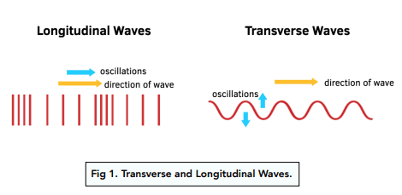
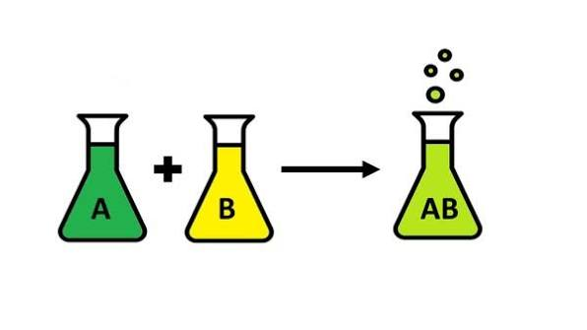

Home Learning expectations
- -Written by yourself, in your own words.
- -Completed by the due date.
- -Finished to the best of your ability.
- -Closely followed the instructions.
- -Green penned and improved when needed.
- -Peer or self-assessed when asked to.
- -Presented so it is clear and neat
- -Proof read the work to ensure spelling, punctuation and grammar is to the best of your ability.
Task 1
Due Date: ___________
Topic: Waves – Key words and definitions
Instructions: Using the booklet and the internet, research and fill in the missing blanks using the word bank below.
Work bank: bounces • brain • colours • direction • ear • hertz • medium • peak • refraction • rest • second • signals • speed • vibrates

Wavelength | The distance between two corresponding points on a wave, for example from one __________ to the next peak.
Amplitude | The maximum displacement of a wave from its __________ position.
Frequency | The number of complete waves passing a point each __________. The unit is __________ (Hz).
Eardrum | A thin membrane found in the _____ that __________ when sound waves reach it.
Auditory Nerve | The nerve that carries electrical __________ from the ear to the __________.
Reflection | When a wave __________ off a surface and changes __________.
Refraction | The change in direction of a wave when it enters a different __________ and changes __________.
Dispersion | The splitting of white light into its different __________ due to different amounts of __________.

Teacher ticks here | Tick | Student comment: How to improve
Excellent homework (good comment)
Good/completed
Requires improvement
Incomplete/unsatisfactory

Peer assessed / Self-assessed
Task 2
Due Date: ___________
Topic: How science works – Variables and graph plotting
Instructions: Complete the tasks below2. A student measures the loudness of a sound. They move a speaker further away from a sound meter and record the loudness of the sound.
Key information:
Independent variable: The variable that the investigator deliberately changes or selects different values for. There should only be one independent variable per investigation.
Dependent variable: The variable that is measured or observed as a result of changing the independent variable. It 'depends on' the independent variable.
Control variable: Any variable that is kept constant throughout an investigation to ensure the test is fair. If a control variable changed, it could affect the dependent variable and make results unreliable.

1
.
Match each term to its correct definition.
[
4
mark
s
]
Independent variable
Dependent variable
Control variable
Anomalous result
The variable deliberately changed by the
investigator
A data point that does not fit the pattern of the
other results
A variable kept constant to ensure a fair test
The variable measured as a result of the
investigation

- What is the independent variable? (The variable that is being changed by the experimenter) ( 1mark)

- What is the dependent variable? (the variable being measured by the experimenter) (1 mark)

- Give one control variable. (variables that must stay the same to ensure the test is fair) (1 mark)

- Make a prediction about how the loudness changes as the speaker moves further away. (2 marks)

As the speaker moves further away…

- The results are shown below. Finish the line graph by plotting the plots and drawing a line of best fit to show visually represent the findings:

Distance from Speaker (m) | Sound Intensity (dB)
1 | 80
2 | 72
3 | 66
4 | 61
5 | 57
6 | 54

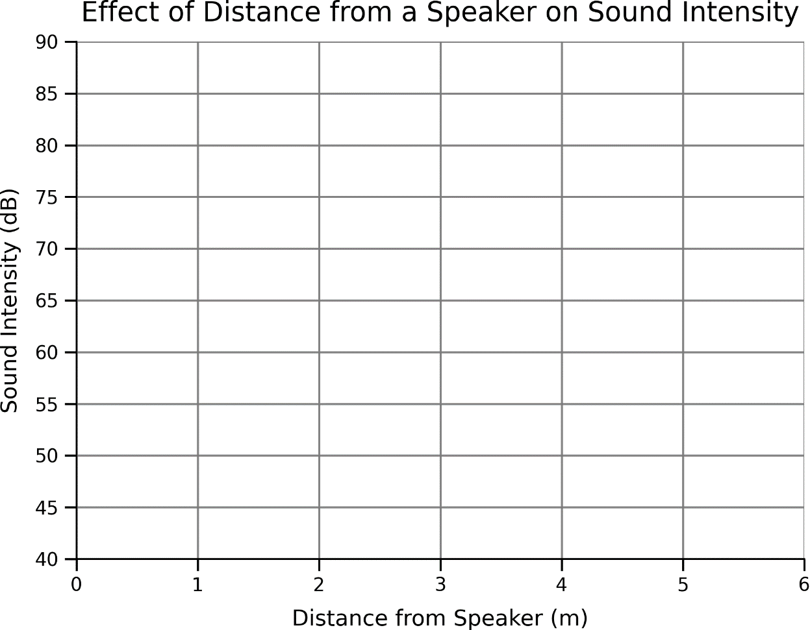

2 marks

Checklist

Plots drawn correctly ☐

A slightly curved line of best fit ☐
Teacher ticks here | Tick | Student comment: How to improve
Excellent homework (good comment)
Good/completed
Requires improvement
Incomplete/unsatisfactory

Peer assessed / Self-assessed

Task 3
Due Date: ___________
Topic: Waves – Sound
Instructions: Complete the following tasks to understand
- Complete the keywords for the following definitions using the following word bank:

luminous | medium | normal | oscillation | photo-sensitive | vacuum
Definition | Key Word
An absence of matter.
A substance or material that carries a wave.
A word that describes objects that emit light.
A line at right angles to a surface.
Reacting to light, for example, by changing colour or producing an electrical signal.
Regular movement from the resting position which varies in position and magnitude.

- Complete the labels on each of the waves and tick the correct type of wave.
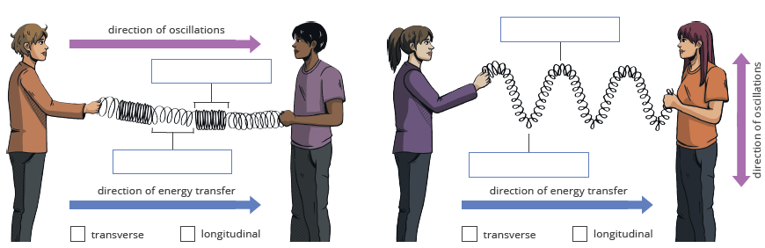

- Label the following diagram of the ear:
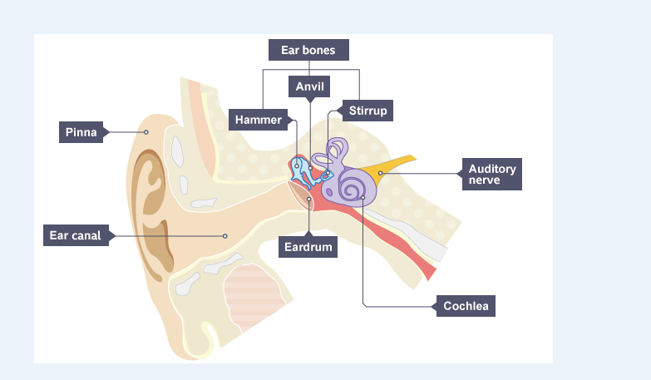
________
____________ Nerve
- State the function of each of the following:

- Ear drum = ________________________________________________

- Auditory nerve = ___________________________________________

- Cochlea = _________________________________________________

Teacher ticks here | Tick | Student comment: How to improve
Excellent homework (good comment)
Good/completed
Requires improvement
Incomplete/unsatisfactory

Peer assessed / Self-assessed

Task 4
Due Date: ___________
Topic: Waves – Frequency and Amplitude
Instructions: Use the information to understand frequency and amplitude.

Information section 1:
Amplitude: The amplitude of a wave is the distance from the centre line (or the still position) to the top of a peak/crest or to the bottom of a trough. Shown by a. The larger the amplitude, the louder the sound is.
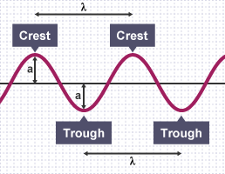
Questions 1
- Which of the following has a larger amplitude? Circle the letter.

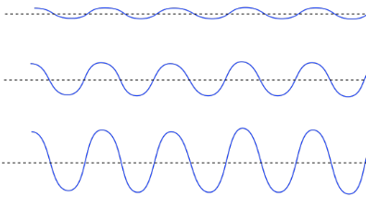

- What is the amplitude of this wave? Circle the letter.
- 1
- 2
- 3
- 4
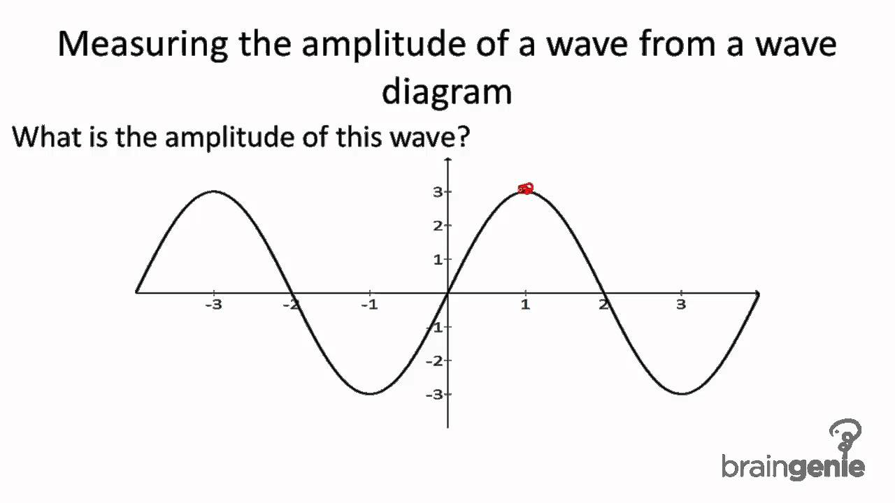
Information set 2: Frequency: The frequency (Hz) of a wave is the number of waves passing a point in a certain time. We normally use a time of one second, so this gives frequency the unit hertz (Hz) since one hertz is equal to one wave per second.
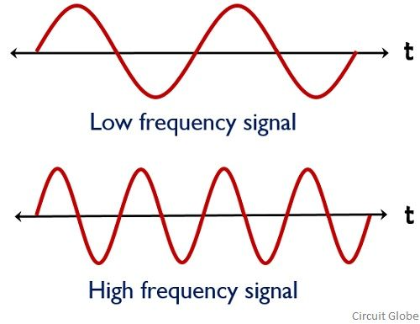
Question set 2:
- State the unit for frequency. _______________ ( ____)

- High frequency means what about the sound?
- High pitch
- Low pitch

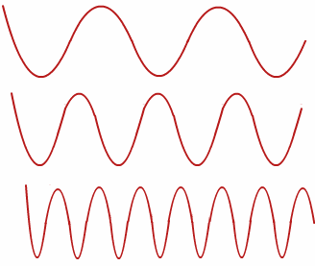
- Which of the following shows the highest frequency? Circle the wave.

b
c.

- Draw wave that decreases in frequency but increases in amplitude (gets louder and the pitch gets deeper)

Teacher ticks here | Tick | Student comment: How to improve
Excellent homework (good comment)
Good/completed
Requires improvement
Incomplete/unsatisfactory

Peer assessed / Self-assessed

Task 5
Due Date: ___________
Topic: Chemical Reactions (Y7 Periodic table recap)
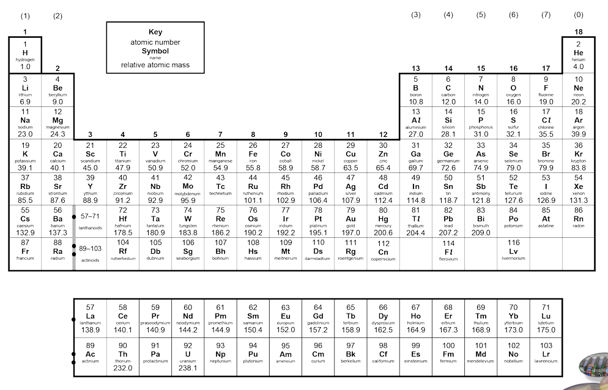
Instructions: Complete the tasks below using the periodic table in your diary and the internet.
- On the periodic table above, identify where the groups are.
- On the periodic table above, write the numbers for the period number.
- On the periodic table above, circle the following elements: Hydrogen, Oxygen, Iron, Neon, Helium, Sodium.
- Write the chemical formula for the following elements in the table below. The first one has been done for you.
Name of element | Chemical formula
Oxygen | O
Calcium
Sodium
- Identify some common elements and compounds below:
Chemical formula of element/compound | Name of the element/compound
H₂O | Water
CO₂
O₂
Challenge: C₆H₁₂O₆

Teacher ticks here | Tick | Student comment: How to improve
Excellent homework (good comment)
Good/completed
Requires improvement
Incomplete/unsatisfactory

Peer assessed / Self-assessed
Task 6
Due Date: ___________
Topic: Chemical Reactions: Balancing equations
Instructions: Identify the number of atoms of each element in the examples below. Use this to explain whether the equations are balanced or not. The first one has been done for you.

*Extension – balance the unbalanced equations!

2H₂ | + | O₂ | → | 2H₂O
On the reactants’ side |  |  | Element | On the products’ side
4 |  |  | H | 4
2 |  |  | O | 2
The equation is unbalanced / balanced because…there are the same number of hydrogen and oxygen atoms on each side.

2NaOH | + | H₂SO₄ | → | Na₂SO₄ | + | 2H₂O
On the reactants’ side |  |  | Element | On the products’ side
 |  |  | Na
 |  |  | O
 |  |  | H
 |  |  | S
The equation is unbalanced / balanced because…

N₂ | + | H₂ | → | 2NH₃
On the reactants’ side |  |  | Element | On the products’ side
 |  |  | N
 |  |  | H
The equation is unbalanced / balanced because…

Al(OH)₃ | + | 3H₂SO₄ | → | Al₂(SO₄)₃ | + | 6H₂O
On the reactants’ side |  |  | Element | On the products’ side
 |  |  | Al
 |  |  | O
 |  |  | H
 |  |  | S
The equation is unbalanced / balanced because…

Teacher ticks here | Tick | Student comment: How to improve
Excellent homework (good comment)
Good/completed
Requires improvement
Incomplete/unsatisfactory

Peer assessed / Self-assessed

Task 7
Topic: Revision homework Waves and Chemical Reactions
Instructions: Complete the poster below to revise Waves and Chemical Reactions. This should cover all of the points below.
Teacher ticks here | Tick | Student comment: How to improve
Excellent homework (good comment)
Good/completed
Requires improvement
Incomplete/unsatisfactory

Peer assessed / Self-assessed
Periodic table
pH Scale
Combustion
Thermal decomposition
Word equations
Colours
Refraction
Reflection
Sound waves
Wave properties
Chemical reactions
Waves
Year 8 Home Learning
Autumn Half Term 2 2026
Dedication
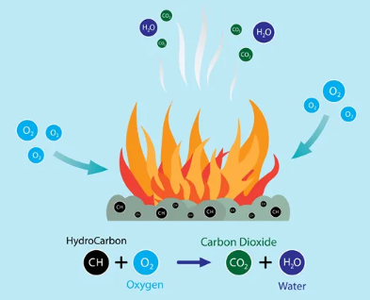

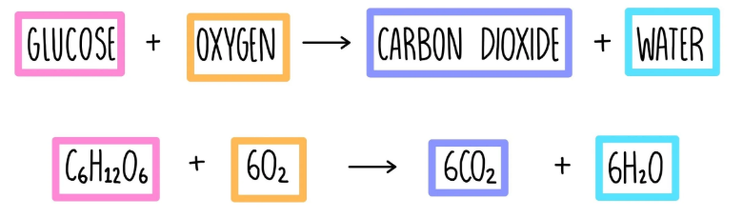

Home Learning expectations
- -Written by yourself, in your own words.
- -Completed by the due date.
- -Finished to the best of your ability.
- -Closely followed the instructions.
- -Green penned and improved when needed.
- -Peer or self-assessed when asked to.
- -Presented so it is clear and neat
- -Proof read the work to ensure spelling, punctuation and grammar is to the best of your ability.

Task 8
Due Date: ___________
Topic: Chemical Reactions – writing word equations
Instruction: Read the text below and then do the task.

The sound of the alarm wakes Sara up. She gets out of bed and goes to the kitchen where she fills up the kettle and puts it on to boil. She grabs two slices of bread and puts them in the toaster. The water in the kettle is bubbling, and it switches off so Sara pours the hot water into a mug with a teabag in it. The water in the mug starts to turn brown as the tea infuses. She removes the teabag, takes a teaspoon of sugar and stirs it into the tea until the sugar crystals are invisible. She pours in some milk.
Then she takes two eggs from the fridge, cracks them into a bowl and beats them with a fork to mix the yolk into the white. Sara takes some butter from the fridge and puts it into a pan, and turns up the heat. The butter starts to melt and foam. Sara pours the egg mixture into the pan onto the butter. The egg mixture starts to solidify and turn opaque.
The smell from the toaster makes Sara look up. The toast is starting to burn and she can see some smoke rising from the toaster. She removes the toast as quickly as possible. It has turned a dark brown, but it is not too burned so she puts it on a plate and pours the eggs on top. Breakfast is served!

For every area of the text highlighted in bold, explain whether the change is a chemical change, or a physical change.

- “water in the kettle is bubbling” .
It is a physical reaction because____________________________

- “water in the mug starts to turn brown”
________________________________________________________________________________________________________________________________________________
- “until the sugar crystals are invisible”
________________________________________________________________________________________________________________________________________________
- “the yolk into the white”
________________________________________________________________________________________________________________________________________________
Teacher ticks here | Tick | Student comment: How to improve
Excellent homework (good comment)
Good/completed
Requires improvement
Incomplete/unsatisfactory

Peer assessed / Self-assessed
Task 2
Read the descriptions of chemical reactions below and write word equations to describe them.

- When highly flammable propane gas encounters the oxygen in the air, it undergoes a vigorous and explosive chemical reaction, resulting in the formation of scorching carbon dioxide and steam.

Propane + oxygen __________ __________ + water

- When corrosive hydrochloric acid meets caustic sodium hydroxide, a rapid and intense chemical reaction takes place, leading to the creation of a sodium chloride solution along with copious amounts of water.

Hydrochloric acid + ___________ ___________ _________ __________ + _________

- In the presence of moisture, iron metal reacts with atmospheric oxygen in a slow and gradual chemical reaction, resulting in the formation of reddish-brown iron(III) oxide, commonly known as rust.

Teacher ticks here | Tick | Student comment: How to improve
Excellent homework (good comment)
Good/completed
Requires improvement
Incomplete/unsatisfactory

Peer assessed / Self-assessed
Task 9
Due Date: ___________
Topic: Respiration – key words and definitions

Instructions: Complete the keyword and definitions list by filling in the gaps. Use your Respiration booklet or the internet.

Keyword | Definition
Independent variable
 | Numerical data, e.g. volume.
Rate | The speed at which something changes.
Aerobic respiration
 | Single-celled fungi involved in fermentation
Breathing
 | The alveoli are where the lungs and the blood exchange oxygen and carbon dioxide during the process of breathing in and breathing out.
 | A sheet of muscle that separates the chest (or thoracic) cavity from the rest of the body.
Fermentation
 | Gas produced in anaerobic respiration
 | Organelle where aerobic respiration takes place

Teacher ticks here | Tick | Student comment: How to improve
Excellent homework (good comment)
Good/completed
Requires improvement
Incomplete/unsatisfactory

Peer assessed / Self-assessed

Task 10
Due Date: ___________
Topic: Respiration basics
Instructions: Complete the following tasks to practice the basics of respiration and recap the structure of a cell. Use the key word list to help.
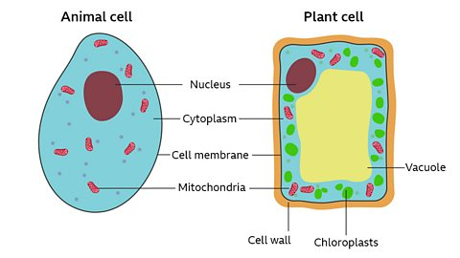
Key word list:
• Mitochondria – the part of the cell where respiration takes place.
• Respiration – a chemical reaction in cells that releases energy.
• Oxygen – a reactant needed for aerobic respiration.
• Carbon dioxide – a product made during aerobic respiration.
• Breathing – moving air into and out of the lungs; it is different from respiration
  - Look at the animal and plant cell above. State which sub-cellular structure respiration occurs in. _______________.

- Finish the word equation for aerobic respiration below:

Glucose + ___________ ___________ ________ + water

- Is respiration the same as breathing?
    - Yes
    - No
- Explain your answer to the above using the definitions of breathing and respiration
________________________________________________________________________________________________________________________________________________________________________

- Stacy says “Respiration only occurs in animals”. Is she correct? Explain your answer and use the information above.
- Yes
- No

Explanation.. ________________________________________________________________________________________________________________________________________________________________________

Teacher ticks here | Tick | Student comment: How to improve
Excellent homework (good comment)
Good/completed
Requires improvement
Incomplete/unsatisfactory

Peer assessed / Self-assessed

Task 11
Due Date: ___________
Topic: Chemical Reactions – Combustion and thermal decomposition
Instructions: Complete the tasks below to understand the different between thermal decomposition and combustion. Use the information below and your booklet to help you.

Thermal Decomposition
Thermal decomposition is a chemical reaction where a compound breaks down into simpler substances when heated.
- Heat is required.
- One substance breaks apart into two or more substances.
- Oxygen is not needed.
Example:
Word equation
Calcium carbonate → Calcium oxide + Carbon dioxide

Combustion
Combustion is a chemical reaction where a substance burns in oxygen and releases energy.
- Oxygen is required.
- Heat and light energy are released.
- New substances are formed.
Example:
Word equation
Methane + Oxygen → Carbon dioxide + Water

  - Match each keyword to the correct definition by writing the letter that corresponds.

Keywords
- Combustion _____
- Thermal decomposition _____
- Reactant _____
- Product _____
- Oxygen _____

Definitions
A. Substance needed for burning
B. A substance present at the start of a reaction
C. A reaction where a substance burns
D. A reaction where heat breaks down a compound
E. A substance formed during a reaction

  - Use the words below to fill In the gaps:
oxygen, heat, burns, breakdown, energy
- Thermal decomposition requires __________.
- Combustion requires __________.
- During combustion a fuel __________.
- Thermal decomposition causes the __________ of a compound.
- Combustion releases __________.

  - Thermal Decomposition equations, complete the blanks.
- Calcium carbonate → __________ + Carbon dioxide
- Magnesium carbonate → Magnesium oxide + __________

  - Combustion equations, complete the blanks.
- Methane + Oxygen → __________ + Water
- Hydrogen + Oxygen → __________

  - Write Thermal Decomposition or Combustion in the blank.
Reaction | Type
CaCO₃ → CaO + CO₂ | __________
CH₄ + 2O₂ → CO₂ + 2H₂O | __________
MgCO₃ → MgO + CO₂ | __________
2H₂ + O₂ → 2H₂O | __________

Teacher ticks here | Tick | Student comment: How to improve
Excellent homework (good comment)
Good/completed
Requires improvement
Incomplete/unsatisfactory

Peer assessed / Self-assessed

Task 12
Due Date: ___________
Topic: How science works: Analysing data in a table
Instructions: Complete the tasks below to describe the following tables and graphs.

Weight (N) | Speed (m/s)
0.1 | 1.0
0.3 | 2.0
0.5 | 3.0
0.7 | 4.0
0.9 | 5.0

1. Fill in the missing words to describe what the table shows:
a. As the ______________ increases, the speed _______________.
b. Which weight had the highest speed?
___________

Time (hr) | Volume (cm³)
0.5 | 34
1.0 | 40
1.5 | 45
2.0 | 51
2.5 | 56
2. Fill in the missing words to describe what the table shows:
a. As the time __________ the volume _______________.
b. Sketch a line to show what the graph might look like.

Volume (cm3)
Time (hr)

- What is the independent variable in this investigation? ____________________
- What is the dependent variable in this investigation?___________________
- Why do we ignore anomalies when we draw a line of best fit? ____________________
- Name the type of variable that is kept the same. C___________ Variable.

Teacher ticks here | Tick | Student comment: How to improve
Excellent homework (good comment)
Good/completed
Requires improvement
Incomplete/unsatisfactory

Peer assessed / Self-assessed

Task 13
Due Date: ___________
Topic: Exam practice – Chemical reactions
Instructions: Complete the exam style questions to practice the chemical reactions topic. You should set yourself a 10 minute timer and complete with no help, then use your booklet or the internet to help you in another colour pen.
Practice Questions
Q1. The diagrams show two Bunsen burners. One burner has the air hole closed, and the other has the air hole open.
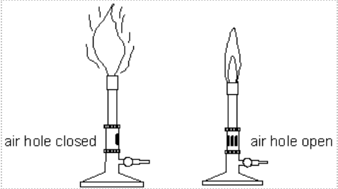
(a) Explain why opening the air hole of a Bunsen burner makes the flame hotter.

............................................................................................................................... 1 mark

(b) Natural gas is methane, CH₄. It is burned in a Bunsen burner.
Complete the word equation for the chemical reaction in the clear blue flame.
methane + ............................. → ............................. + ............................. 2 marks

Q2. (a) The diagrams below show the arrangement of atoms or molecules in five substances A, B, C, D and E.
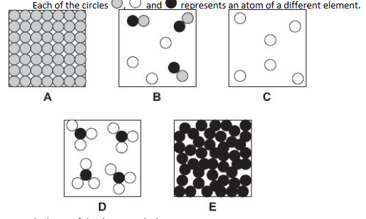
Each of the circles , and represents an atom of a different element.
Give the letter of the diagram which represents:

(i) a mixture of gases .............. 1 mark

(ii) a single compound. .............. 1 mark

(b) The diagram below shows a model of a chemical reaction between two substances.
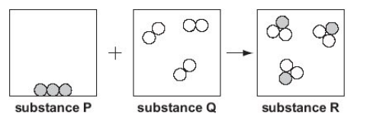
(i) How can you tell from the diagram that a chemical reaction took place between substance P and substance Q?

.................................................................................................................................................................1 mark
(ii) Substance P is carbon. Suggest what substances Q and R could be.

substance Q ........................................................ substance R .............................................1 mark
(iii) How does the diagram show that mass has been conserved in this reaction?

..............................................................................................................................................................1 mark
Q3. Michelle added universal indicator solution to four liquids. Michelle uses the pH chart to fill in a table of results.
pH chart
pH | 1 | 2 | 3 | 4 | 5 | 6 | 7 | 8 | 9 | 10 | 11 | 12 | 13 | 14
colour | red |  |  | orange |  |  | green | blue |  |  | purple
(a) The table below shows some of Michelle’s results. Complete the table of results below, using the pH chart below.
liquid | colour of universal indicator solution | pH
milk | green
rain water |  | 5
hydrochloric acid | red
bleach |  | 11
2 marks
Teacher ticks here | Tick | Student comment: How to improve
Excellent homework (good comment)
Good/completed
Requires improvement
Incomplete/unsatisfactory

Peer assessed / Self-assessed

