Name:_______________________________ Class:_______

  - Year 8
  - Spanish
  - Cuaderno de deberes
  - Topic 1 : El tiempo libre
  - Autumn Term 1
  - Dedication


Home Learning expectations
-Written by yourself, in your own words.
-Completed by the due date.
-Finished to the best of your ability.
-Instructions to be read carefully.
-Green pen and improve when needed.
-Peer or self-assess when asked to.
-Presented so your work is clear and neat
-Proof read your work to ensure spelling, punctuation and grammar is to the best of your ability.

Use your Knowledge Organisers to support with your Home Learning Tasks

Contents
Topic 1
Topic 1 Task 1: Grammar, Present Tense 2
Topic 1 Task 2: Vocabulary 3
Topic 1 task 3: Reading Aloud 4
Topic 1 Task 4: Vocabulary 5
Topic 1 Task 5: Linguascope 6

Topic 1 Task 1: Grammar, Present Tense
Due: ______________________
Match the English and the Spanish.

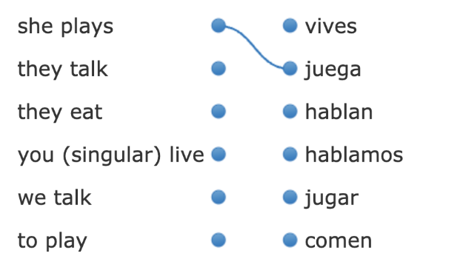

Circle the right verb in each sentence.

- Normalmente yo jugar / juego al fútbol.
- Yo hablo / habla francés.
- Mi hermano y yo vivir / vivimos en Londres.
- Juan y Miguel como / comen chocolate.
- Yo navego / navegas por Internet todos los días.

EXT: Translate into English



Topic 1 Task 2: Vocabulary
Due: ______________________
Use the Knowledge Organiser 1 (El tiempo libre) at the back of your booklet.
Choose 10 words from the box ‘Opiniones’ and practice using the grid below.
Spanish Vocabulary | English Translation | Look and Say (tick) | Look, Say and Write in Spanish | Look, Say and Write in Spanish | Look, Say and Write in Spanish
Extension: Write three sentences using the vocabulary that you’ve learned
- __________________________________________________________
- __________________________________________________________
- __________________________________________________________
Peer-assessed
Write with your green pen
-How confident do you feel about it from 1 to 5 (1 is not confident at all, and 5 is very confident)? _____
-How to improve further:

Topic 1 task 3: Reading Aloud
Due: ______________________

Prepare and practice the text below

¡Hola!
Mi pasatiempo favorito es jugar a los videojuegos. También me gusta mucho escuchar música. Mi tipo de música favorito es la música pop.

Teacher assessed
Feedback:

Topic 1 Task 4: Vocabulary
Due: ______________________
Use the Knowledge Organiser 1 (El tiempo libre) at the back of your booklet.
Choose 10 words from the box ‘Qué vas a hacer?’ and practice using the vocab grid.
Spanish Vocabulary | English Translation | Look and Say (tick) | Look, Say and Write in Spanish | Look, Say and Write in Spanish | Look, Say and Write in Spanish

EXT: Write three sentences using the vocab that you’ve learned
- __________________________________________________________
- __________________________________________________________
- __________________________________________________________
Peer-assessed
Write with your green pen
-How confident do you feel about it from 1 to 5 (1 is not confident at all, and 5 is very confident)? _____
-How to improve further:

Due: ______________________
Peer assessed
Positive points:
How to improve further:

Topic 1 Task 5: Linguascope
Login into Linguascope

Username: Heathland
Password: _________________________________

Instruction:
- Click on the French flag and select ‘Beginner’ section
- On the right side select ‘El ocio’ from the list of topics
- Select ‘Los pasatiempos’
- Spend 20 minutes practising the new vocab in the following sections



EXT: Practise one more section of your choice

Write your score here for the Examen Final: ________
Do you think you can do it better? Try again and write your best score _____

Self-Assessed
Write with your green pen
-How confident do you feel about it from 1 to 5 (1 is not confident at all, and 5 is very confident)? _____
-How to improve further:

Peer assessed
Positive points:
How to improve further:

