
Name:
Set:
Teacher:
Home Learning Expectations:
- All work is written by yourself, in your own words.
- All work is completed by the due date.
- All work is finished to the best of your ability.
- All instructions are read and followed closely, before starting.
- All work is green-penned and improved when needed.
- All work that is marked and/or peer-assessed when asked to.
- All work is presented clearly and all writing is legible.
- All work is proofread to ensure spelling, punctuation and grammar is to the best of your ability.

Read through the requirements and divide the problem up into:
Due Date:

- Data that is input into the system.
- Data that is processed by the system (a calculation or testing a condition).
- Data stored by the system, what is kept in the system even when the quiz is not being played.
- Data that is output from the system onto the screen.
Assuming the quiz asks 10 questions. There are at least 11 inputs (although the answers can be listed in one row). There are 14 outputs and at least 5 processes.
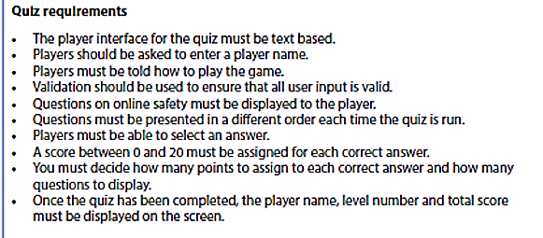
Input/Process/ Storage/ Output | Explain the sub-task
Input: name | The program requests the player enters their name
What went well:
Even better if:

Self Assessed Work

- Below are the requirements for the quiz. Before you start coding you need to decompose the problem by breaking it down into smaller problems/tasks.
Due Date:

- Read through the requirements and work out what data needs to be stored. This will give you the variable names. Assuming the quiz asks 10 questions. There would be 10 variables for the quiz questions (you can put these on one line). There are at least 25 variables to be listed.
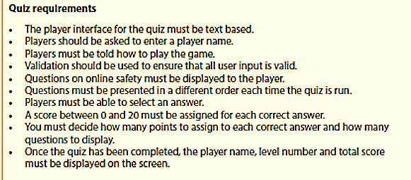
Variable name | Data type
playername | string
What went well:
Even better if:

Peer Assessed Work

Start
Due Date:

Ask for name (output)
Check name has been input, if not ask for
Input name

Instructions
Instructions (output)

Questions
Show question (output)
Input answer
Check if it correct (decision)– two outputs
1) correct answer – add score (rectangle – process)
2) wrong answer – no points (or minus) (rectangle process) – could display answer (output)
Update score

End
Player’s name displayed (output)
Score displayed (output)
Calculate level (process)
Display level (output)

Flowcharts
Due Date:

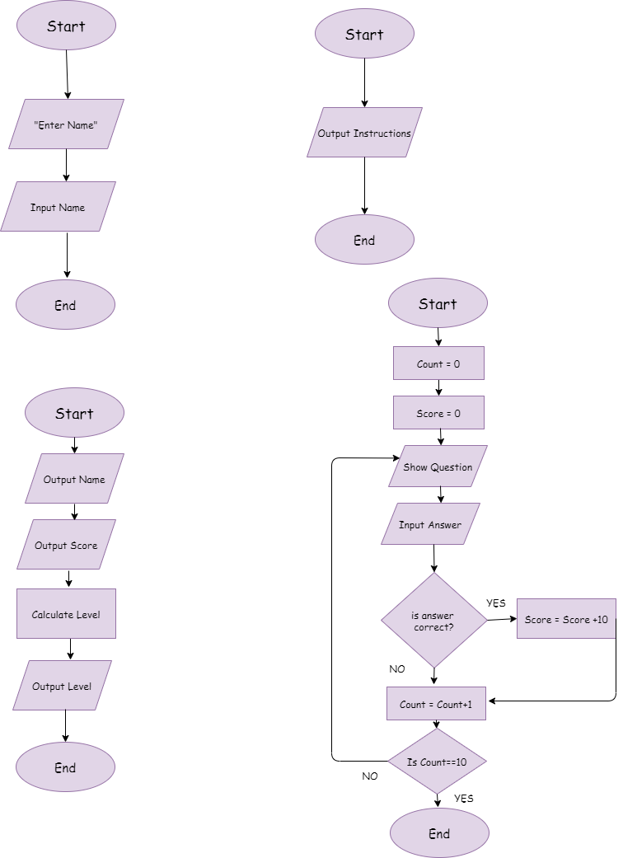
Start Instructions

Questions – asking 10 question

End/Final Outputs

Introduction: In this piece of code identify & label:
Due Date:

- The subroutines (5)
- The local variables (6)
- The parameters (2)
- Where parameters are passed between sub-routines
- The functions (4)
- The selection
sub-routine
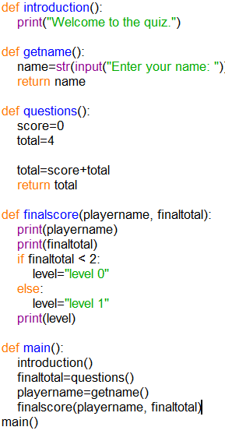
Orange – sub routine (small piece of programming)
Purple – function (pre-created program)
Black - Local variables (places to store data)
Parameters – highlighted in yellow

- What will the following code output?
name = "Sam"
print(name)

- "name"
- Sam
- Name
- Error

- Which line correctly asks the user for their age and stores it as an integer?

- age = print(input("Age?"))
- age = input("Age?")
- age = int(input("Age?"))
- input(age)

- What is the output of the following code?
print(4 + 3 * 2)

A. 14
B. 11
C. 10
D. 8

- What will this code output?

def greet():
print("Hello")
greet()

A. greet
B. Hello
C. Error
D. Nothing

- Which statement correctly returns a value from a function?

- output x
- return x
- print x
- value x

What went well: /10
Even better if:

Self Assessed Work

Due Date:

- What will this code output?

name = "Alex"
age = 14
print(name, age)

A. Alex14
B. Alex age
C. Alex 14
D. Error

- Which operator checks if two values are equal?

- =
- ==
- !=
- >=

- What is the output of this code?

x = 7
if x > 5:
print("High")
else:
print("Low")

A. High
B. Low
C. 7
D. Error

- What will this function return?
def square(num):
return num * num
print(square(5))

A. 10
B. 25
C. num * num
D. Error

10. Which loop repeats code a specific number of times?
A. if loop
B. while loop
C. for loop
D. repeat loop

