Year 9 Home Learning
Name: __________________________ Tutor Group: _______________
Geography teacher: ________________ Set: _______________________
Autumn term 2 - Aspiration
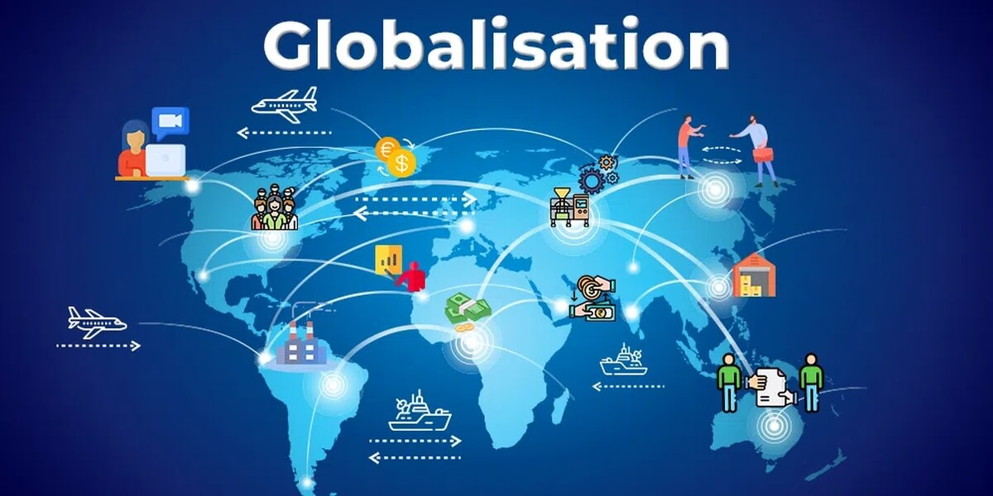
Topic: Globalisation

What Makes Us Global Citizens?
Home Learning expectations
- Written by yourself, in your own words.
- Completed by the due date.
- Finished to the best of your ability.
- Closely followed the instructions.
- Green penned and improved when needed.
- Peer or self-assessed when asked to.
- Presented so it is clear and neat
- Proofread the work to ensure spelling, punctuation and grammar is to the best of your ability.

Year 9 Geography home learning
Key terms:
You will be using these key geographical terms in class throughout this unit of work.
For task 4 you will be learning these words and their meanings for a quiz, which you will do in class the following week

Key word | Definition
Child labour | The (usually illegal) employment of children
De-industrialisation | Closure/ reduction in industrial activity
Exploitation | Treating someone unfairly in order to benefit from their work
Formal economy | Economic activity that is taxed and monitored by the government
Globalisation | The increasing connections between places and people across the planet
Host country | A country that a TNC has chosen to establish part of its operations in
Industrialisation | The process by which an economy is transformed from a primarily agricultural one to one based on the manufacturing of goods.
Informal economy | Economic activity that is neither taxed nor monitored by the government
Labour | Physical work
Outsourcing | Hiring an outside agency to improve efficiency and reduce costs. Usually to developing/ emerging countries
Slave labour | Work done by people who are treated as though they are enslaved
Spiral of decline | Where one negative impact has knock on impacts. Also known as the negative multiplier effect.
Sweatshops | A factory or workshop where workers are treated unfairly, for example having low wages, working long hours or in unsafe environments
Trade | The buying and selling of goods and services between different countries around the world.
Transnational corporations (TNCs) | Transnational corporations are an organisation/ company that is involved with the international production of goods or services

Task 1- How Does Globalisation Link To You?
Instructions: Use the knowledge from your exercise book to complete the retrieval questions

- What does the term globalisation mean?
___________________________________________________________________________________
- Name three countries where products you use every day are made. (look at the labels in your clothes)
__________________________________________________________________________________
- What country was your mobile phone / computer manufactured in?
___________________________________________________________________________________
- Name two foods you eat that are imported from another country.
__________________________________________________________________________________
- Name three countries that the UK trades with.
___________________________________________________________________________________
- What is a TNC?
___________________________________________________________________________________
- How does the internet make the world more connected?
___________________________________________________________________________________
- How can social media connect people around the world?
___________________________________________________________________________________
- Why do some clothes sold in the UK come from countries in Asia?
___________________________________________________________________________________
- How can air travel contribute to global connections?
___________________________________________________________________________________

Positive points: /10
How to improve further:

Peer- assessed

Task 2 – Reading Task. The Almighty Dollar Extract
Instructions: Read the following text and complete the task below
Diapers, bread, milk, juice, apples, chicken…the super-market conveyor belt is a roll-call of Lauren Miller’s weekly essentials. It’s the family shopping list familiar across suburban America. And tagged onto this occasion: a brand new radio., Lauren reaches into her bag and pulls out a bundle of the most instantly recognisable currency on the planet: the almighty dollar bill. Lauren’s grocery shop is a weekly ritual, as is making the most of her budget. Pay rises aren’t what they used to be but she still squeezes in the odd luxury. Today, that’s a new radio for her kitchen. The price is almost unbelievably low. Everywhere she looks, more bargains vie for her attention in the packed aisles of the cavernous Walmart.
Every week, close to 100 million Americans undertake a pilgrimage to a similar cathedral of consumption. The item they are most likely to put in their trolley The humble banana. Pop into the nearest Walmart Supercenter (and with 3,504 dotted across the USA there’s likely to be one within a 15 minute drive) and up to 142,000 different items – some edible, some not – will line the shelves.
To Walmart and its customers, price is everything. The household income of the typical Walmart shopper is slightly below the American average. One in five shopping in the store might be paying with food stamps, issued by the government to those with the lowest earnings. Walmart’s pricing allows the budget of shoppers such as Lauren Miller to stretch further.
This is the American dream on the cheap. Those low prices equal big bucks for bucks for Walmart. Around $1 billion flows through its tills across America every day. Its offshoots around the globe earn a further $250 million or so. That added up to sales worth $481 billion in 2016. It’s the equivalent of $900,000 every minute of every day.
Sam Walton founded Walmart, his ‘pile ‘em high, sell it cheap’ empire, in Arkansas in 1962 under the banner ALWAYS LOW PRICES. ALWAYS. In Sam Walton’s words, ‘A lot of America-made goods simply aren’t competitive in price, or quality or both.’ Ironically, this ultimately led to the company built by the ultra-capitalist, God-fearing Mr Walton relying heavily on an alliance with the People’s Republic of China – which is where the factory that produced Lauren Miller’s radio is most likely to be. Walmart disclosed it had ordered $18 billion worth of goods from China in 2004.
That bargain radio is a minute drop in a boundless ocean of goods reaching America’s shores and shop shelves. Walmart is far from China’s only American customer but it accounts for more than one in ten dollars spent by the USA on Chinese-made goods. By parting with her hard-earned dollar, Lauren Miller is entering into a global contract: cheap electronics in exchange for the most important currency on earth.
Lauren Miller is just echoing the humdrum daily routine of millions of Americans: spending a dollar at Walmart. But that humble, solitary dollar is part of an immense, global story. It is more, even, than just a cog in the thunderous machinery of the highest consuming nation on earth; it’s a crucial part of the explosion in global trade that’s become the economic and political story of our age, a process that’s shifted not just wealth, job, and well-being but the very centres of power too.
Self -assessed
Positive points:
How to improve further:

This extract shows how globalisation is taking place by…………(try to think of at least 3 ways)
________________________________________________________________________________________________________________________________________________________________________________________

Task 3 – Retrieval Quiz

Refer to your exercise book. Answer the following retrieval questions:

1. What is globalisation?
A. The growth of local businesses only
B. The increasing connection of countries through trade, communication, and culture
C. The separation of countries from one another
D. The reduction of international travel

2. Which invention has greatly increased global communication?
A. Steam engine
B. Printing press
C. Internet
D. Compass

3. How has air travel helped globalisation?
A. By making travel slower
B. By reducing international trade
C. By allowing people and goods to move quickly between countries
D. By preventing cultural exchange

4. Which of these is a factor accelerating globalisation?
A. Improved transport systems
B. Closed borders
C. Reduced communication
D. Higher trade barriers

5. What role do transnational companies play in globalisation?
A. They only operate in one country.
B. They help connect economies by operating in many countries.
C. They stop international trade.
D. They reduce cultural exchange.

6. Why has container shipping accelerated globalisation?

A. It makes transporting goods more expensive.
B. It slows down trade.
C. It makes moving goods between countries faster
and cheaper.
D. It prevents international business.

7. What is free trade?
A. Trading without paying workers
B. Trading with fewer restrictions between countries
C. Trading only within one country
D. Trading without transport costs

8. Social media contributes to globalisation because it:
A. Limits communication between countries
B. Allows people worldwide to share ideas and information quickly
C. Stops cultural exchange
D. Prevents businesses from advertising

9. Which of the following is NOT a factor accelerating globalisation?
A. Internet access
B. Improved transport
C. International trade agreements
D. Increased trade barriers

10. Which combination best explains why globalisation has accelerated in recent decades?
A. Slower transport and reduced communication
B. Better technology, faster transport, and increased trade agreements
C. More trade barriers and fewer multinational companies
D. Less internet use and reduced travel

Challenge Question
Which factor has probably had the biggest impact on accelerating globalisation since 1990?
A. Internet and digital communication
B. Horse transport
C. Reduction in air travel
D. Fewer international businesses

Positive points: /11
How to improve further:

Self -assessed
Task 4 –Key word glossary
Instructions: Refer to the globalisation glossary in your exercise book and at the front of this booklet

Task one: Match the key term and definition
Key term | Definition
- Sweatshop  - Exploitation  - Host country  - TNCs | - A country that a TNC has chosen to establish part of its operations in  - Transnational corporations are an organisation/ company that is involved with the international production of goods or services  - Treating someone unfairly in order to benefit from their work  - The (usually illegal) employment of children

Task two: Write the meaning of each term in your own words
1 Formal economy________________________________________________________________________
2 Trade_________________________________________________________________________________
3 Globalisation___________________________________________________________________________
4 Spiral of decline_________________________________________________________________________
5 Sweatshops___________________________________________________________________________

Task three: Write a sentence using the key word correctly
1 Exploitation ________________________________________________________________________
_____________________________________________________________________________________
2 Globalisation ________________________________________________________________________
______________________________________________________________________________________
3 TNCs ________________________________________________________________________________
_______________________________________________________________________________________
Self -assessed
Positive points:
How to improve further:

Task 5 – Global TNC
Instructions: Choose a global company (TNC)
TNC logo (draw or print and stick in)
Complete research to find out how global they are.
Consider the following success criteria

- Where is the headquarters
- When was the company started
- What are their annual profits
- How many people work for them
- What are their most popular products
- Where are their offices/ factories
- How do they advertise their products
- Do they have sponsorship of teams or individuals
- Any other facts that you think make them a global TNC

____________________________________________________________________________________________________________________________________________________________________________________________________________________________________________________________________________________________________________________________________________________________
____________________________________________________________________________________________________________________________________________________________________________________________________________________________________________________________________________________________________________________________________________________________
____________________________________________________________________________________________________________________________________________________________________________________________________________________________________________________________________________________________________________________________________________________________
____________________________________________________________________________________________________________________________________________________________________________________________________________________________________________________________________________________________________________________________________________________________
____________________________________________________________________________________________________________________________________________________________________________________________________________________________________________________________________________________________________________________________________________________________

Positive points:
How to improve further:

Teacher- assessed

Task 6 –Christmas and Globalisation
Instructions: Think about all the work you have completed about globalisation. Write down how you think Christmas is part of globalisation. Use the picture clues to help you.


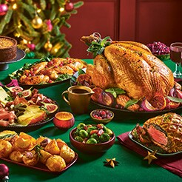



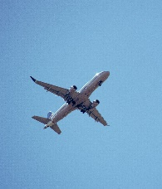
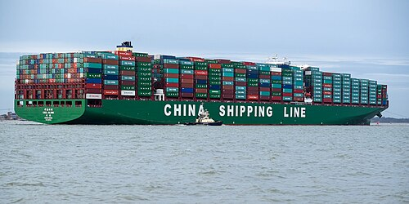

Christmas is part of globalisation because……. ____________________________________________________________________________________________________________________________________________________________________________________________________________________________________________________________________________________________________________________________________________________________
____________________________________________________________________________________________________________________________________________________________________________________________________________________________________________________________________________________________________________________________________________________________
____________________________________________________________________________________________________________________________________________________________________________________________________________________________________________________________________________________________________________________________________________________________
____________________________________________________________________________________________________________________________________________________________________________________________________________________________________________________________________________________________________________________________________________________________

Positive points:
How to improve further:

Self -assessed

