Year 9 Home Learning
Name: __________________________ Tutor Group: _______________
Geography teacher: ________________ Set: _______________________
Autumn term 1 – Aspiration
Topic: Rivers
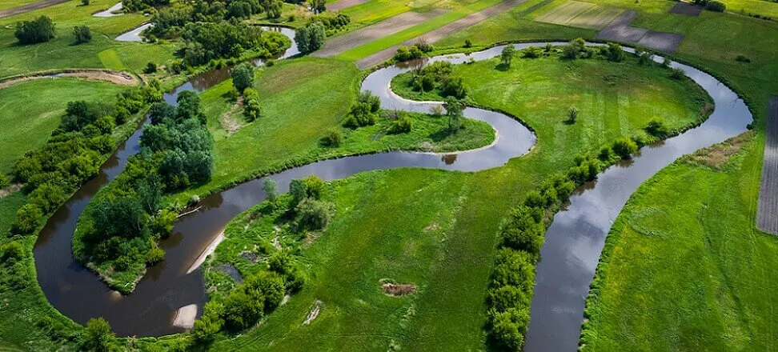

Why Do Rivers Rage? What Impacts Can They Have?

Home Learning expectations
- Written by yourself, in your own words.
- Completed by the due date.
- Finished to the best of your ability.
- Closely followed the instructions.
- Green penned and improved when needed.
- Peer or self-assessed when asked to.
- Presented so it is clear and neat
- Proofread the work to ensure spelling, punctuation and grammar is to the best of your ability.

Year 9 Geography home learning
Key terms:
You will be using these key geographical terms in class throughout this unit of work.
For task 4 you will be learning these words and their meanings for a quiz, which you will do in class the following week
Key word | Definition
Channel | The bed and banks of the river.
Delta | A fan-shaped area of sediment built up at the mouth of a river.
Drainage Basin | The area of land that is drained by a river and its tributaries.
Impermeable | A surface that does not allow water to pass through it.
Permeable | A surface that allows water to pass through it.
Storm Hydrograph | A graph which shows the change in both rainfall and discharge from a river following a storm.
Surface Runoff | All water flowing on the Earth’s surface.
Discharge | The volume of water in the river at any given point (measured in cumecs).
Interlocking spurs | Hills that stick out on alternating sides of a V-shaped valley, like the teeth of a zip.
Saturated | Soil is saturated when the water table has come to the surface. The water then flows over land.

Task 1 - Water Cycle Quick Quiz
Instructions: Use the knowledge from your exercise book to complete the retrieval questions

1. What is the water cycle?
A. The movement of water around Earth through different stages
B. The process of making drinking water
C. The movement of ocean currents only
D. The study of weather
2. What is evaporation?
A. Water freezing into ice
B. Water changing from a liquid to a gas
C. Water falling as rain
D. Water soaking into the ground
3. What is condensation?
A. Water vapor changing into liquid water
B. Ice melting into water
C. Rainwater entering rivers
D. Water flowing underground
4. What is precipitation?
A. Water vapor rising into the air
B. Water collecting in oceans
C. Any form of water falling from clouds
D. Water soaking into soil
5. What is runoff?
A. Water flowing over land into rivers, lakes, or oceans
B. Water evaporating from plants
C. Water freezing into glaciers
D. Water turning into clouds
6. What is the process called when plants release water vapor into the atmosphere?
A. Infiltration
B. Transpiration
C. Condensation
D. Collection
7. Why is the water cycle important?
A. It creates new water on Earth
B. It removes all pollution from water
C. It continually moves and recycles water around the planet
D. It prevents weather from changing
8. Clouds form mainly because of:
A. Evaporation
B. Condensation
C. Collection
D. Runoff
Peer assessed
Positive points: /8
How to improve further:

Task 2 –Flooding Event. Pakistan/ Cornwall or Another Recent Example
Instructions: Refer to the task research support in teams.

Task one: Using the research links, explain 3 reasons why the floods in your chosen location took place
1.______________________________________________________________________________
2.______________________________________________________________________________
3.______________________________________________________________________________

Task two: Write a diary entry imagining that you experienced the flood. Think carefully about the impacts (effects) that the flood would have on the local area. Make sure to consider the environment, people and the economy.

Dramatic opening with facts and figures ____________________________________________________________________________________________________________________________________________________________________________________________________________
Impact of the economy (think how developed your country is) ________________________________________________________________________________________________________________________________________________________________________________________________________________________________________________________________________________________________________________________________________________________________________________________________________________________
Impact of the environment (both long and short term)
___________________________________________________________________________________________________________________________________________________________________________________________________________________________________________________________________________________________________________________________________________________________________________________________________________________________________________________________________________

Picture/ map

Impact of local people, how the rest of the country may be impacted.
___________________________________________________________________________________________________________________________________________________________________________________________________________________________________________________________________________________________________________________________________________________________________________

Teacher assessed
Positive points:
How to improve further:

Task 3 – Retrieval Quiz
Instructions: Refer to your exercise book

Answer the following retrieval questions:

- What is a long river profile?

_________________________________________________________________________________

- Where does a river begin?

_________________________________________________________________________________

- How does the gradient (slope) change from the source to the mouth?

_________________________________________________________________________________

- What landforms are commonly found in the upper course?

_________________________________________________________________________________

- What happens to the rivers width as it flows downstream?

_________________________________________________________________________________

- What is a meander and where is it found?

_________________________________________________________________________________

- What is deposition and where is it most common on the long river profile?

_________________________________________________________________________________

- What is the mouth of the river?

_________________________________________________________________________________

- How does discharge generally change downstream?

_________________________________________________________________________________

- Why is the middle and lower course of the river more prone (likely) to flood?

_________________________________________________________________________________

Positive points:
How to improve further:

Self-assessed

Task 4 – Key Word Glossary

Instructions: Refer to the rivers glossary in your exercise book and at the start of this booklet

Task one: Match the key term and definition
Key term | Definition
- Permeable  - Watershed  - Confluence  - Flood plain | - The boundary between two drainage basins  - Flat land around a river that gets flooded when the river overflows  - The point at which a tributary joins the main river channel  - A surface that allows water to pass through it

Task two: Write the meaning of each term in your own words
1 Mouth______________________________________________________________________________
2 Interception___________________________________________________________________________
3 Saturated_____________________________________________________________________________
4 Surface runoff _________________________________________________________________________
5 Delta_______________________________________________________________________________

Task three: Write a sentence using the key word correctly
1 Impermeable ________________________________________________________________________
_____________________________________________________________________________________
2 Channel ____________________________________________________________________________
____________________________________________________________________________________
3 Discharge _____________________________________________________________________________________________________________________________________________________________________________
Self-assessed
Positive points:
How to improve further:

Task 5 – River Pollution
Instructions: Refer to the support information on teams to create a poster to show how rivers are being polluted around the world. Your work should include pictures, writing, and facts.

Success criteria
Is it about rivers (not oceans)
Are the pictures suitable
Has some research taken place
There are facts/ figures to show the problem

Positive points:
How to improve further:

Peer assessed

Task 6 – Hydrographs, Flooding and Over Extraction
Instructions: Refer to your classwork in your exercise book

Answer the following retrieval questions:

- What is a flood hydrograph?

_________________________________________________________________________________

- Name two factors that would have an impact on a flood hydrograph

_________________________________________________________________________________

_________________________________________________________________________________

- What does lag time mean?

_________________________________________________________________________________

- Describe two problems that flooding creates

_________________________________________________________________________________

_________________________________________________________________________________

- What is an embankment and how does it help reduce impacts of flooding?

_________________________________________________________________________________

- Afforestation is an example of soft engineering. Explain what it is and how it reduces flooding

_________________________________________________________________________________

- If more houses are built on flood plains, explain what impact this could have
_________________________________________________________________________________

- How could climate change have an impact on RIVER flooding?

_________________________________________________________________________________

Positive points:
How to improve further:

Self-assessed

Task 7- River Management Part a – complete the quick questions
Q1. What is the main aim of river management?
- To make rivers wider
- To reduce the risk and impact of flooding
- To increase rainfall
- To build more rivers
Q2. __________engineering involves building permanent structures to prevent flooding.
Q3. What does soft engineering focus on?
- Using very heavy machinery
- Stopping rainfall
- Building bigger walls
- Working with nature to reduce flood risk
Q4. Why is it wrong to believe that hard engineering always protects against flooding?
- Because it is cheap and easy to maintain
- Because it can fail or cause problems elsewhere
- Because it is always very effective at preventing floods
- Because it protects wildlife habitats
Part b- complete the table below
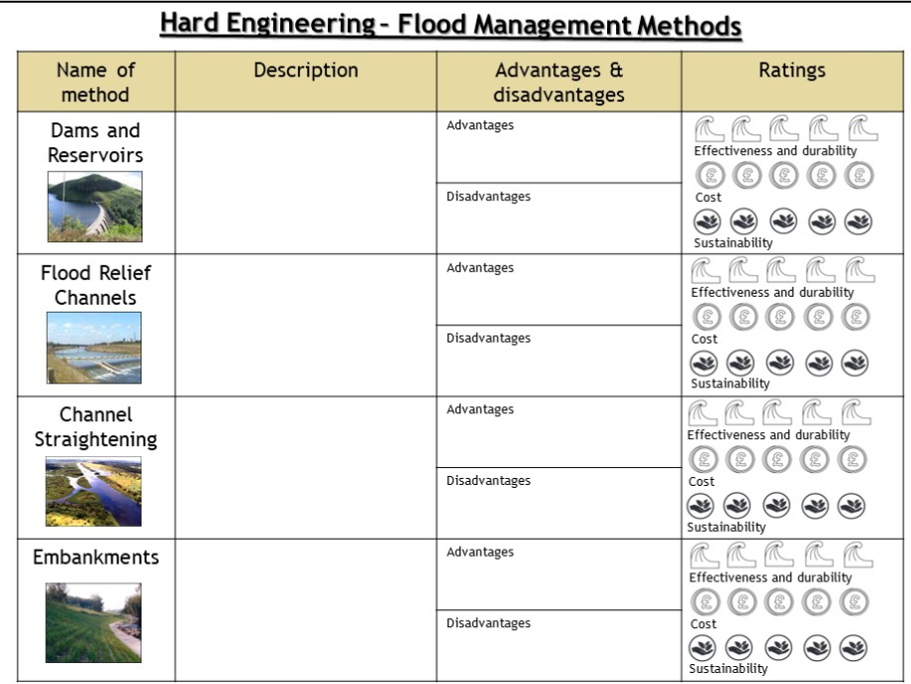
Sustainability means thinking about now and the future

Peer assess
Positive points:
How to improve further:

