Year 9 Home Learning
Name: __________________________ Tutor Group: _______________
Geography teacher: ________________ Set: _______________________
Autumn term 2 – Dedication
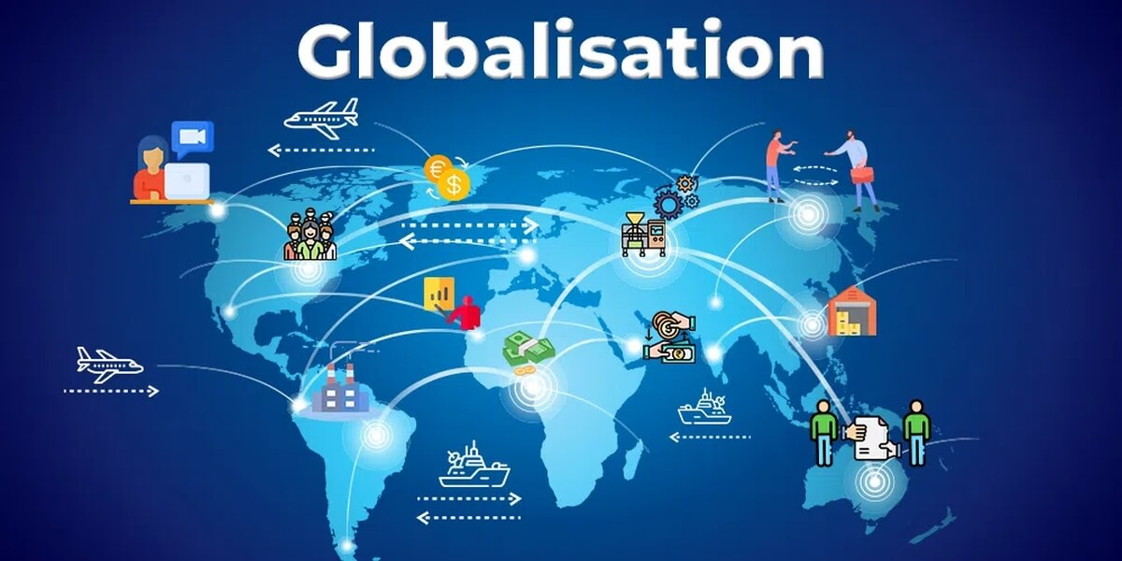
Topic: Globalisation
What Makes Us Global Citizens?
Home Learning expectations
- Written by yourself, in your own words.
- Completed by the due date.
- Finished to the best of your ability.
- Closely followed the instructions.
- Green penned and improved when needed.
- Peer or self-assessed when asked to.
- Presented so it is clear and neat
- Proofread the work to ensure spelling, punctuation and grammar is to the best of your ability.

Year 9 Geography Home Learning
Key terms:
You will be using these key geographical terms in class throughout this unit of work.
For task 4 you will be learning these words and their meanings for a quiz, which you will do in class the following week

Key word | Definition
Child labour | The (usually illegal) employment of children
De-industrialisation | Closure/ reduction in industrial activity
Exploitation | Treating someone unfairly in order to benefit from their work
Formal economy | Economic activity that is taxed and monitored by the government
Globalisation | The increasing connections between places and people across the planet
Host country | A country that a TNC has chosen to establish part of its operations in
Industrialisation | The process by which an economy is transformed from a primarily agricultural one to one based on the manufacturing of goods.
Informal economy | Economic activity that is neither taxed nor monitored by the government
Labour | Physical work
Outsourcing | Hiring an outside agency to improve efficiency and reduce costs. Usually to developing/ emerging countries
Slave labour | Work done by people who are treated as though they are enslaved
Spiral of decline | Where one negative impact has knock on impacts. Also known as the negative multiplier effect.
Sweatshops | A factory or workshop where workers are treated unfairly, for example having low wages, working long hours or in unsafe environments
Trade | The buying and selling of goods and services between different countries around the world.
Transnational corporations (TNCs) | Transnational corporations are an organisation/ company that is involved with the international production of goods or services

Task 1 - How Does Globalisation Link To You?
Instructions: Use the knowledge from your exercise book to complete the retrieval questions

- Globalisation means…
___________________________________________________________________________________
- Look at the labels in your clothes, which country are they made in? (choose 3 items)
__________________________________________________________________________________
- Where was your mobile phone / computer made (manufactured) in?
___________________________________________________________________________________
- Name two foods you eat that are from another country.
__________________________________________________________________________________
- Name three countries that the UK trades with.
___________________________________________________________________________________
- A TNC is (not what it stands for)
___________________________________________________________________________________
- The internet makes the world more connected because
___________________________________________________________________________________
- Social media connects people around the world by….
___________________________________________________________________________________
- Clothes sold in the UK often come from countries in Asia because……
___________________________________________________________________________________
- Air travel contributes to global connections because…..
___________________________________________________________________________________

Positive points: /10
How to improve further:

Peer-assessed

Task 2 – Reading Task. The Almighty Dollar Extract
Instructions: Read the following text and complete the task below

Lauren Miller is shopping for things her family needs every week, like diapers, bread, milk, juice, apples, and chicken. This is a normal shopping trip for many families in America. Today, she is also buying a new radio. To pay, she takes out some dollar bills.
Lauren tries to make her money last because wages are not increasing much. Even so, she can sometimes afford a small treat. Today, that treat is the radio, which is surprisingly cheap. As she walks through Walmart, she sees lots of other low-priced items.
Every week, nearly 100 million Americans shop at Walmart. The most popular item they buy is bananas. There are over 3,500 Walmart Supercenters in the United States, and most people live within a 15-minute drive of one. Each store can sell up to 142,000 different products.
Walmart focuses on keeping prices low. Many of its customers earn less than the average American family, and some use government food assistance to buy groceries. Low prices help shoppers like Lauren get more for their money.
These low prices also make Walmart a huge business. The company earns about $1 billion every day in the United States and even more from stores in other countries. In 2016, Walmart sold $481 billion worth of products.
Walmart was started by Sam Walton in Arkansas in 1962. His idea was simple: sell large amounts of products at very low prices. To keep costs down, Walmart buys many products from China. Lauren's new radio was probably made there.
The radio is just one tiny part of the huge number of goods shipped from China to America. Walmart buys more Chinese-made products than almost any other American company. When Lauren spends her dollar, she is taking part in a worldwide trade system where countries exchange goods and money.
Lauren's shopping trip may seem ordinary, but it is connected to a much bigger story. Her dollar helps support global trade, which affects jobs, wealth, and even the balance of power between countries around the world.
This extract shows how globalisation is taking place by…………(try to think of at least 3 ways)
- __________________________________________________________________________________________________________________________________________________________________________

- __________________________________________________________________________________________________________________________________________________________________________

- __________________________________________________________________________________________________________________________________________________________________________

Self -assessed
Positive points:
How to improve further:

Task 3 –Retrieval Quiz

Refer to your exercise book. Answer the following retrieval questions:

1. What is globalisation?
A. The growth of local businesses only
B. The increasing connection of countries through trade, communication, and culture
C. The separation of countries from one another
D. The reduction of international travel

2. Which invention has greatly increased global communication?
A. Steam engine
B. Printing press
C. Internet
D. Compass

3. How has air travel helped globalisation?
A. By making travel slower
B. By reducing international trade
C. By allowing people and goods to move quickly between countries
D. By preventing cultural exchange

4. Which of these is a factor accelerating globalisation?
A. Improved transport systems
B. Closed borders
C. Reduced communication
D. Higher trade barriers

5. What role do transnational companies play in globalisation?
A. They only operate in one country.
B. They help connect economies by operating in many countries.
C. They stop international trade.
D. They reduce cultural exchange.

6. Why has container shipping accelerated globalisation?
A. It makes transporting goods more expensive.
B. It slows down trade.
C. It makes moving goods between countries faster
and cheaper.
D. It prevents international business.

7. What is free trade?
A. Trading without paying workers
B. Trading with fewer restrictions between countries
C. Trading only within one country
D. Trading without transport costs

8. Social media contributes to globalisation because it:
A. Limits communication between countries
B. Allows people worldwide to share ideas and information quickly
C. Stops cultural exchange
D. Prevents businesses from advertising

9. Which of the following is NOT a factor accelerating globalisation?
A. Internet access
B. Improved transport
C. International trade agreements
D. Increased trade barriers

10. Which combination best explains why globalisation has accelerated in recent decades?
A. Slower transport and reduced communication
B. Better technology, faster transport, and increased trade agreements
C. More trade barriers and fewer multinational companies
D. Less internet use and reduced travel

Self -assessed
Positive points: /10
How to improve further:

Task 4 – Key Word Glossary
Instructions: Refer to the globalisation glossary in your exercise book and at the front of this booklet

Task one: Match the key term and definition
Key term | Definition
- Sweatshop  - Exploitation  - Host country  - TNCs | - A country that a TNC has chosen to establish part of its operations in  - Transnational corporations are an organisation/ company that is involved with the international production of goods or services  - Treating someone unfairly in order to benefit from their work  - The (usually illegal) employment of children

Task two: Write the meaning of each term in your own words
1 Formal economy________________________________________________________________________
2 Trade_________________________________________________________________________________
3 Globalisation___________________________________________________________________________
4 Spiral of decline_________________________________________________________________________
5 Sweatshops___________________________________________________________________________

Task three: Write a sentence using the key word correctly
1 Exploitation ________________________________________________________________________
_____________________________________________________________________________________
2 Globalisation ________________________________________________________________________
______________________________________________________________________________________
3 TNCs ________________________________________________________________________________
_______________________________________________________________________________________
Self -assessed
Positive points:
How to improve further:

Task 5 – Global TNC
Instructions: Choose a global company (TNC)
Complete research to find out how global they are.
TNC logo (draw or print and stick in)

Consider the following success criteria

- Where is the headquarters
_________________________________________________________________________________
- When was the company started
_________________________________________________________________________________
- What are their annual profits
_________________________________________________________________________________
- How many people work for them
_________________________________________________________________________________
- What are their most popular products
_________________________________________________________________________________
- Where are their offices/ factories
_________________________________________________________________________________
- How do they advertise their products
_________________________________________________________________________________
- Do they have sponsorship of teams or individuals
_________________________________________________________________________________
- Any other facts that you think make them a global TNC
___________________________________________________________________________________________________________________________________________________________________________________________________________________________________________________

Positive points:
How to improve further:

Teacher- assessed

Task 6 – Christmas and Globalisation
Instructions: Think about all the work you have completed about globalisation. Write down how you think Christmas is part of globalisation. Use the picture clues to help you.






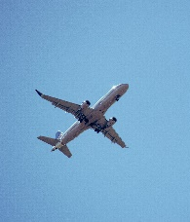
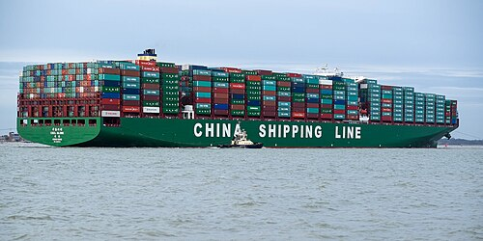

Christmas is part of globalisation because……. ____________________________________________________________________________________________________________________________________________________________________________________________________________________________________________________________________________________________________________________________________________________________
______________________________________________________________________________________________________________________________________________________________________________Another way that christmas traditions around the world make it global is because…._____________________________________________________________________________________________________________________________________________________________________
____________________________________________________________________________________________________________________________________________________________________________________________________________________________________________________________________________________________________________________________________________________________
____________________________________________________________________________________________________________________________________________________________________________________________________________________________________________________________________________________________________________________________________________________________

Positive points:
How to improve further:

Self -assessed

