Year 9 Homework project
Autumn term 2: Soldier project

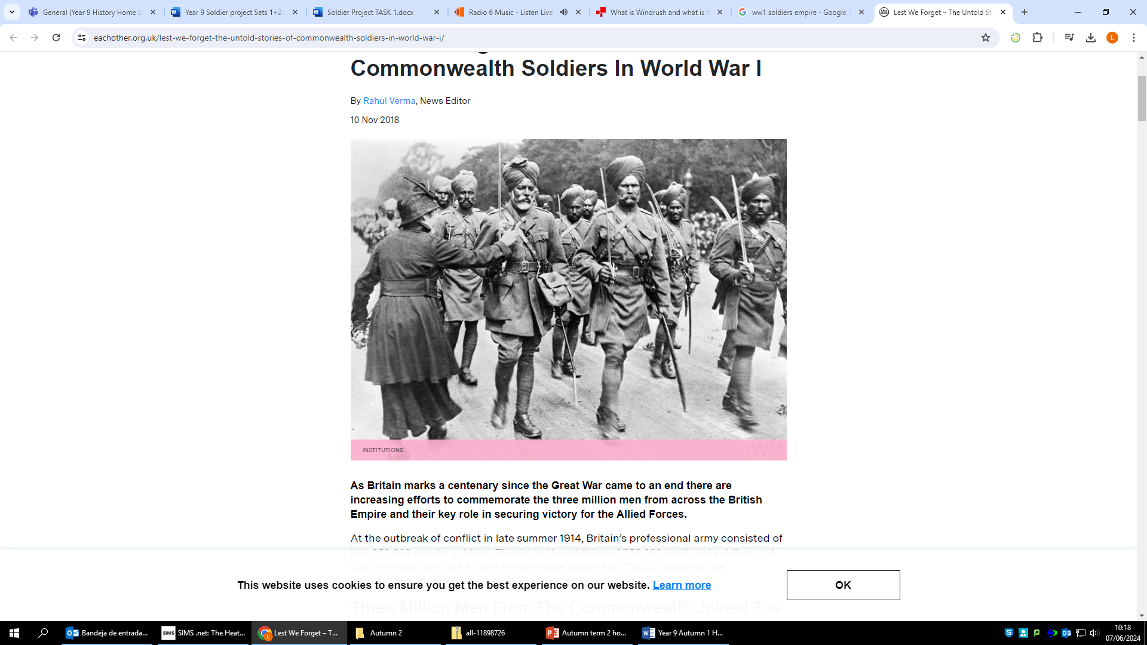

Homework expectations
-Written by yourself, in your own words.
-Completed by the due date.
-Finished to the best of your ability.
-Closely followed the instructions.
-Green penned and improved when needed.
-Peer or self-assessed when asked to.
-Presented so it is clear and neat
-Proof read the work to ensure spelling, punctuation and grammar is to the best of your ability.

Task One –Who to choose?
Due Date:

Instructions: Refer to the Task research support () in teams.

Research the links on slide 2.

Make a list of at least 5 countries and 5 different ethnic minorities who were involved in World War One.

Countries: Different ethnic minorities
1. 1.
2. 2.
3. 3.
4. 4.
5. 5.

World War One was mostly fought in Europe. Why were men from different countries and different ethnicities involved in fighting for the British? Explain your answer in a paragraph using examples.

______________________________________________________________________________________________________________________________________________________________________________ ______________________________________________________________________________________________________________________________________________________________________________

Research a soldier from the list on slide 2 and complete the following fact file.

- His name
Add picture/drawing

- Where he was from

- His rank (position in the army)

- His regiment (which group he fought with)

- Where he fought (which country, area, battle)

Positive points:
How to improve further:

Self assessed

Task Two – Retrieval Task
Due Date:

What do the following letters stand for when discussing long term causes of WW1:
M___________________
A____________________
I____________________
N____________________
Who was assassinated in Sarajevo?
_________________________________________________________________
Define the word propaganda:
__________________________________________________________________________________________________________________________________

List two details in this source:

What can you infer from the source about how
Commonwealth soldiers were persuaded to join the war?

I can infer that__________________________________
______________________________________________
A detail in the source that tells me this ______________
______________________________________________
______________________________________________

Peer assessed
Positive points:
How to improve further:

Task Three - Muslim experience WW1
Due Date:

Instructions: Refer to the Task research support (slide 3) on teams.

Task one Create a poster to inform others about the Muslim Experiences during WW1.
Your poster must include facts on:
- Living conditions in the trenches
- Food
- Religion
- Statistics (How many Muslim soldiers fought in the war/where did they come from?)

Teacher assessed
Positive points:
How to improve further:

Task Four –Retrieval Task
Due Date:

What does conscription mean?
______________________________________________________________________________________________________________________________________________________________________________

- What age range did men have to be to be conscripted into war?
______________________________________________________________________________________________________________________________________________________________________________
- Define the following words:
Stalemate -

Trench -

Trench foot -
- Write down five adjectives to describe what life was like for soldiers in the trenches:
______________________________________________________________________________________________________________________________________________________________________________
- Write down three positive things about trench warfare:
_____________________________________________________________________________________________________________________________________________________________________________________________________________________________________________________________________
- Write down three negative things about trench warfare:
_____________________________________________________________________________________________________________________________________________________________________________________________________________________________________________________________________
- In your opinion what was the most effective weapon used in WW1? Why?
___________________________________________________________________________________________________________________________________________________________________________________________________________________________________________________________________________________________________________________________________________________________________________________________________________________________________________________

Peer assessed
Positive points:
How to improve further:

Task five –Migration stories
Due Date:

Instructions: Refer to the PPT in teams for info.
Imagine you are a soldier involved in the First World War. You must write a letter home telling a family member/friend about your experiences.
The letter should be written creatively but still use facts from your homework tasks.
You must include:
- What life is like for you in the war (food, religion, living conditions)
- Someone from a different country/ a different ethnicity you met
- What you did during your free time
- How difficult is life in the war for you? (Use a comparison to another soldier)
__________________________________________________________________________
__________________________________________________________________________
__________________________________________________________________________
__________________________________________________________________________
__________________________________________________________________________
__________________________________________________________________________
__________________________________________________________________________
__________________________________________________________________________
__________________________________________________________________________
__________________________________________________________________________
__________________________________________________________________________
__________________________________________________________________________
__________________________________________________________________________
__________________________________________________________________________
__________________________________________________________________________
__________________________________________________________________________
__________________________________________________________________________
__________________________________________________________________________
Teacher assessed
Positive points:
How to improve further:

Task Six –Retrieval Task
Due Date:

List three countries from the commonwealth that helped Britain fight in WW1:
____________________________________________________________________________________________________________________________________________________
- True or false – ✔ for true X for false:

- Plastic surgery was used in WW1

- MRI scans were invented in 1914

- Blood transfusions were used in WW1

- 90% of soldiers who survived WW1 got a leg or an arm amputated in.

- Who lead the Somme offensive?
_______________________________________________________________________________________
- How many people from both sides died on the first day of the Battle of the Somme?
_______________________________________________________________________________________
- How many people in total died from the Battle of the Somme?
_______________________________________________________________________________________
- Who is thought to have won the battle of the Somme?
_______________________________________________________________________________________
- Why was gas a dangerous weapon used in WW1?
_____________________________________________________________________________________________________________________________________________________________________________________________________________________________________________________________________________________________________________________________________

Peer assessed
Positive points:
How to improve further:

