Year 9 Home Learning Project
Autumn term 1: Black British History

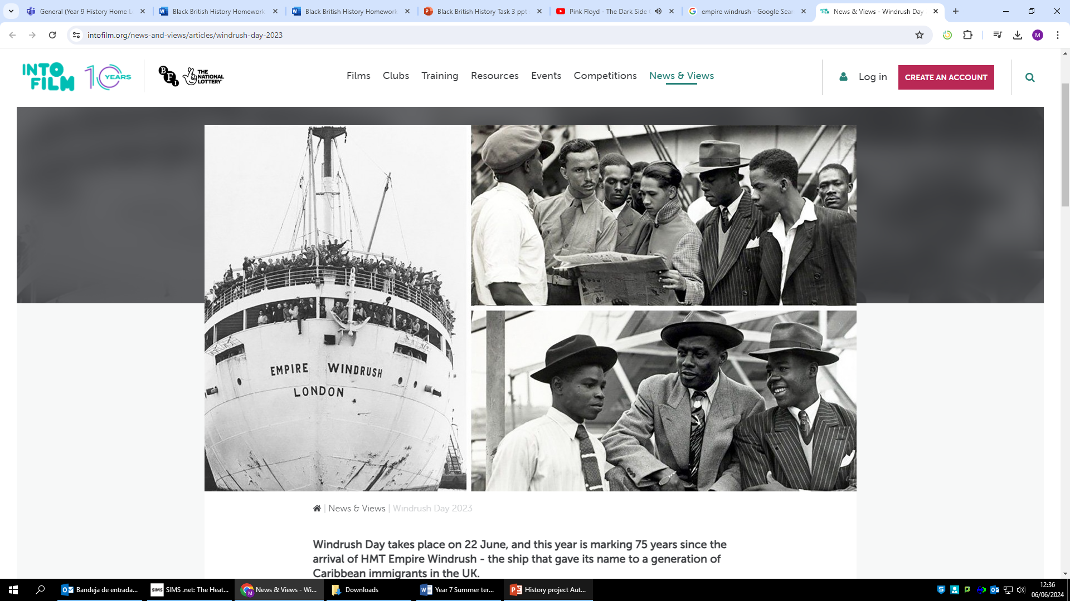

Homework expectations
-Written by yourself, in your own words.
-Completed by the due date.
-Finished to the best of your ability.
-Closely followed the instructions.
-Green penned and improved when needed.
-Peer or self-assessed when asked to.
-Presented so it is clear and neat
-Proof read the work to ensure spelling, punctuation and grammar is to the best of your ability.

Task One –Significant individuals
Due Date:

Instructions: Refer to the Task research support (slides 2-4) in teams.

Research the stories of the following individuals and complete the following fact files.

Mary Seacole

Background
__________________________________________________________________________________

Achievements
_____________________________________________________________________________________________________________________________________________________________________________________________________________
__________________________________________________________________________________

What makes them so significant?
_____________________________________________________________________________________________________________________________________________________________________________________________________________
__________________________________________________________________________________

Ignatius Sancho

Background
__________________________________________________________________________________

Achievements
_____________________________________________________________________________________________________________________________________________________________________________________________________________
__________________________________________________________________________________

What makes them so significant?
_____________________________________________________________________________________________________________________________________________________________________________________________________________
__________________________________________________________________________________

Olaudah Equiano.

Background
________________________________________________________________________________________

Achievements
________________________________________________________________________________________________________________________________________________________________________________

What makes them so significant?
________________________________________________________________________________________________________________________________________________________________________________

Positive points:
How to improve further:

Self assessed

Task two- Retrieval Task
Due Date:

Define the following words:
Upper class –

Middle Class –

Lower class –

Socia Classes –

- Before 1832 in the UK, what percentage of males were allowed to vote?
________________________________________________________________________________________________________________________________________________________________________________________________________________________
- Why couldn’t all men vote?
________________________________________________________________________________________________________________________________________________________________________________________________________________________
- What caused women to start to campaign for the right to vote (suffrage)?
________________________________________________________________________________________________________________________________________________________________________________________________________________________
- Which social class of women started campaigning and why?
________________________________________________________________________________________________________________________________________________________________________________________________________________________

Positive points:
How to improve further:

Peer assessed

Task three–Brighton Pavillion
Due Date:

Instructions: Refer to the Task research support (slide 4 and 5) on teams.

Task 1

- What can you infer from Source A (from teams) about the care for Indian soldiers in England?
This source suggest___________________________________________________________________
The details in the source that tells me this are______________________________________________

- What can you infer from Source B (from teams) about the care for Indian soldiers in England?
This source suggest___________________________________________________________________
The details in the source that tells me this are______________________________________________

Look at Source A again.

- Do you think the author will give an honest account of the Indians soldiers’ experience? Explain why
________________________________________________________________________________________________________________________________________________________________________________________________________________________

Look at Source B again.

Do you think this photo gives an accurate impression of the Indians soldiers’ experience? Explain why
________________________________________________________________________________________________________________________________________________________________________________________________________________________

Which source do think is more useful to an historian. Explain why.
_______________________________________________________________________________________________________________________________________________________________________________________________________________________
Positive points:
How to improve further:

Teacher assessed

Task Four –Retrieval task
Due Date:

- Define the word Suffrage:
________________________________________________________________________________________________________________________________________________________________________________________________________________________

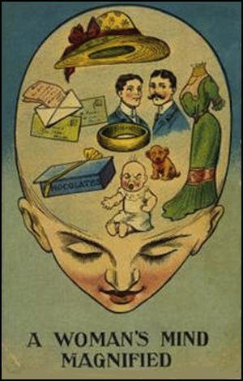
- What is the poster trying to suggest?

_______________________________________________
_______________________________________________
_______________________________________________
_______________________________________________
_______________________________________________

- What does the poster teach us about attitudes at this time?

_______________________________________________
_______________________________________________
_______________________________________________
_______________________________________________
_______________________________________________

- Who were the suffragists? _______________________________________________________________________________________________________________________________________________________________________________________________________________
- Who were the suffragettes? _______________________________________________________________________________________________________________________________________________________________________________________________________________

Task Five –Empire Windrush Scandal
Due Date:

Instructions: Refer to the PPT in teams for info.

Use the research on the powerpoint.
Write a newspaper front page focused on the Windrush Scandal of 2018.
Include:
-What happened, Why it happened, How it happened, Actions taken by the government.
-Include a picture. Include an account of a person affected by the Windrush scandal.
Add suitable headline here

Task Six –Retrieval task
Due Date:

Who was the leader of the Suffragists?
_________________________________________________________________________
- Who was the leader of the suffragettes?
_________________________________________________________________________
- Write a narrative account of what happened to Emily Davison at the Epsom Derby. You must include the following phrases:
This led to, therefore, as a result.
______________________________________________________________________________________________________________________________________________________________________________________________________________________________
______________________________________________________________________________________________________________________________________________________________________________________________________________________________
______________________________________________________________________________________________________________________________________________________________________________________________________________________________
______________________________________________________________________________________________________________________________________________________________________________________________________________________________
______________________________________________________________________________________________________________________________________________________________________________________________________________________________
______________________________________________________________________________________________________________________________________________________________________________________________________________________________
______________________________________________________________________________________________________________________________________________________________________________________________________________________________
Teacher assessed
Positive points:
How to improve further:

