Year 9 Homework project
Autumn term 2: Soldier project

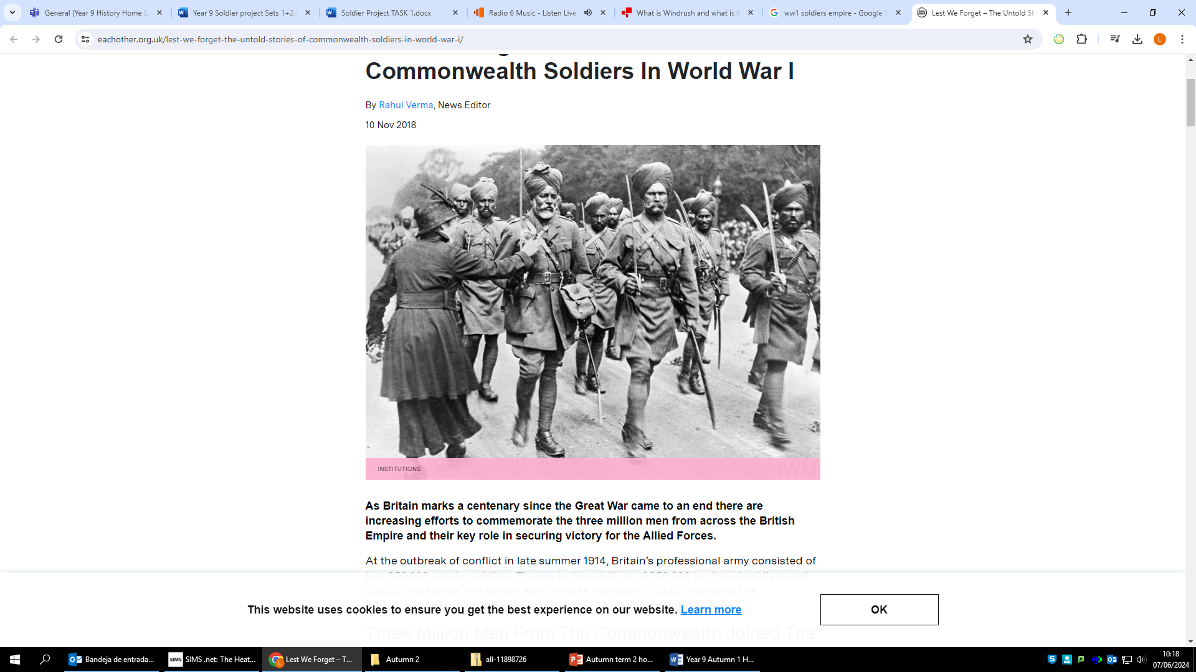

Homework expectations
-Written by yourself, in your own words.
-Completed by the due date.
-Finished to the best of your ability.
-Closely followed the instructions.
-Green penned and improved when needed.
-Peer or self-assessed when asked to.
-Presented so it is clear and neat
-Proof read the work to ensure spelling, punctuation and grammar is to the best of your ability.

Task One –Who to choose?
Due Date:

Instructions: Refer to the Task research support () in teams.

Research the links on slide 2.

Make a list of at least 3 countries and 4 different ethnic minorities who were involved in World War One.

Countries: Different ethnic minorities
1. 1.
2. 2.
3. 3.

Why were men from different countries and different ethnicities involved in fighting for the British? Explain your answer in a paragraph using examples.

______________________________________________________________________________________________________________________________________________________________________________ ______________________________________________________________________________________________________________________________________________________________________________

Research a soldier from the list on slide 2 and complete the following fact file.

- His name
Add picture/drawing

- Where he was from

- His rank (position in the army)

- His regiment (which group he fought with)

- Where he fought (which country, area, battle)

Positive points:
How to improve further:

Self assessed

Task Two – Retrieval Task
Due Date:

What do the following letters stand for when discussing long term causes of WW1:
M___________________
A____________________
I____________________
N____________________
- Who was assassinated in Sarajevo?
Archduke F_________________________
- Define the word propaganda:
__________________________________________________________________________________________________________________________________

List two details in this source (what can you see):

What can you infer from the source about how
Commonwealth soldiers were persuaded to join the war?
I can infer that______________________________________
__________________________________________________
A detail in the source that tells me this (one thing I can see)
__________________________________________________
__________________________________________________

Peer assessed
Positive points:
How to improve further:

Task Three - Muslim experience WW1
Due Date:

Instructions: Refer to the Task research support (slide 3) on teams.

Task one Create a poster to inform others about the Muslim Experiences during WW1.
Your poster must include facts on:
- Living conditions in the trenches
- Food
- Religion
- Statistics (How many Muslim soldiers fought in the war/where did they come from?)

Teacher assessed
Positive points:
How to improve further:

Task Four –Retrieval Task
Due Date:

What does conscription mean?
______________________________________________________________________________________________________________________________________________________________________________

- What age range did men have to be to be conscripted into war?
______________________________________________________________________________________________________________________________________________________________________________
- Define the following words:
Stalemate -

Trench -

Trench foot -
- Write down five adjectives to describe what life was like for soldiers in the trenches:
______________________________________________________________________________________________________________________________________________________________________________
- Write down 2 positive things about trench warfare:
_____________________________________________________________________________________________________________________________________________________________________________________________________________________________________________________________________
- Write down 2 negative things about trench warfare:
_____________________________________________________________________________________________________________________________________________________________________________________________________________________________________________________________________
- In your opinion what was the best (most effective) weapon used in WW1? Why?
_____________________________________________________________________________________________________________________________________________________________________________________________________________________________________________________________________
Peer assessed
Positive points:
How to improve further:

Task five –Migration stories
Due Date:

Instructions: Refer to the PPT in teams for info.
Imagine you are a soldier involved in the First World War. You must write a letter home telling a family member/friend about your experiences.
The letter should be written creatively but still use facts from your homework tasks.
You must include:
- What life is like for you in the war (food, religion, living conditions)
- Someone from a different country/ a different ethnicity you met
- What you did during your free time
- How difficult is life in the war for you? (Use a comparison to another soldier)
__________________________________________________________________________
__________________________________________________________________________
__________________________________________________________________________
__________________________________________________________________________
__________________________________________________________________________
__________________________________________________________________________
__________________________________________________________________________
__________________________________________________________________________
__________________________________________________________________________
__________________________________________________________________________
__________________________________________________________________________
__________________________________________________________________________
__________________________________________________________________________
__________________________________________________________________________
__________________________________________________________________________
__________________________________________________________________________

Positive points:
How to improve further:

Peer assessed

Task Six –Retrieval Task
Due Date:

List three countries from the commonwealth that helped Britain fight in WW1:
E.g Canada __________________________________________________________________________
- True or false – ✔ for true X for false:

- Plastic surgery was used in WW1

- MRI scans were invented in 1914

- Blood transfusions were used in WW1

- 90% of soldiers who survived WW1 got a leg or an arm amputated in.

- Who lead the Somme offensive?
Sir ____________________________________________________________________________________
- How many people from both sides died on the first day of the Battle of the Somme?
_______________________________________________________________________________________
- How many people in total died from the Battle of the Somme?
_______________________________________________________________________________________
- Who is thought to have won the battle of the Somme?
_______________________________________________________________________________________
- Why was gas a dangerous weapon used in WW1?
_____________________________________________________________________________________________________________________________________________________________________________________________________________________________________________________________________________________________________________________________________

Peer assessed
Positive points:
How to improve further:

