Mathematics Home Learning
AUTUMN TERM 1 – Year 9
ASPIRATION

Home Learning Expectations

SPARX Login Details

All students can access SPARX from home by going to https://sparxmaths.com and using their school Microsoft login details.

SPARX expectations:
- All students must complete Home Learning work in the BLUE exercise book provided
- Divide your page in half
- Draw margins using a ruler and a pencil
- Use blue or black ink
- The title should be the date the homework is due
- Write SPARX question codes for all questions
- Show working out for each question where applicable
- Once you have completed a question, mark you answer with a green pen
- When all questions have been completed write down the percentage you achieved
- If you get a question wrong, reattempt the question using a green pen
- Make sure all your working out is neat and legible.

EXAMINATION questions expectations:
- Use blue or black ink
- If the question is 2 or more marks you must show working out in the spaces provided
- Make sure all your working out is neat and legible
- Write final answer on the dotted line

HOME LEARNING SCHEDULE – Autumn Term

Homework is set on: | DATE COMPLETED
TASK 1: Week beginning 7th Sept 26 – Complete SPARX in BLUE homework books
TASK 2: Week beginning 14th Sept 26 – Complete SPARX in BLUE homework books
TASK 3: Week beginning 21st Sept 26 – Complete SPARX in BLUE homework books
TASK 4: Week beginning 28th Sept 26 – Complete EXAM questions on Straight line graphs on pages 3 and 4
TASK 5: Week beginning 5th Oct 26 – Complete SPARX in BLUE homework books
TASK 6: Week beginning 12th Oct 26 – Complete SPARX in BLUE homework books
TASK 7: Week beginning 19th Oct 26 – Complete EXAM questions on Forming and Solving Equations on pages 5 and 6
HALF TERM

TASK 1: Week beginning 2nd Nov 26 – Complete SPARX in BLUE homework books

TASK 2: Week beginning 9th Nov 26 – Complete SPARX in BLUE homework books

TASK 3: Week beginning 16th Nov 26 – Complete EXAM questions on Testing Conjectures on pages 7 and 8

TASK 4: Week beginning 23rd Nov 26 – Complete SPARX in BLUE homework books

TASK 5: Week beginning 30th Nov 26 - Complete SPARX in BLUE homework books

TASK 6: Week beginning 7th Dec 26 - Complete EXAM questions on pages - Complete EXAM questions on Three-Dimensional Shapes on pages 10 and 11

Week beginning 14th Dec 26 – No home learning this week

CHRISTMAS HOLIDAYS

Straight Line Graphs

1 Find the equation of the line that passes through P and Q.
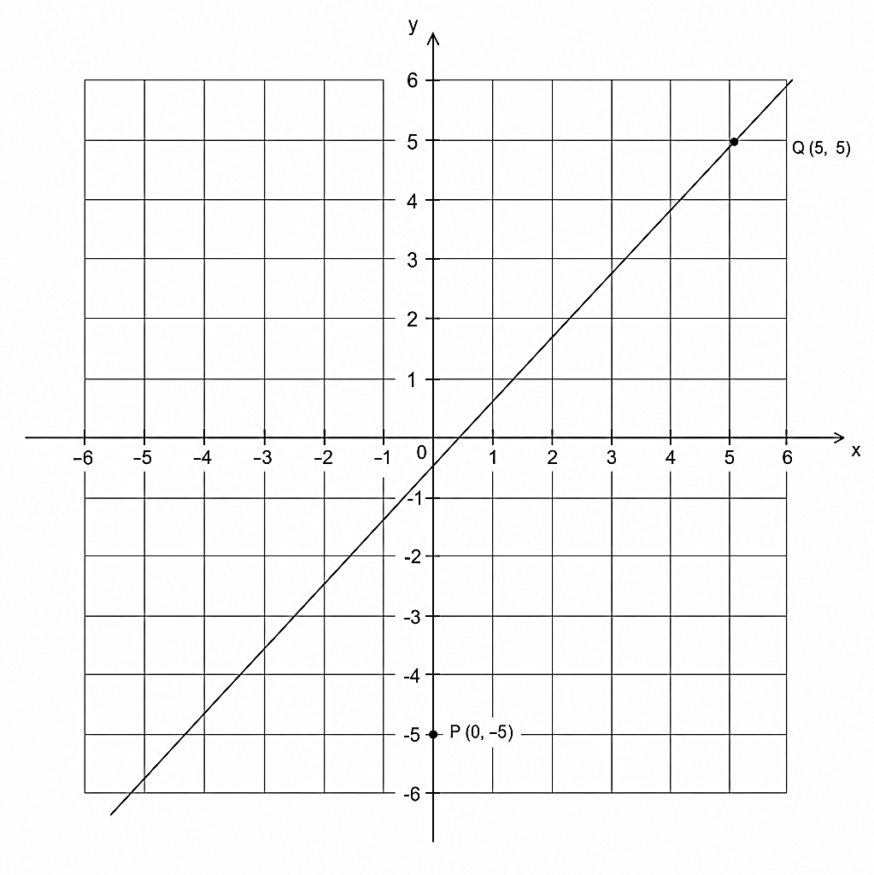

……………………………
(3)
2. A straight-line L has a gradient of 0.5. L passes through the point (0, 10).
Write down the equation of line L. Show your working.

……………………………

(2)
3. A straight line has equation 5y − 4x = 10. Work out the gradient of this line.

………………………………
(2)
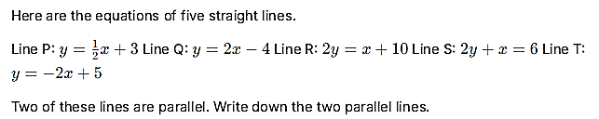
4.

………………………………
(2)

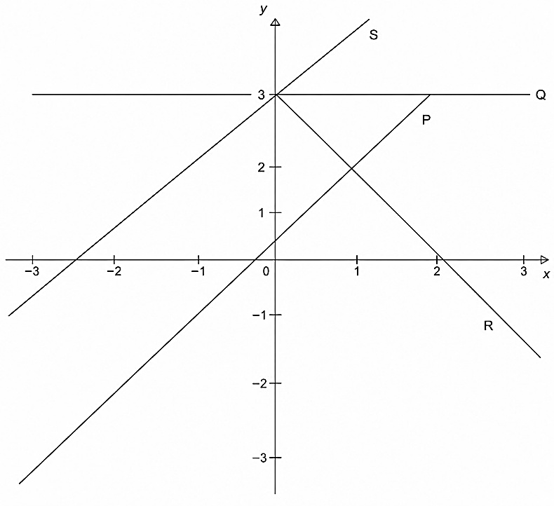
5

The diagram shows 4 straight lines, labelled P, Q, R and S. The equations of the straight lines are:
A: y = 2x
B: y = 3 − 2x
C: y = 2x + 3
D: y = 3
Match each straight line, P, Q, R and S to its equation. Complete the table.

Equation | A | B | C | D
Straight line

(2)

6. The line AB passes through the points A(−2, k) and (4, 8). The gradient of AB is −2.
Work out the value of k.

……………………………………..
(2)

Forming and Solving Equations

1.
Rearrange the formula p = 5q − 8 to make q the subject.

………………………………….
(2)

2. (a)
Solve $\frac{3x}{5}=12$

………………………………..
(2)

(b) Solve 4(y + 3) = 18

……………………………….
(2)

3.
q+8 3
Make q the subject of p =

…………………………………
(3)

4.

$p= \frac{a^{2}- b^{2}}{2c}$

a = 9 b = 1 c = 8

Work out the value of p.

……………………………………
(2)

5. A metal worker cuts two shapes: a rectangular plate and a triangular plate.
The rectangular plate has dimensions (2x + 8) cm by (2x − 3) cm. The triangular plate has side lengths of (3x + 4) cm, (2x + 5) cm, and (2x + 6) cm.
The total distance around the edge of the rectangle is the same as the total distance around the edge of the triangle.
Work out the value of x.

………………………………………
(3)

Testing Conjectures

- Write down two prime numbers that have a sum of 32

……………………………….
(2)

- Write 72 as a product of its prime factors

…………………………..
(2)
- Find the highest common factor (HCF) of 72 and 90

………………………….
(2)
- Find the Lowest Common Multiple (LCM) of 108 and 120

………………………….

(2)

- Expand and simplify (x + 5)(x − 4)

………………………….
(2)

- Expand and simplify (x + 3)(x + 4)(3x − 2)

…………………………….
(3)
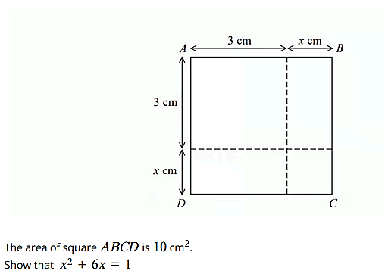

(3)
Three Dimensional Shapes

1 A cuboid has a length of 8 cm, a width of 5 cm, and a height of x cm. The volume of the cuboid is
160 cm³.
Calculate the value of x.

………………………………………………..(2)

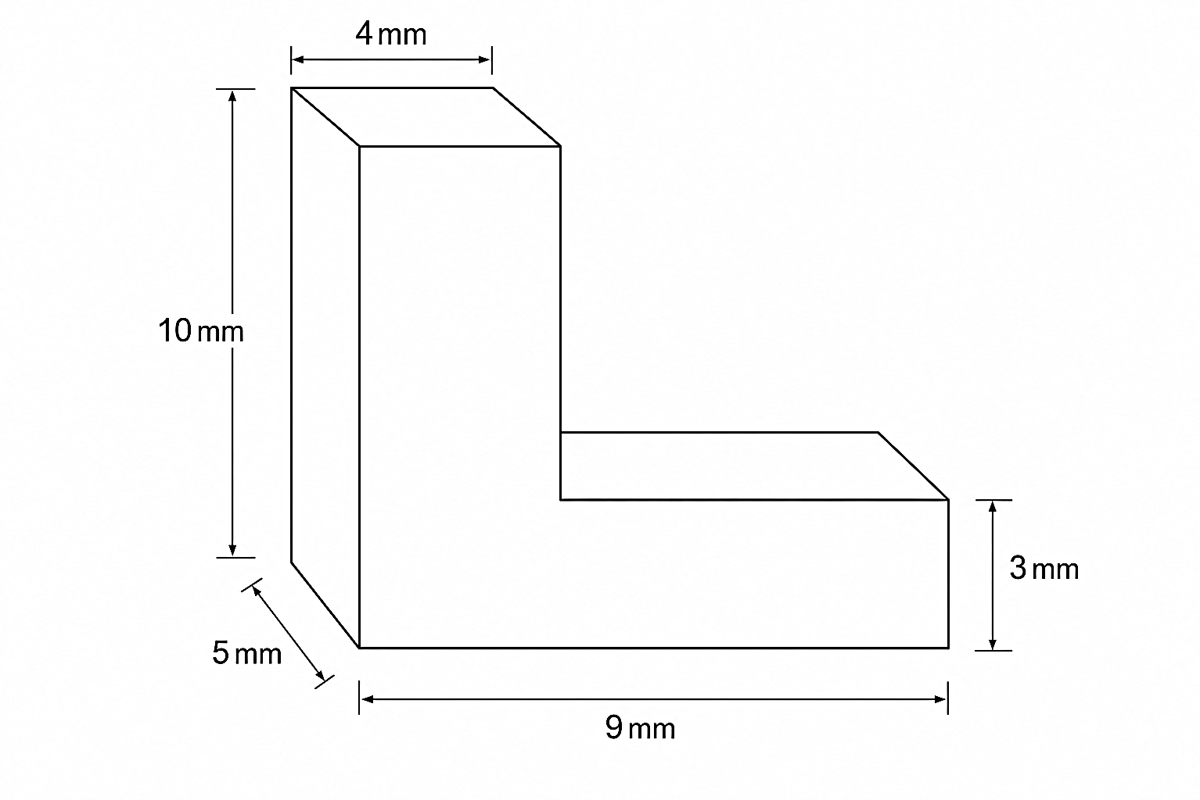
2.

The diagram shows a wooden support in the shape of a prism.

Work out the volume of the wooden support.

…………………………………………………………..(3)

3 A square garden of side length 12 m has a circular pond in the center. The pond touches all four sides of the garden boundary.
Work out the area of the garden that is not covered by the pond. Give your answer correct to 1 decimal place.

……………………………………………………..(3)

4.

A solid cylindrical weight has a radius of 3 cm and a height of 8 cm.

Work out the total surface area of the cylindrical weight. Give your answer in terms of π.

……………………………………………………………(4)

