Mathematics Home Learning
AUTUMN TERM 1 – Year 9
DEDICATION
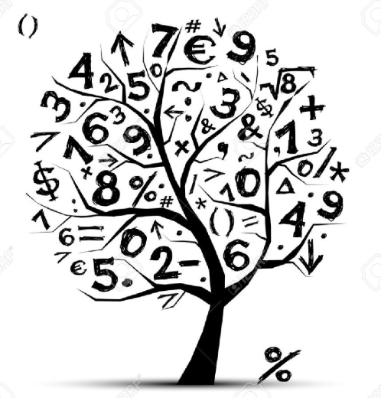
Home Learning Expectations

SPARX Login Details

All students can access SPARX from home by going to https://sparxmaths.com and using their school Microsoft login details.

SPARX expectations:
- All students must complete Home Learning work in the BLUE exercise book provided
- Divide your page in half
- Draw margins using a ruler and a pencil
- Use blue or black ink
- The title should be the date the homework is due
- Write SPARX question codes for all questions
- Show working out for each question where applicable
- Once you have completed a question, mark you answer with a green pen
- When all questions have been completed write down the percentage you achieved
- If you get a question wrong, reattempt the question using a green pen
- Make sure all your working out is neat and legible.

EXAMINATION questions expectations:
- Use blue or black ink
- If the question is 2 or more marks you must show working out in the spaces provided
- Make sure all your working out is neat and legible
- Write final answer on the dotted line

HOME LEARNING SCHEDULE – Autumn Term

Homework is set on: | DUE COMPLETED
TASK 1: Week beginning 7th Sept 26 – Complete SPARX in BLUE homework books
TASK 2: Week beginning 14th Sept 26 – Complete SPARX in BLUE homework books
TASK 3: Week beginning 21st Sept 26 – Complete SPARX in BLUE homework books
TASK 4: Week beginning 28th Sept 26 – Complete EXAM questions on Straight line graphs on pages 3 and 4
TASK 5: Week beginning 5th Oct 26 – Complete SPARX in BLUE homework books
TASK 6: Week beginning 12th Oct 26 – Complete SPARX in BLUE homework books
TASK 7: Week beginning 19th Oct 26 – Complete EXAM questions on Forming and Solving Equations on pages 5 and 6
HALF TERM

TASK 8: Week beginning 2nd Nov 26 – Complete SPARX in BLUE homework books

TASK 9: Week beginning 9th Nov 26 – Complete SPARX in BLUE homework books

TASK 10: Week beginning 16th Nov 26 – Complete EXAM questions on Testing Conjectures on page 7

TASK 11: Week beginning 23rd Nov 26 – Complete SPARX in BLUE homework books

TASK 12: Week beginning 30th Nov 26 - Complete SPARX in BLUE homework books

TASK 13: Week beginning 7th Dec 26 - Complete EXAM questions on pages - Complete EXAM questions on Three-Dimensional Shapes on page 8

Week beginning 14th Dec 26 – No home learning this week

CHRISTMAS HOLIDAYS

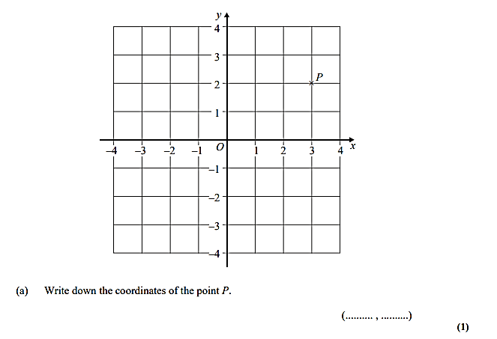
Straight Line Graphs - Dedication

Q1)

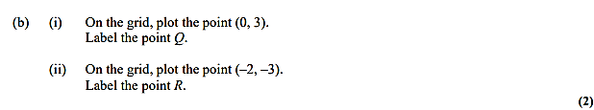

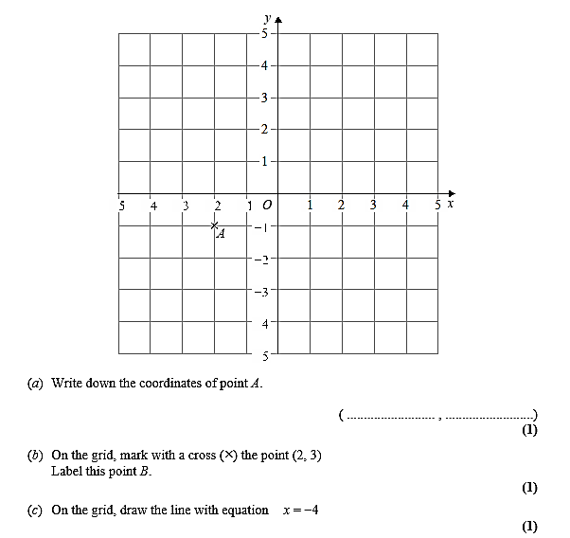
Q2)

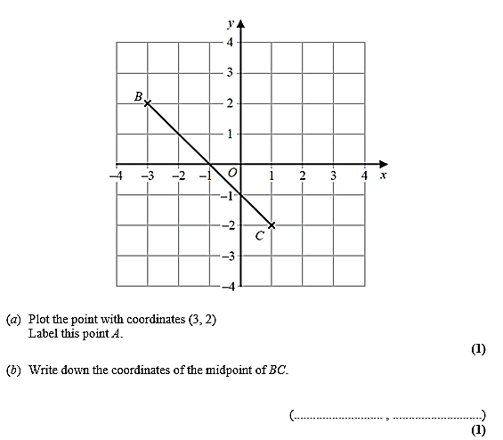
Q3)

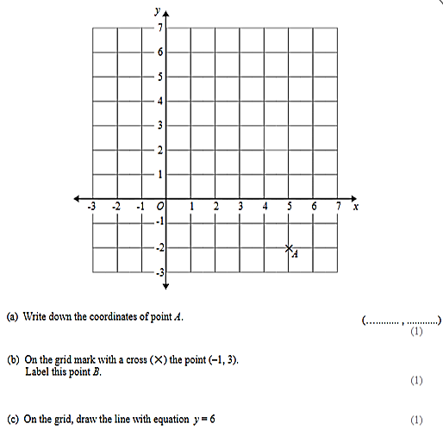
Q4)

Forming and Solving Equations – Dedication

SHOW YOUR METHOD

1
Solve z + 11 = 30

………………………………………….(1)

2
Solve 20 − m = 12

…………………………………………….(1)

3
Solve 6w = 54

…………………………………………….(1)

4 y is an integer such that −5 ≤ y < 0
Write down all the possible values of y.

………………………………………………(2)

5
- Solve y + y + y + y = 28

……………………………………………………(1)

- Solve x = 9
5

…………………………………………………..(1)

- Solve 3w − 4 = 11

…………………………………………………(1)

6
Solve 3(x + 9) = 45

………………………………………(2)

7 Solve $\frac{w}{4}+2=6$

…………………………………………(2)

8
Solve 2(3n − 5) > 12

………………………………………..(2)

Testing Conjectures - Dedication

1 Write down all the factors of 28

…………….………………………………..(2)

2 Express 126 as a product of its prime factors.

………………………………………………(2)
3 E = {even numbers between 1 and 31}
A = {2, 4, 8, 14, 18, 22, 28} B = {8, 10, 16, 18, 22, 30}
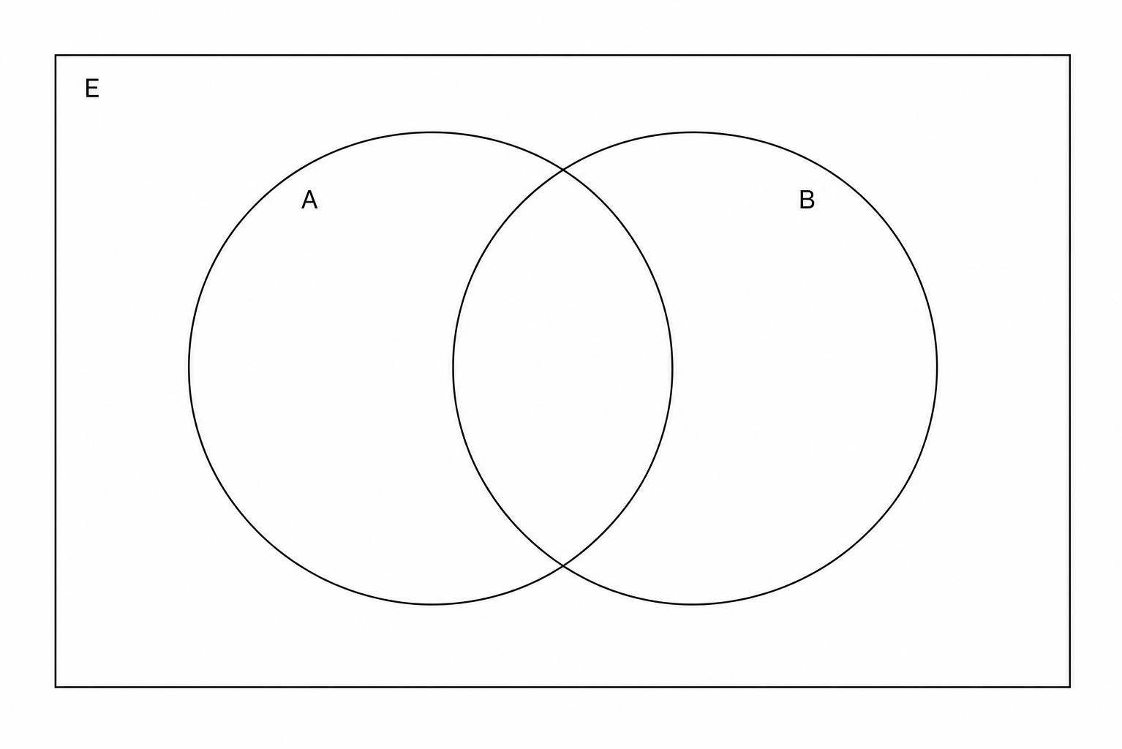
- Complete the Venn diagram to represent this information.
(4)

- A number is chosen at random from the universal set, E. What is the probability that the number is in the set A ∪ B ?
………………..(3)

4 Bus A leaves the station every 8 minutes.
Bus B leaves the station every 10 minutes. Bus C leaves the station every 12 minutes.
All three buses leave the station at the same time.

Work out how long it will take for all three buses to leave the station at the same time again.

……..………………………………………(3)

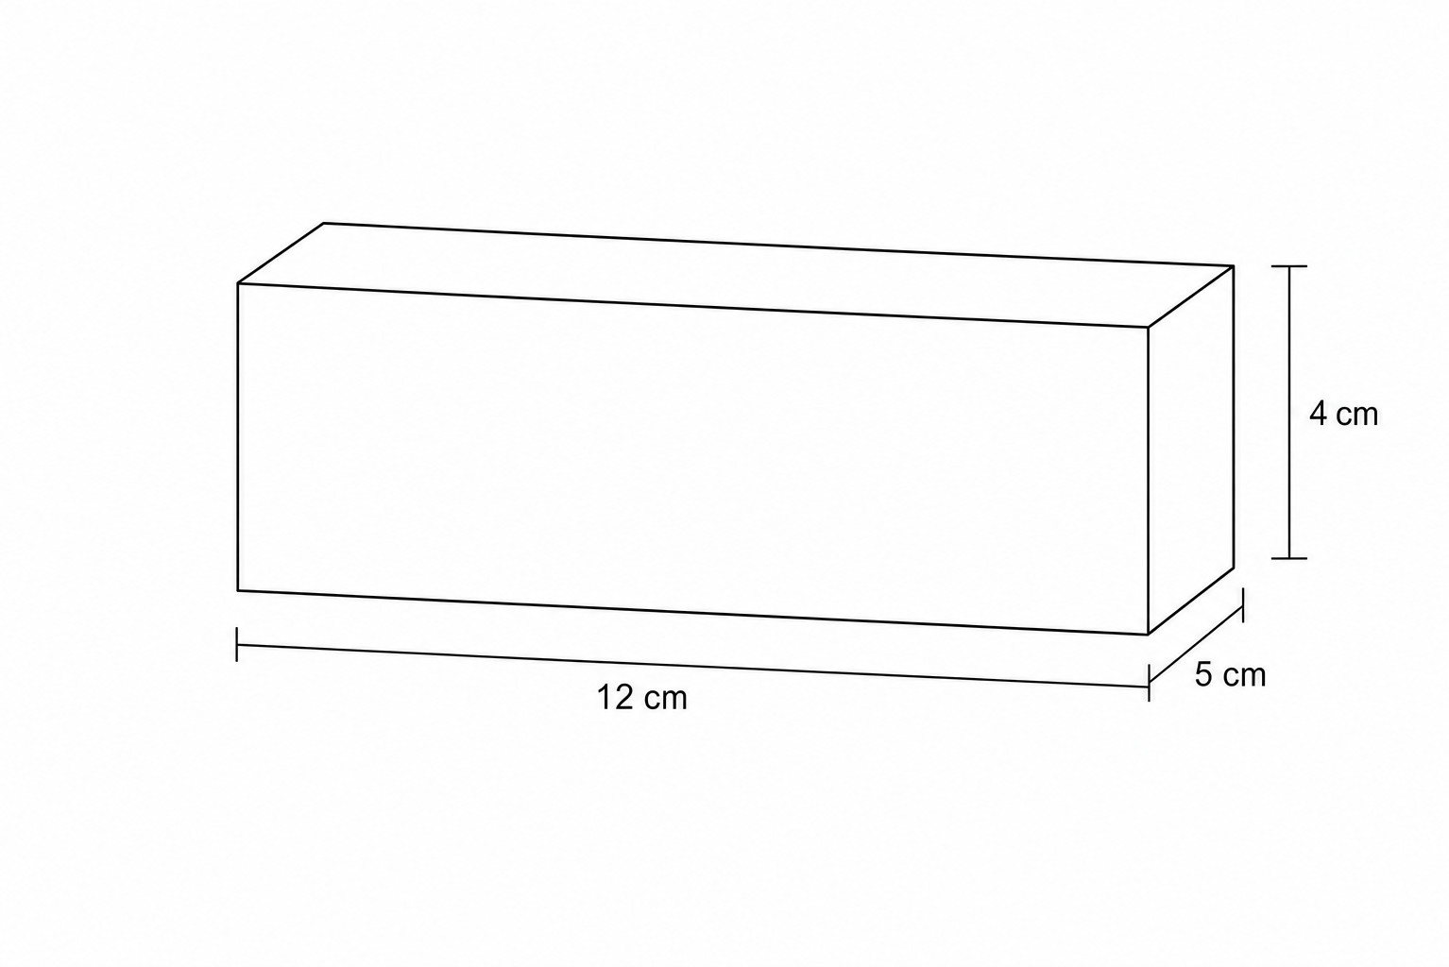
Three Dimensional Shapes – Dedication
1) The diagram shows a cuboid. Find the total surface area of the cuboid.

.………………………………(3)
2) A jewellery box is in the shape of a cuboid with length 8 cm, width 5 cm and height 2 cm.
Work out the total surface area of the jewellery box.

…………………………………(3)
3) A cube has side lengths of 2 cm.
Work out the total volume of 10 of these cubes.

………………………………….(2)
4) A square garden plot has an area of 144 m2.
Find the total length of the fence needed to surround the garden.

…………………………………..(2)
5) A rectangular block of wood has a base measuring 15 cm by 4 cm and a height of x cm. The total
volume of the block is 150 cm³. Calculate the value of x.

……………………………………….(2)

