Year 9 Home Learning
Autumn term 1 2026
Aspiration

Home Learning expectations
- -Written by yourself, in your own words.
- -Completed by the due date.
- -Finished to the best of your ability.
- -Closely followed the instructions.
- -Green penned and improved when needed.
- -Peer or self-assessed when asked to.
- -Presented so it is clear and neat
- -Proof read the work to ensure spelling, punctuation and grammar is to the best of your ability.

Task 1
Due Date: ___________
Topic: Genetics
Instructions: Using the booklet and the internet, research and fill in the missing blanks using the word bank below.
Work bank: section, characteristic/protein, parents, offspring, DNA,
genetic, alleles, genes, pairs, version, gene, traits

Key words: | Definitions:  (Provide a clear and concise definition of the key word.) | Add a diagram or example of the key word here!
- DNA
- Gene

- Chromosome

- Allele
- Inheritance
- Mutation
- Genotype

Teacher ticks here | Tick | Student comment: How to improve
Excellent homework (good comment)
Good/completed
Requires improvement
Incomplete/unsatisfactory

Peer assessed / Self-assessed
Task 2
Due Date: ___________
Topic: How science works
Instructions: Complete the tasks below
Key information:
Independent variable: The variable that the investigator deliberately changes or selects different values for. There should only be one independent variable per investigation.
Dependent variable: The variable that is measured or observed as a result of changing the independent variable. It 'depends on' the independent variable.
Control variable: Any variable that is kept constant throughout an investigation to ensure the test is fair. If a control variable changed, it could affect the dependent variable and make results unreliable.

1
.
Match each term to its correct definition.
[
4
mark
s
]
Independent variable
Dependent variable
Control variable
Anomalous result
The variable deliberately changed by the
investigator
A data point that does not fit the pattern of the
other results
A variable kept constant to ensure a fair test
The variable measured as a result of the
investigation

Teacher ticks here | Tick | Student comment: How to improve
Excellent homework (good comment)
Good/completed
Requires improvement
Incomplete/unsatisfactory

Peer assessed / Self-assessed
- A scientist studies the effect of temperature on the rate of evolution in bacteria by measuring how quickly antibiotic resistance develops in bacterial populations kept at different temperatures.
    - Name the independent variable in this investigation and give a unit that this could be measured in. [2 mark]

    - Name the dependent variable in this investigation and suggest a unit this could be measured in [2 marks]

    - State two variables that must be controlled to make this a fair test and explain the importance of these being kept the same. [4 marks]
1.
2.

Task 3
Due Date: ___________
Topic: Genetics
Instructions: Complete the following tasks to understand how the structure of DNA was discovered. You can use lesson 2 in your genetics booklet to help you.

TIMELINE: KEY EVENTS IN THE DISCOVERY OF DNA
1869:
Friedrich Miescher first isolated DNA from cell nuclei. He called it 'nuclein'.
1920
s–1940s
:
Scientists confirmed that DNA, not protein, carries genetic information.
1950:
Erwin Chargaff discovered that A always pairs with T and G always pairs with C (Chargaff's
rules).
1952:
Rosalind Franklin produced Photo 51 — a clear X-ray image showing that DNA has a helical
(
twisted) shape.
1953:
Watson and Crick published their model of the DNA double helix in the scientific journal Nature.
They used Franklin's X-ray data (shared without her knowledge by Wilkins) to complete their model.
1962:
Watson, Crick, and Wilkins were awarded the Nobel Prize for Physiology or Medicine. Rosalind
Franklin had died in 1958 and Nobel Prizes are not awarded posthumously.

- Match each term to it’s correct definition:
DNA
Double helix
Nucleotide
Gene
X-ray crystallography
Chromosome
A section of DNA that codes for a specific
protein
Molecule that carries genetic information in
cells
Technique used to reveal the shape of DNA
using X-rays
A long coiled strand of DNA found in the
nucleus
The twisted ladder shape of the DNA molecule
Individual building block that makes up DNA

- Describe the structure of DNA [2 marks]

____________________________________________________________________________________

____________________________________________________________________________________

- Which base pairing rule is correct? [1 mark]
  - Adenine pairs with Guanine
  - Thymine pairs with Cytosine
  - Adenine pairs with Thymine
  - Guanine pairs with Adenine

- Answer the following questions about the key scientists involved in the discovery of DNA.
  - State what technique Rosalind Franklin used to study the shape of DNA. [1 mark]

  - Name the two scientists who published the first accurate model of the DNA double helix in 1953 and describe what they used to come up with the model.
  - Give the name of the famous X-ray image produced by Rosalind Franklin that helped reveal the helical structure of DNA.

  - Explain using research, why Rosalind Franklin was not recognised originally for her work in the DNA model. [4 marks]

______________________________________________________________________________________________________________________________________________________________________________
______________________________________________________________________________________________________________________________________________________________________________
______________________________________________________________________________________________________________________________________________________________________________

Teacher ticks here | Tick | Student comment: How to improve
Excellent homework (good comment)
Good/completed
Requires improvement
Incomplete/unsatisfactory

Peer assessed / Self-assessed

Task 4
Due Date: ___________
Topic: Revision skills homework
Instructions:
Revise the genetics topic by creating 10 flashcards. Make sure you have the question on one side and the answer on the other.

Example:

Front of revision card:
Describe the structure of DNA (2 marks)

Back of revision card:
- Double helix (1)
- Twisted ladder (1)

Task 5
Due Date: ___________
Topic: How Science Works
Instructions: Complete the following tasks to practice your graph skills.
1. Use Table 1 and Graph 1 to answer the following questions.
TABLE 1: CURRENT RECORDED AS BULBS ARE ADDED IN SERIES
Number of bulbs | Current (A)
1 | 20
2 | 10
3 | 5
4 | 2.5
5 | 1.5

GRAPH 1: CURRENT AGAINST NUMBER OF BULBS IN SERIES
0
1
2
3
4
5
0
5
10
15
20
Complete the graph above:
  - Add your axis labels. Independent variable on the x axis and dependent on the y axis.
  - Plot the remaining data points from Table 1 onto Graph 1 and draw a smooth curve
of best fit through all six points. [3 marks]

  - Describe the shape of your graph. Include data in your answer. [3 marks]
______________________________________________________________________________________________________________________________________________________________________________
  - Explain the graph above, you may need to research how the number of bulbs affects current in a circuit. (4 marks)
_____________________________________________________________________________________
____________________________________________________________________________________________________________________________________________________________________________________________________________________________________________________________________________________________________________________________________________________________

Teacher ticks here | Tick | Student comment: How to improve
Excellent homework (good comment)
Good/completed
Requires improvement
Incomplete/unsatisfactory

Peer assessed / Self-assessed
Task 6
Due Date: ___________
Topic: Electricity
Instructions: Complete the tasks below
- Use your textbook and the internet to fill in the gaps in the table below. The first one has been done for you. The website ‘BBC Bitesize’ is recommended to help you complete the homework.

Component | Symbol | Function
switch |  | A switch used to turn a circuit on (closed) and off (open).
variable resistor
voltmeter
ammeter
cell
battery
motor
- Research how a variable resistor works and explain a real life example below (3 marks)
Teacher ticks here | Tick | Student comment: How to improve
Excellent homework (good comment)
Good/completed
Requires improvement
Incomplete/unsatisfactory

Peer assessed / Self-assessed
____________________________________________________________________________________________________________________________________________________________________________________________________________________________________________________________
Task 7
Due Date: ___________
Topic: Electricity
Instructions: Complete the following questions on Ohm’s Law. You can use lesson 1 and 2 from your booklet to help you and the information below. You will need a calculator.

V = Voltage in volts, I = Current in amps, R = Resistance in ohms
V = IR R = V/I I = V/R

Worked example:
Q. An alarm clock draws 0.5 A of current when connected to a 120 volt circuit. Calculate its resistance.

- Write out the equation you need
R = V/I
- Put the numbers from the question into the equation
R = 120 / 0.5
- Now use your calculator to calculate the answer
R = 240
- Write your answer, don’t forget the unit!
Resistance = 240 Unit: Ω

- Write the equation for calculating resistance
Resistance =
- Write the name of the unit for resistance and draw the symbol below:

- A subwoofer needs a household voltage of 110 V to push a current of 5.5 A through its coil. What is the resistance of the subwoofer?
- Write out the equation you need

- Put the numbers from the question into the equation

- Now use your calculator to calculate the answer

- Write your answer, don’t forget the unit!
Resistance = _____ Unit: Ω

- A Sony Walkman uses a standard 1.5 V battery. How much resistance is in the circuit if it uses a current of 0.01A?

Resistance = _____ Unit: ___

- A circuit contains a 1.5 volt battery and a bulb with a resistance of 3 ohms. Calculate the current.

Resistance = _____ Unit: ___

- What current flows through a hair dryer plugged into a 120 Volt circuit if it has a resistance of 25 ohms?

Resistance = _____ Unit: ___
Challenge questions!
Teacher ticks here | Tick | Student comment: How to improve
Excellent homework (good comment)
Good/completed
Requires improvement
Incomplete/unsatisfactory

Peer assessed / Self-assessed
- A circuit contains a 6 V battery and a 12 Ω resistor. Calculate the current in the circuit.

Resistance = _____ Unit: ___
- Why does a bulb shine brighter when the potential difference across it increases?

- A student doubles the voltage and doubles the resistance in a circuit. What happens to the current? Explain your answer.

- Compare the advantages and disadvantages of connecting bulbs in series and in parallel.

Task 8
Topic: How Science Works: Planning a practical. Literacy task.
Instructions: Read the information and complete the questions.
Title: Investigation into how the concentration of acid affects the rate of reaction
In this practical, you will investigate the effect of hydrochloric acid concentration on the rate of reaction with magnesium ribbon.
Place a 2 cm piece of magnesium ribbon into a beaker containing 20 cm³ of hydrochloric acid. Start a stopwatch as soon as the magnesium is added to the acid. Observe the reaction and record the time taken for the magnesium ribbon to dissolve completely.
Repeat the experiment using a range of hydrochloric acid concentrations. Ensure that the length of magnesium ribbon, volume of acid, and temperature remain constant throughout the investigation.
Record your results in a suitable table and look for patterns in the data. Use your results to determine how acid concentration affects the rate of reaction and explain your findings using collision theory.
Complete the questions below:
  - What is the independent variable in this experiment? (1 mark)
_____________________________________________
  - What is the dependent variable in this experiment? (1 mark)
_____________________________________________
  - Name two control variables that must stay the same. (2 marks)
- _____________________________________________

- _____________________________________________
  - What is the aim of the practical? (1 mark)

_____________________________________________
  - What happens when magnesium reacts with hydrochloric acid? (1 mark)

_____________________________________________
  - Why is it important to keep the length of the magnesium ribbon the same? (2 marks)

_____________________________________________

  - Why does changing the concentration of acid affect the rate of reaction? (2 marks)
_____________________________________________
Teacher ticks here | Tick | Student comment: How to improve
Excellent homework (good comment)
Good/completed
Requires improvement
Incomplete/unsatisfactory

Peer assessed / Self-assessed

Task 9
Due Date: ___________
Topic: Electrical Power – Topic review
Instructions: Complete the following activities, use the information from your booklet to help you:
1
.
Match each electrical quantity to its correct unit.
[
5
mark
s
]
Current
Voltage
Resistance
Power
Energy
Volts (V)
Joules (J)
Watts (W)
Ohms (Ω)
Amperes (A)
2
.
Fill in the blanks about energy and power.
[
6
mark
s
]
energy
power
kilowatts
second
watts
kilowatt-hours
Power is the amount of
transferred every
. Power is measured in
. A
device that uses more energy each second has a higher
rating. Multiplying power in
by time in hours gives energy in
.
WORKED EXAMPLE — EFFICIENCY
Formula: efficiency (%) = (useful energy output ÷ total energy input) × 100
Example: A motor receives 500 J of electrical energy and produces 350 J of useful kinetic energy.
efficiency = (350 ÷ 500) × 100 = 70%
3. An electric bulb is supplied with 200 J of electrical energy. It produces 50 J of useful light energy and the rest is wasted as heat.
  - Calculate the amount of energy wasted as heat. [1 mark]

Answer = _______ J
  - Calculate the efficiency of the bulb. Show your working. [2 marks]

Answer = _______ %
  - Explain what the efficiency value tells you about how well the bulb converts
electrical energy into light energy. [2 marks]
________________________________________________________________________________________________________________________________________________________________________________
Teacher ticks here | Tick | Student comment: How to improve
Excellent homework (good comment)
Good/completed
Requires improvement
Incomplete/unsatisfactory

Peer assessed / Self-assessed

Task 10
Due Date: ___________
Topic: Photosynthesis

Instructions: Complete the tasks about photosynthesis

- What is the word and balanced symbol equation for photosynthesis?

Word equation: _____________________________________________________

Balanced symbol equation: ______________________________________________________

- Which subcellular structure is the site of photosynthesis in plant cells?

- What colour is chlorophyll?

- Which gas do plants take in during photosynthesis?

- What useful substance does a plant make during photosynthesis?

4. Explain why chloroplasts are important in photosynthesis. Help: What do they contain? What happens here?

5. A plant is kept in a dark cupboard for two weeks. Explain how this would affect photosynthesis and why.

Teacher ticks here | Tick | Student comment: How to improve
Excellent homework (good comment)
Good/completed
Requires improvement
Incomplete/unsatisfactory

Peer assessed / Self-assessed

Task 11
Due Date: ___________
Topic: How science works
Instructions: Complete the following tasks to practice drawing a line of best fit:
- Why draw a line of best fit? (2 marks)
______________________________________________________________________________________________________________________________________________________________________________
- Draw a line of best fit on each graph.
Remember: If the pattern is in a straight line you use a ruler, if it is in a curve you draw the line free hand. This must be a continuous line and not the dots joined up.

3. When drawing a line of best fit we do not include the anomaly.
- Circle the anomaly on the graph on the right.
- Draw a line of best fit, leaving out the anomaly.

- Tick the correct answer:
      - We use a line graph if…
☐Both variables are continuous
☐One of the variables is categorical
      - We use a bar chart if…
☐ Both variables are continuous
☐ One of the variables is categorical

Angle of incidence (degrees) | Angle of reflection (degrees)
10 | 10
20 | 20
30 | 30
40 | 40
- Ralph shines light on a mirror at different angles of incidence and measures the angle of reflection. A. Are these data continuous or categorical?
b. Should Ralph plot a bar chart or a line graph?
Teacher ticks here | Tick | Student comment: How to improve
Excellent homework (good comment)
Good/completed
Requires improvement
Incomplete/unsatisfactory

Peer assessed / Self-assessed
Task 12
Due Date: ___________
Topic: Photosynthesis: Literacy task, importance of green plants
Instructions: Read through the information below and complete the questions. You can also use lesson 4 from your photosynthesis booklet.
Reading Task: Why Are Plants Important?
Plants and algae use sunlight to make food in a process called photosynthesis. During photosynthesis, they take in carbon dioxide and release oxygen, which humans and animals need to breathe. Plants help reduce global warming by removing carbon dioxide from the air. Tiny ocean organisms called phytoplankton also do photosynthesis and produce about half of the oxygen we breathe.
Plants help clean the air by absorbing some harmful pollution. They also stop desertification, which happens when good soil becomes dry and barren. Tree roots hold soil together and help keep it healthy.
Plants are important parts of habitats. They provide food, oxygen, and shelter for living things. However, habitats can be damaged by deforestation, pollution, and building new towns and cities. We can help by planting more trees and reducing pollution. Protecting plants helps keep our planet healthy for all living things

  - What gas do plants release during photosynthesis?
________________________________________________________
  - What can damage plant habitats?
______________________________________________________________________________________________________________________________________________________________________________
  - Write the definition of each of the following:
Definition =
Photosynthesis

Definition =
Habitat

Definition =
Pollution

  - Plants photosynthesis, describe 2 ways in which this is important for earth. (3 marks)

_____________________________________________________________________________________________________________________________________________________________________________________________________________________________________________________________________

  - What is desertification? (1 mark)
______________________________________________________________________________________________________________________________________________________________________________

  - How are trees and plants beneficial to animals in terms of giving them a place to live? 2 marks)

_____________________________________________________________________________________________________________________________________________________________________________________________________________________________________________________________________

Teacher ticks here | Tick | Student comment: How to improve
Excellent homework (good comment)
Good/completed
Requires improvement
Incomplete/unsatisfactory

Peer assessed / Self-assessed

Teacher ticks here | Tick | Student comment: How to improve
Excellent homework (good comment)
Good/completed
Requires improvement
Incomplete/unsatisfactory

Peer assessed / Self-assessed

Task 13
Due Date: ___________
Topic: How science works
Instructions: Complete the following tasks to practice your scientific skills:

10 20 30 40 50 60
100
80
60
40
20
0
Temperature (ºC)
Reactant Used (%)
  - On the graph, circle the anomaly
2.
Independent variable
= Temperature
Dependent variable
= Reactant used (%)
      - State what the independent variable is below:

_______________________________
      - State what the dependent is variable is below:

1 2 3 4 5 6 7 8 9 10 11 12 13
80
70
60
50
40
30
20
10
0
Current (A)
Potential Difference (V)

- On the graph, circle the anomaly
- Describe the pattern of the graph below:
______________________________________
______________________________________
______________________________________

- State how much more potential different a current of 5 amps has than a current of 8 amps.

Answer = _________ V.

- Explain why it is important to ignore anomalies. (3 marks)
Teacher ticks here | Tick | Student comment: How to improve
Excellent homework (good comment)
Good/completed
Requires improvement
Incomplete/unsatisfactory

Peer assessed / Self-assessed
__________________________________________________________________________________________________________________________________________________________________________________________________________________________________________________________________
Task 14
Due Date: ___________
Topic: Chemical reactions
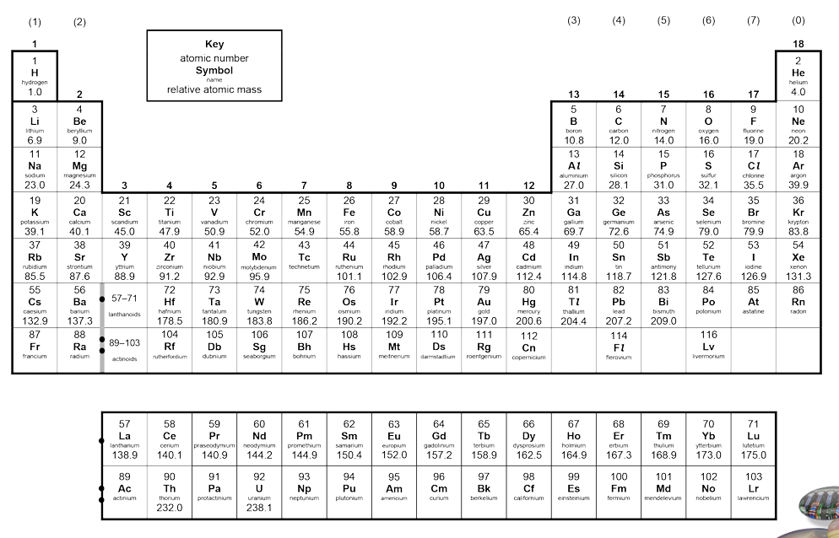
Instructions: Complete the tasks below on the topic ‘chemical reactions’.

- Use your periodic table in your diary (or the copy above).
- Write the chemical formula for the following elements in the table below.
Name of element | Chemical formula
Oxygen
Calcium
Iron
Hydrogen

- Identify some common elements and compounds below:

Chemical formula of element/compound | Name of the element/compound
H₂O | Water
CO₂
O₂
Challenge: C₆H₁₂O₆

- Research the structure of an atom using your booklet or the internet and complete the tasks below:

- Label the atom’s sub-atomic particles

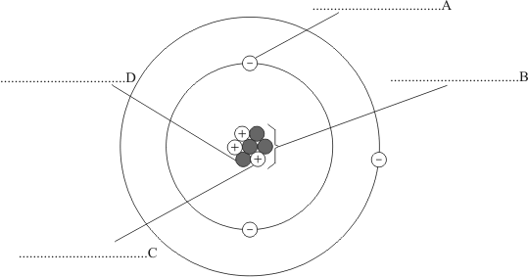

- Write a sentence explaining the charges of each subatomic particle. Come up with a way to remember this.
______________________________________________________________________________________________________________________________________________________________________________

- Write a sentence explaining the masses of each subatomic particle. Come up with a way to remember this.
______________________________________________________________________________________________________________________________________________________________________________
- Write down the number of subatomic particles the following elements have:
- Oxygen
Number of electrons = _____
Number of protons = _____
Number of neutrons = _____
- Carbon
Number of electrons = _____
Number of protons = _____
Number of neutrons = _____
Teacher ticks here | Tick | Student comment: How to improve
Excellent homework (good comment)
Good/completed
Requires improvement
Incomplete/unsatisfactory

Peer assessed / Self-assessed

