Year 9 Home Learning
Autumn term 1 2026
Dedication

Home Learning expectations
- -Written by yourself, in your own words.
- -Completed by the due date.
- -Finished to the best of your ability.
- -Closely followed the instructions.
- -Green penned and improved when needed.
- -Peer or self-assessed when asked to.
- -Presented so it is clear and neat
- -Proof read the work to ensure spelling, punctuation and grammar is to the best of your ability.

Task 1
Due Date: ___________
Topic: Genetics
Instructions: Using the booklet and the internet, research and fill in the missing blanks using the word bank below.
Work bank: section, characteristic/protein, parents, offspring, DNA,
genetic, alleles, genes, pairs, version, gene, traits

Key words: | Definitions:  (Provide a clear and concise definition of the key word.)
- DNA | Worked example..  The material in cells that carries genetic information. It tells the body how to grow and work.
- Gene | A gene is a small ______ of DNA that codes for a specific ______.
- Chromosome | A chromosome is a long structure made of DNA that carries many ______. Humans have 23 ______ of chromosomes.
- Allele | An allele is a different ______ of the same ______.
- Inheritance | Inheritance is the passing of ______ from ______ to ______.
- Mutation | A mutation is a change in the base sequence of ______
- Genotype | Genotype is the ______ makeup of an organism, made up of the ______ it has.

Teacher ticks here | Tick | Student comment: How to improve
Excellent homework (good comment)
Good/completed
Requires improvement
Incomplete/unsatisfactory

Peer assessed / Self-assessed
Task 2
Task 2
Due Date: ___________
Topic: How science works
Instructions: Complete the tasks below
Key information:
Independent variable: The variable that the investigator deliberately changes or selects different values for. There should only be one independent variable per investigation.
Dependent variable: The variable that is measured or observed as a result of changing the independent variable. It 'depends on' the independent variable.
Control variable: Any variable that is kept constant throughout an investigation to ensure the test is fair. If a control variable changed, it could affect the dependent variable and make results unreliable.

1
.
Match each term to its correct definition.
[
4
mark
s
]
Independent variable
Dependent variable
Control variable
Anomalous result
The variable deliberately changed by the
investigator
A data point that does not fit the pattern of the
other results
A variable kept constant to ensure a fair test
The variable measured as a result of the
investigation

Teacher ticks here | Tick | Student comment: How to improve
Excellent homework (good comment)
Good/completed
Requires improvement
Incomplete/unsatisfactory

Peer assessed / Self-assessed
- A scientist studies the effect of temperature on the rate of evolution in bacteria by measuring how quickly antibiotic resistance develops in bacterial populations kept at different temperatures.
    - Name the independent variable in this investigation. [1 mark]

    - Name the dependent variable in this investigation. [1 mark]

    - Give two variables that must be controlled to make this a fair test. [2 marks]
1.
2.

Task 3
Due Date: ___________
Topic: Genetics
Instructions: Complete the following tasks to understand how the structure of DNA was discovered. You can use lesson 2 in your genetics booklet to help you.

TIMELINE: KEY EVENTS IN THE DISCOVERY OF DNA
1869:
Friedrich Miescher first isolated DNA from cell nuclei. He called it 'nuclein'.
1920
s–1940s
:
Scientists confirmed that DNA, not protein, carries genetic information.
1950:
Erwin Chargaff discovered that A always pairs with T and G always pairs with C (Chargaff's
rules).
1952:
Rosalind Franklin produced Photo 51 — a clear X-ray image showing that DNA has a helical
(
twisted) shape.
1953:
Watson and Crick published their model of the DNA double helix in the scientific journal Nature.
They used Franklin's X-ray data (shared without her knowledge by Wilkins) to complete their model.
1962:
Watson, Crick, and Wilkins were awarded the Nobel Prize for Physiology or Medicine. Rosalind
Franklin had died in 1958 and Nobel Prizes are not awarded posthumously.

- Match each term to it’s correct definition:
DNA
Double helix
Nucleotide
Gene
X-ray crystallography
Chromosome
A section of DNA that codes for a specific
protein
Molecule that carries genetic information in
cells
Technique used to reveal the shape of DNA
using X-rays
A long coiled strand of DNA found in the
nucleus
The twisted ladder shape of the DNA molecule
Individual building block that makes up DNA

- Which of the following correctly describes the structure of DNA? [1 mark]
  - A single strand coiled into a helix
  - Two strands twisted around each other in a double helix
  - Three strands arranged in a triple helix
  - A flat ladder-shaped molecule
- Which base pairing rule is correct? [1 mark]
  - Adenine pairs with Guanine
  - Thymine pairs with Cytosine
  - Adenine pairs with Thymine
  - Guanine pairs with Adenine
- Answer the following questions about the key scientists involved in the discovery of DNA.
(a) State what technique Rosalind Franklin used to study the shape of DNA. [1 mark]

Name the two scientists who published the first accurate model of the DNA double helix in 1953. | [1 mark]
Give the name of the famous X-ray image produced by Rosalind Franklin that helped reveal the helical structure of DNA. | [1 mark]
(b)

(c)

Teacher ticks here | Tick | Student comment: How to improve
Excellent homework (good comment)
Good/completed
Requires improvement
Incomplete/unsatisfactory

Peer assessed / Self-assessed

Task 4
Due Date: ___________
Topic: Revision skills homework
Instructions:
Revise the genetics topic by creating 10 flashcards. Make sure you have the question on one side and the answer on the other.

Example:

Front of revision card:
Describe the structure of DNA (2 marks)

Back of revision card:
- Double helix (1)
- Twisted ladder (1)

Task 5
Due Date: ___________
Topic: How Science Works
Instructions: Complete the following tasks to practice your graph skills.
1. Use Table 1 and Graph 1 to answer the following questions.
TABLE 1: CURRENT RECORDED AS BULBS ARE ADDED IN SERIES
Number of bulbs | Current (A)
1 | 20
2 | 10
3 | 5
4 | 2.5
5 | 1.5

GRAPH 1: CURRENT AGAINST NUMBER OF BULBS IN SERIES
0
1
2
3
4
5
0
5
10
15
20
Current
(A)

Number of bulbs
(a) Plot the remaining data points from Table 1 onto Graph 1 and draw a smooth curve
of best fit through all six points. [3 marks]
(b) Describe the shape of your graph [2 marks)

Teacher ticks here | Tick | Student comment: How to improve
Excellent homework (good comment)
Good/completed
Requires improvement
Incomplete/unsatisfactory

Peer assessed / Self-assessed
Task 6
Due Date: ___________
Topic: Electricity
Instructions: Use your textbook and the internet to fill in the gaps in the table below. The first one has been done for you. The website ‘BBC Bitesize’ is recommended to help you complete the homework.

Component | Symbol | Function
switch |  | A switch used to turn a circuit on (closed) and off (open).
variable resistor
voltmeter
ammeter
cell
battery
motor
Teacher ticks here | Tick | Student comment: How to improve
Excellent homework (good comment)
Good/completed
Requires improvement
Incomplete/unsatisfactory

Peer assessed / Self-assessed
Task 7
Due Date: ___________
Topic: Electricity
Instructions: Complete the following questions on Ohm’s Law. You can use lesson 1 and 2 from your booklet to help you and the information below. You will need a calculator.

V = Voltage in volts, I = Current in amps, R = Resistance in ohms
V = IR R = V/I I = V/R

Worked example:
Q. An alarm clock draws 0.5 A of current when connected to a 120 volt circuit. Calculate its resistance.

- Write out the equation you need
R = V/I
- Put the numbers from the question into the equation
R = 120 / 0.5
- Now use your calculator to calculate the answer
R = 240
- Write your answer, don’t forget the unit!
Resistance = 240 Unit: Ω

- Write the equation for calculating resistance
Resistance =
- Write the name of the unit for resistance and draw the symbol below:

- A subwoofer needs a household voltage of 110 V to push a current of 5.5 A through its coil. What is the resistance of the subwoofer?
- Write out the equation you need

- Put the numbers from the question into the equation

- Now use your calculator to calculate the answer

- Write your answer, don’t forget the unit!
Resistance = _____ Unit: Ω

- A Sony Walkman uses a standard 1.5 V battery. How much resistance is in the circuit if it uses a current of 0.01A?

Resistance = _____ Unit: ___

- A circuit contains a 1.5 volt battery and a bulb with a resistance of 3 ohms. Calculate the current.

Resistance = _____ Unit: ___

- What current flows through a hair dryer plugged into a 120 Volt circuit if it has a resistance of 25 ohms?

Resistance = _____ Unit: ___
Challenge questions!
Teacher ticks here | Tick | Student comment: How to improve
Excellent homework (good comment)
Good/completed
Requires improvement
Incomplete/unsatisfactory

Peer assessed / Self-assessed
  - What happens to the current in a circuit if a 1.5-volt battery is removed and is replaced by a 3-volt battery?

  - What happens to the current in a circuit if a 10Ω resistor is removed and replaced by a 20Ω resistor?

Task 8
Topic: How Science Works: Planning a practical. Literacy task.
Instructions: Read the information and complete the questions.
Title: Investigation into how the concentration of acid affects the rate of reaction
In this practical, you will investigate how the concentration of acid affects the rate of reaction between hydrochloric acid and magnesium ribbon. The independent variable in this experiment is the concentration of the hydrochloric acid, because this is the factor that is changed each time. The dependent variable is the time taken for the magnesium ribbon to dissolve, because this shows how fast the reaction happens. Several control variables must stay the same to keep the test fair: the length of the magnesium ribbon, the volume of acid used, and the temperature of the room.
To carry out the practical, a 2 cm piece of magnesium ribbon is placed into a beaker. Then 20 ml of hydrochloric acid at a chosen concentration is added. As soon as the magnesium touches the acid, the timer is started. The reaction produces bubbles, and the magnesium slowly disappears. The timer is stopped when the magnesium has fully dissolved. This process is repeated using different acid concentrations, while keeping all control variables the same. The aim of the practical is to find out how changing the concentration of acid affects the speed of the reaction.
Complete the questions below:
  - What is the independent variable in this experiment? (1 mark)
_____________________________________________
  - What is the dependent variable in this experiment? (1 mark)
_____________________________________________
  - Name two control variables that must stay the same. (2 marks)
- _____________________________________________

- _____________________________________________
  - What is the aim of the practical? (1 mark)

_____________________________________________
  - What happens when magnesium reacts with hydrochloric acid? (1 mark)

_____________________________________________
  - Why is it important to keep the length of the magnesium ribbon the same? (2 marks)

_____________________________________________

  - Why does changing the concentration of acid affect the rate of reaction? (2 marks)
_____________________________________________
Teacher ticks here | Tick | Student comment: How to improve
Excellent homework (good comment)
Good/completed
Requires improvement
Incomplete/unsatisfactory

Peer assessed / Self-assessed

Task 9
Due Date: ___________
Topic: Electrical Power – Topic review
Instructions: Complete the following activities, use the information from your booklet to help you:
1
.
Match each electrical quantity to its correct unit.
[
5
mark
s
]
Current
Voltage
Resistance
Power
Energy
Volts (V)
Joules (J)
Watts (W)
Ohms (Ω)
Amperes (A)
2
.
Fill in the blanks about energy and power.
[
6
mark
s
]
energy
power
kilowatts
second
watts
kilowatt-hours
Power is the amount of
transferred every
. Power is measured in
. A
device that uses more energy each second has a higher
rating. Multiplying power in
by time in hours gives energy in
.
WORKED EXAMPLE — EFFICIENCY
Formula: efficiency (%) = (useful energy output ÷ total energy input) × 100
Example: A motor receives 500 J of electrical energy and produces 350 J of useful kinetic energy.
efficiency = (350 ÷ 500) × 100 = 70%
3. An electric bulb is supplied with 200 J of electrical energy. It produces 50 J of useful light energy and the rest is wasted as heat.
  - Calculate the amount of energy wasted as heat. [1 mark]

Answer = _______ J
  - Calculate the efficiency of the bulb. Show your working. [2 marks]

Answer = _______ %
  - Explain what the efficiency value tells you about how well the bulb converts
electrical energy into light energy. [2 marks]
________________________________________________________________________________________________________________________________________________________________________________
Teacher ticks here | Tick | Student comment: How to improve
Excellent homework (good comment)
Good/completed
Requires improvement
Incomplete/unsatisfactory

Peer assessed / Self-assessed

Task 10
Due Date: ___________
Topic: Photosynthesis

Instructions: Complete the tasks about photosynthesis

Multiple choice questions: circle the letter of the the correct answer.
1. What is the word equation for photosynthesis?
A. Carbon dioxide + water → glucose + oxygen
B. Glucose + oxygen → carbon dioxide + water
C. Water + oxygen → glucose + carbon dioxide
D. Carbon dioxide + glucose → water + oxygen

2. Which subcellular structure is the site of photosynthesis in plant cells?
A. Nucleus
B. Chloroplast
C. Cell membrane
D. Vacuole

3. What colour is chlorophyll?
A. Red
B. Blue
C. Green
D. Yellow

4. Which gas do plants take in during photosynthesis?
A. Oxygen
B. Nitrogen
C. Carbon dioxide
D. Hydrogen
3. What useful substance does a plant make during photosynthesis? Help: Look at the equation, what is the chemical the plants can use for energy?

4. Explain why chloroplasts are important in photosynthesis. Help: What do they contain? What happens here?

5. A plant is kept in a dark cupboard for two weeks. Explain how this would affect photosynthesis and why.

Teacher ticks here | Tick | Student comment: How to improve
Excellent homework (good comment)
Good/completed
Requires improvement
Incomplete/unsatisfactory

Peer assessed / Self-assessed

Task 11
Due Date: ___________
Topic: How science works
Instructions: Complete the following tasks to practice drawing a line of best fit:
- Why draw a line of best fit? Tick the correct answer.
- To make it easier to see what is happening in the graph
- To estimate values we did not measure
- Both
- Draw a line of best fit on each graph. The first one has been done for you.
Remember: If the pattern is in a straight line you use a ruler, if it is in a curve you draw the line free hand. This must be a continuous line and not the dots joined up.

3. When drawing a line of best fit we do not include the anomaly.
- Circle the anomaly on the graph on the right.
- Draw a line of best fit, leaving out the anomaly.
Teacher ticks here | Tick | Student comment: How to improve
Excellent homework (good comment)
Good/completed
Requires improvement
Incomplete/unsatisfactory

Peer assessed / Self-assessed
- Each of the lines of best fit below has an error. State the problem with each one.
Problem:
Problem:
Problem:
Task 12
Due Date: ___________
Topic: Photosynthesis: Literacy task, importance of green plants
Instructions: Read through the information below and complete the questions. You can also use lesson 4 from your photosynthesis booklet.
Reading Task: Why Are Plants Important?
Plants and algae use sunlight to make food in a process called photosynthesis. During photosynthesis, they take in carbon dioxide and release oxygen, which humans and animals need to breathe. Plants help reduce global warming by removing carbon dioxide from the air. Tiny ocean organisms called phytoplankton also do photosynthesis and produce about half of the oxygen we breathe.
Plants help clean the air by absorbing some harmful pollution. They also stop desertification, which happens when good soil becomes dry and barren. Tree roots hold soil together and help keep it healthy.
Plants are important parts of habitats. They provide food, oxygen, and shelter for living things. However, habitats can be damaged by deforestation, pollution, and building new towns and cities. We can help by planting more trees and reducing pollution. Protecting plants helps keep our planet healthy for all living things

  - What gas do plants release during photosynthesis? Circle one.
A. Carbon dioxide
B. Oxygen
C. Nitrogen
  - What can damage plant habitats? Circle one.
A. Planting trees
B. Deforestation
C. Recycling
  - Draw a line to match the word to its meaning.
A place where plants and animals live

Photosynthesis

Harmful substances in the environment

Habitat

The process plants use to make food using sunlight

Pollution

  - Plants photosynthesis, describe why this is important for earth. Think about what gas they release and what gas they remove from the atmosphere. (3 marks)

Word bank to help: oxygen, carbon dioxide, remove, fossil fuels, release, reduce

_____________________________________________________________________________________________________________________________________________________________________________________________________________________________________________________________________

  - What is desertification? (1 mark) Circle the correct answer:
A. When fertile land becomes dry and unable to support plants
B. When forests grow larger every year
C. When there is too much rain and flooding

  - How are trees and plants beneficial to animals in terms of giving them a place to live? (2 marks)

_____________________________________________________________________________________________________________________________________________________________________________________________________________________________________________________________________

Teacher ticks here | Tick | Student comment: How to improve
Excellent homework (good comment)
Good/completed
Requires improvement
Incomplete/unsatisfactory

Peer assessed / Self-assessed

Teacher ticks here | Tick | Student comment: How to improve
Excellent homework (good comment)
Good/completed
Requires improvement
Incomplete/unsatisfactory

Peer assessed / Self-assessed

Task 13
Due Date: ___________
Topic: How science works
Instructions: Complete the following tasks to practice your scientific skills:

10 20 30 40 50 60
100
80
60
40
20
0
Temperature (ºC)
Reactant Used (%)
  - On the graph, circle the anomaly
2.
Independent variable
= Temperature
Dependent variable
= Reactant used (%)
  - The independent variable (the variable we change) is found on the x axis. State what the independent variable is below:

_______________________________
  - The dependent variable (the variable we measure) is found on the y axis. State what the dependent is variable is below:

1 2 3 4 5 6 7 8 9 10 11 12 13
80
70
60
50
40
30
20
10
0
Current (A)
Potential Difference (V)

- On the graph, circle the anomaly
- Describe the pattern of the graph below by filling in the words:

As the current ________________, the potential difference also ______________.

- State how much more potential different a current of 5 amps has than a current of 8 amps.

Answer = _________ V.

Teacher ticks here | Tick | Student comment: How to improve
Excellent homework (good comment)
Good/completed
Requires improvement
Incomplete/unsatisfactory

Peer assessed / Self-assessed

Task 14
Due Date: ___________
Topic: Chemical reactions
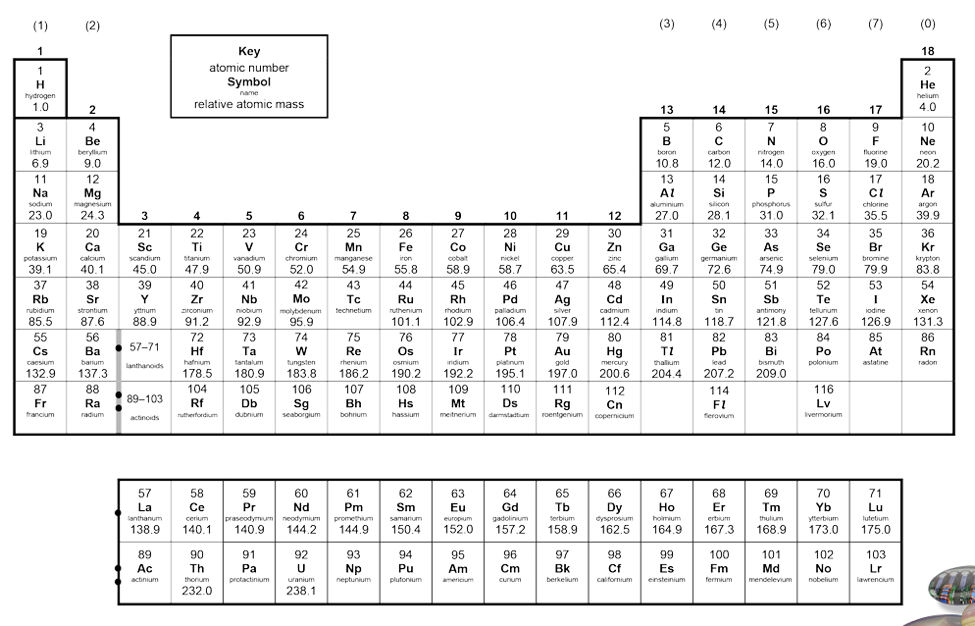
Instructions: Complete the tasks below on the topic ‘chemical reactions’.

- Use your periodic table in your diary (or the copy above).
- Write the chemical formula for the following elements in the table below. The first one has been done for you.
Name of element | Chemical formula
Oxygen | O
Calcium
Iron
Hydrogen

- Identify some common elements and compounds below:

Chemical formula of element/compound | Name of the element/compound
H₂O | Water
CO₂
O₂
Challenge: C₆H₁₂O₆
- Research the structure of an atom using your booklet or the internet and complete the tasks below:

- Label the atom’s sub-atomic particles

Word bank: Neutron, nucleus, electron, proton.

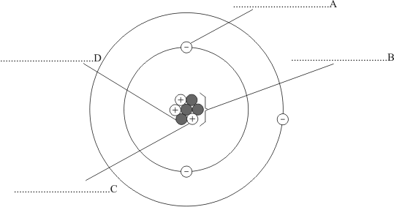

- Match up the charges of each of the subatomic particles below:
0
Proton
+ 1

Electron

- Write a sentence explaining the masses of each subatomic particle.
Neutron
-1
Protons and neutrons both have a relative mass of ______. Electrons do have mass, but it is so small we consider it ______.

Teacher ticks here | Tick | Student comment: How to improve
Excellent homework (good comment)
Good/completed
Requires improvement
Incomplete/unsatisfactory

Peer assessed / Self-assessed

