Name: ___________________________ Tutor group: _________
Geography teacher: ___________________________ Set: _________
Autumn term 1- Dedication
Topic: Development

Home Learning expectations
- Written by yourself, in your own words.
- Completed by the due date.
- Finished to the best of your ability.
- Closely read and followed the instructions.
- Green penned and improved when needed.
- Peer- or self-assessed when asked to.
- Presented clearly and neatly

Key terms:
You will be using these key geographical terms in class throughout this unit of work.
For task 4 you will be learning these words and their meanings for a quiz, which you will do in class the following week.
Key word | Definition
Aid | Assistance in the form of grants or loans at below market rates.
Bottom-up development | Experts work with communities to identify their needs, offer assistance and let people have more control over their lives, often run by NGOs.
Colonialism | Acquiring control over another country, occupying it with settlers and exploiting it economically.
Debt | Money owed by a country to another country, to private creditors (e.g. commercial banks) or to international agencies such as the World Bank or IMF.
Developed country | A country with very high human development.
Developing country | A country with low human development.
Development | The economic or social progress a country or people makes.
Development gap | The difference in income and the quality of life in general between the richest and poorest countries in the world.
Emerging economies | Countries that have recently industrialised and are progressing towards an increased role in the world economy.
Formal economy | Means one which is official, meets legal standards for accounts, taxes and workers’ pay and conditions.
Industrialisation | Where a mainly agricultural society changes and begins to depend on manufacturing industries instead.
Informal economy | Means an unofficial economy, where no records are kept. People in the informal economy have no contracts or employment rights.
Transnational companies (TNCs) | Those which operate across more than one country.
Top-down development | When decision making about the development of a place is done by the governments or large companies.

Week 1- Practising map skills
Instructions: Since you started Geography, you have been practicing map skills. You have a test coming up, time to practice the different skills you have learnt.
Map Symbols
Find and draw the symbols for:
- A school
- A church
- A campsite
- A river
- A railway line
Bonus
Explain why map symbols are useful?

Topography
Topography means the shape of the land.
Questions
- What do contour lines show?
__________________________________________________________________________
- In the boxes below draw a example of steep contour lines and gentle contour lines.

Four-Figure Grid References

Find these on your map:
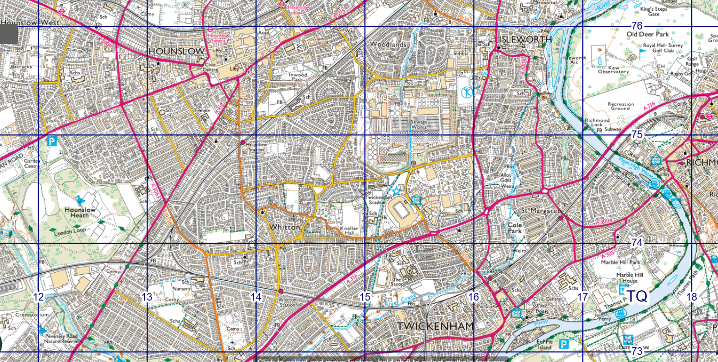
Feature | Grid Reference
Woodland
Bridge
Car Park

Six-Figure Grid References
Use six figures to locate:
Peer-assessment:
What went well:

Even better if:

- The Heathland School ___________
- A footpath ___________
- A museum ___________

Week 2- Development Project
Instructions: Over the next the coming weeks you will be completing a project on different countries understanding how and why they have developed differently. You will use the same three countries throughout your project.
Section 1: Choose 3 countries you are going to compare.
Country 1: My developing country is (circle one): Botswana Burundi Malawi Haiti Nepal
Country 2: My emerging country is (circle one): India China Brazil Indonesia Turkey
Country 3: My developed country is (circle one): USA Germany Japan Australia Norway

Section 2: Describe where your three countries are located
Think about: Continent and which part of it (compass directions), location relative to the UK e.g. north / east / south / west, neighbouring countries, oceans. Use phrases like close to, far from, next to
Country 1: _____________________
________________________________________________________________________________________________________________________________________________________________________________________________________________________________________________________________________________________________________________________________________________________________________________________________________________________________________________________________________________________________________________________________________________________________________
Country 2: _____________________
________________________________________________________________________________________________________________________________________________________________________________________________________________________________________________________________________________________________________________________________________________________________________________________________________________________________________________________________________________________________________________________________________________________________________
Country 3: _____________________
________________________________________________________________________________________________________________________________________________________________________________________________________________________________________________________________________________________________________________________________________________________________________________________________________________________________________________________________________________________________________________________________________________________________________
Section 3: This week you are going to look into social and economic development factors of your selected countries (remember to use the same countries as last week.
Pick at least 2 indicators to compare the countries:
www.datapandas.org/search is a good place to find the info
Definitions:
GDP:
__________________________________________________________________________________________________________________________________________________________________
Literacy Rates: __________________________________________________________________________________________________________________________________________________________________
HDI:
__________________________________________________________________________________________________________________________________________________________________
Indicator | Country 1 | Country 2 | Country 3
GDP (Gross domestic product) per capita ($)
Literacy rate (%)
Life expectancy (Years)
HDI (Human development index)

Week 3: How Developed Are Your Countries?
Use the information you found in the table for task 3 as evidence to show how developed the countries are.
The indicators of development show that country 1 is a developed country because _______________________________________________________________________________________________
_______________________________________________________________________________________________
_______________________________________________________________________________________________
_______________________________________________________________________________________________
_______________________________________________________________________________________________

Country 2 is an emerging country. The indicators of development show this because
_______________________________________________________________________________________________
_______________________________________________________________________________________________
_______________________________________________________________________________________________
_______________________________________________________________________________________________
_______________________________________________________________________________________________

I can see that country 3 is a developing country because the indicators show that it has _______________________________________________________________________________________________
_______________________________________________________________________________________________
_______________________________________________________________________________________________
_______________________________________________________________________________________________
_______________________________________________________________________________________________

Peer assessment by _________________________ One area I think you could improve further is:
o I have found data for the GDP and literacy rate o have found the HDI of each of the countries (GDP, literacy rate
o I have used the same countries as above o Something else __________________________

Week 4 – Research
Using the same countries as the previous weeks, you need to research historical (in the past) causes (reasons why) they have developed at different speeds and what impact these have had on the country.
For section 5 you will need to think about what the three countries will be like in the future and why they will be like this.

Section 4: Why are your countries at different stages of development?

Country 1: _____________________
________________________________________________________________________________________________________________________________________________________________________________________________________________________________________________________________________________________________________________________________________________________________________________________________________________________________________________________________________________________________________________________________________________________________________

Country 2: _____________________
________________________________________________________________________________________________________________________________________________________________________________________________________________________________________________________________________________________________________________________________________________________________________________________________________________________________________________________________________________________________________________________________________________________________________

Country 3: _____________________
________________________________________________________________________________________________________________________________________________________________________________________________________________________________________________________________________________________________________________________________________________________________________________________________________________________________________________________________________________________________________________________________________________________________________

What do you think your countries will be like in 50 years’ time?
Country 1: _____________________
____________________________________________________________________________________________________________________________________________________________________________________________________________________________________________________________________________________________________________________________________________________________________________________________________________________________________________________________________________________________________________________________________________________________________________________________________________________________________________________________________
Country 2: _____________________
____________________________________________________________________________________________________________________________________________________________________________________________________________________________________________________________________________________________________________________________________________________________________________________________________________________________________________________________________________________________________________________________________________________________________________________________________________________________________________________________________
Country 3: _____________________
____________________________________________________________________________________________________________________________________________________________________________________________________________________________________________________________________________________________________________________________________________________________________________________________________________________________________________________________________________________________________________________________________________________________________________________________________________________________________________________________________
Sections 4 and 5: Teacher marked
I have NOT WRITEN THAT IT WILL HAVE LOTS OF TECHNOLOGY AND EVERYONE WILL BE ABLE TO LIVE IN SPACE!
I have been realistic and used at least 3 ideas below:
Is it going to be rich?
Is it going to be developed?
Is it going to suddenly start to trade with resources?
Is it likely to be LESS developed?
Is it likely to still be poorer than developed countries?
As the people in the country get richer will they pay more tax? This means that……
Week 5- Development key terms
Learning your glossary words
Instructions: You need to learn the glossary key terms from page 2 of this booklet for a quiz in class next week. To help you do this, answer the following recall questions:
- Aid is ________________________________________________________________.
- What’s the difference between top-down and bottom-up? ________________________________________________________________________________________________________________________________________________
- The difference a formal and informal economy is ________________________________________________________________________________________________________________________________________________
- What are three economic measurements of development?
  - ________________
  - ________________
  - ________________
Part 2: Use a key term from your glossary to complete these sentences. You can use each term more than once.
- Those which operate across more than one ___________.
- The economic or social ___________ a country or people makes.
- Where a mainly agricultural society __________ and begins to depend on manufacturing industries instead.
- Acquiring control over another country, occupying it with settlers and _______________ it economically.
- The difference in income and the __________ of life in general between the richest and poorest countries in the world.

changes, progress, quality, exploiting, country, practical

Week 6 - Development plan
Instructions: Pick one of the countries from the previous weeks. You are going to be part of a team that is involved in helping further develop this country.
Task 1: Write a short paragraph explaining the challenges your country faces.
Fill in the boxes below.

Development Indicator | What is it like in this country?
Education | ________________________________________________
Healthcare | ________________________________________________
Clean Water | ________________________________________________
Jobs and Money | ________________________________________________
Life Expectancy | ________________________________________________
What is the biggest challenge for this country?
☐ Education
☐ Healthcare
☐ Poverty
☐ Clean Water
☐ Jobs
☐ Other: ______________________

Explain why:
___________________________________________________________________________________________________________________________________________________________________________________________________________________________________________________
Task 2: Create a plan with 3 ideas that could help the country develop further.
Idea | Why this will help development

Task 3: Complete the following sentences
I think life will be better because…

One thing that still needs to improve is…

Self assessment
One area I think I could improve further is:
o I have explained how my ideas will help the countries o Good ideas for future development
o Using the same countries as above o Something else __________________________

