Name: ___________________________ Tutor group: _________
Geography teacher: ___________________________ Set: _________
Autumn term 1- Dedication
Topic: The Perfect Geographer
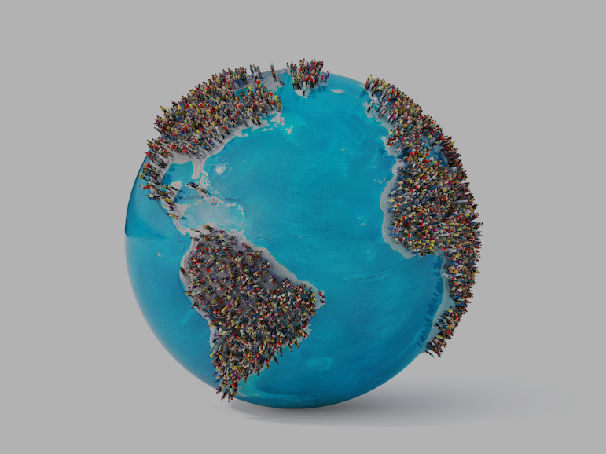
Home Learning expectations
- Written by yourself, in your own words.
- Completed by the due date.
- Finished to the best of your ability.
- Closely read and followed the instructions.
- Green penned and improved when needed.
- Peer- or self-assessed when asked to.
- Presented clearly and neatly

Key terms:
You will be using these key geographical terms in class throughout this unit of work.
For task 4 you will be learning these words and their meanings for a quiz, which you will do in class the following week.
Key word | Definition
Cartography | Mapmaking
Contour line | Thin brown lines that join together paces at the same height. The height is printed on the line
Fieldwork | Practical work conducted in the natural/open environment
Field sketch | A drawing produced to help grasp both the human and physical aspects of a particular landscape. A field sketch also helps to assess a landscape in regards to both processes taking place and issues that may arise
Geography | People, places and the natural world, and how they affect each other.
Human Geography | How and where people live, develop and earn a living
Latitude | Imaginary lines drawn on the world that run parallel to help decide how far North or South a place is
Longitude | Imaginary lines drawn on the world that run vertically to help decide how far East or West a place is
Map | A graphic representation, presenting a spatial understanding of places, ideas or events in the human and physical worlds
Physical Geography | What are planet is like, the work of rivers, the sea and ice
Prime meridian | The line of longitude which divides the Earth into the Eastern and Western hemisphere – O degrees – a starting point for measuring longitude
Rural | An area in the countryside. An example is the village of Shere.
Spot height | Marked by a black dot with the height in metres alongside it
Scale | A measurement of enlargement or reduction from the original size, often shown as a ratio
Triangulation Pillars | Often found on hill tops, shown by a blue triangle with a dot in the middle and the height marked next to it
Urban | A built-up area- a town or city. An example is Hounslow.
Task 1- What is Geography quiz?
Instructions: Using your own knowledge or researching if needed, complete the following quiz about Geography.

1. What is the largest ocean on Earth?
A) Atlantic Ocean
B) Indian Ocean
C) Pacific Ocean
D) Arctic Ocean
2. Which continent is the Sahara Desert located in?
A) Asia
B) Africa
C) Australia
D) Europe
3. What is the capital city of France?
A) Rome
B) Madrid
C) Berlin
D) Paris
4. Which country is famous for the Great Wall?
A) Japan
B) China
C) India
D) Mexico
5. Mount Everest is the tallest mountain in the world. Which mountain range is it part of?
A) Alps
B) Rockies
C) Himalayas
D) Andes

6. Which river is the longest in the world?
A) River Thames
B) Nile River
C) Amazon River
D) Mississippi River
7. Which continent is also a country?
A) Europe
B) Antarctica
C) Australia
D) South America
8. What do we call land surrounded by water?
A) Island
B) Desert
C) Valley
D) Forest
9. Which direction does the sun rise from?
A) North
B) South
C) East
D) West
10. Which is the coldest continent on Earth?
A) Europe
B) Antarctica
C) Asia
D) North America

Peer-assessment:
What went well:
Even better if:

Task 2- Continents of the world
Instructions: Create a fact file about one of the worlds continents.
Continent: ___________________________
Location
Where is this continent on the world map?

Countries

Capital Cities of chosen countries

Population

Climate
☐ Hot ☐ Cold ☐ Dry ☐ Rainy ☐ Mixed
Animals

Famous Places or Features

Food

Fun Facts

Picture
Draw a map, flag, animal, or famous landmark here:

Peer assessment by _________________________ One area I think you could improve further is:
o Information about the continent o Interesting facts about the continent
o Description of location o Something else _________________________________

Task 3- Oceans of the world
Instructions: Learn about the five oceans of the world and complete the activities below.

Name the Oceans
Fill in the missing oceans:
- __________________ Ocean
- __________________ Ocean
- __________________ Ocean
- __________________ Ocean
- __________________ Ocean

Match the Fact
Write the correct ocean next to each fact.
Pacific Ocean – Atlantic Ocean – Indian Ocean – Arctic Ocean – Southern Ocean
Fact | Ocean
The coldest ocean
The largest ocean
Found between Africa and Australia
Separates North America and Europe
Surrounds Antarctica
Self-assessment:
What went well:
Even better if:

True or False
Write T for true or F for false.
- _____ The Pacific Ocean is the biggest ocean.
- _____ The Arctic Ocean is very warm.
- _____ There are 3 oceans in the world.
- _____ The Southern Ocean surrounds Antarctica.
- _____ Oceans are made of salt water.

Ocean Creatures
Name 3 animals that live in the ocean.

Protect the Oceans
Write one thing people can do to help keep oceans clean.

Challenge Question
Which ocean would you most like to visit and why?

Task 4: Learning your glossary words
Instructions: You need to learn the glossary key terms from page 2 of this booklet for a quiz in class next week. To help you do this, answer the following recall questions:
- Cartography is the study of ___________________.
- What’s the difference between rural and urban areas? __________________________________________________________________________________________________________________________________________
- The difference between the lines of longitude and latitude is __________________________________________________________________________________________________________________________________________
- How do we show the height of land on a map?
  - ________________
  - ________________
  - ________________
Part 2: Use a key term from your glossary to complete these sentences. You can use each term more than once.
- __________ work conducted in the natural/open environment
- A drawing produced to help grasp both the human and __________ aspects of a particular landscape
- The line of longitude which divides the Earth into the ______ and __________ hemispheres
- The village of Shere is an example of a ________ area.
- _____________ is an example of an urban area.

Physical, Rural, Western, Hounslow, Eastern, Practical

Task 5- Continents and Oceans
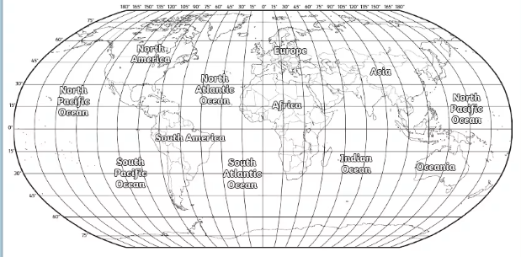
Instructions: Look at the map below and label the continents and oceans
The Prime Meridian is located at 0°
Task 1: Using the map above answer the following questions:

On what continent would you find each of the following locations?

a. 60°N, 100°W __________________________________
b. 60°N, 100°E __________________________________
c. 20°S, 60°W __________________________________
d. 20°N, 20°E __________________________________
e. 20°S, 140°E __________________________________

Part 2: Use the map above to identify and select the correct answer.

1. In what ocean does the Prime Meridian cross the equator?
a. Atlantic b. Pacific c. Indian d. Arctic

2. What two continents does the equator cross?
a. North America and South America c. Africa and Europe
b. Africa and South America d. Australia

3. Which one of these continents lies completely in the Southern Hemisphere?
a. North America c. South America
b. Asia d. Australia

4. What ocean lies completely in the Eastern Hemisphere?
a. Atlantic b. Indian c. Pacific d. Arctic

Peer-assessment:
What went well:
Even better if:

