Name: ___________________________ Tutor group: _________
Geography teacher: ___________________________ Set: _________
Autumn term 1- Aspiration
Topic: The Perfect Geographer
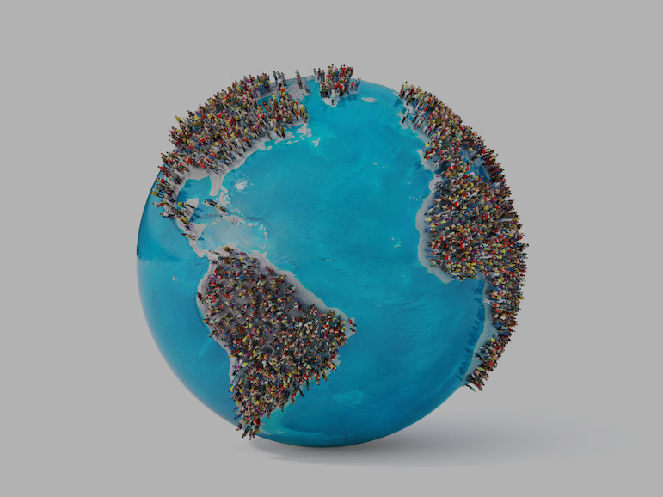
Home Learning expectations
- Written by yourself, in your own words.
- Completed by the due date.
- Finished to the best of your ability.
- Closely read and followed the instructions.
- Green penned and improved when needed.
- Peer- or self-assessed when asked to.
- Presented clearly and neatly

Key terms:
You will be using these key geographical terms in class throughout this unit of work.
For task 4 you will be learning these words and their meanings for a quiz, which you will do in class the following week.
Key word | Definition
Cartography | Mapmaking
Contour line | Thin brown lines that join together paces at the same height. The height is printed on the line
Fieldwork | Practical work conducted in the natural/open environment
Field sketch | A drawing produced to help grasp both the human and physical aspects of a particular landscape. A field sketch also helps to assess a landscape in regards to both processes taking place and issues that may arise
Geography | People, places and the natural world, and how they affect each other.
Human Geography | How and where people live, develop and earn a living
Latitude | Imaginary lines drawn on the world that run parallel to help decide how far North or South a place is
Longitude | Imaginary lines drawn on the world that run vertically to help decide how far East or West a place is
Map | A graphic representation, presenting a spatial understanding of places, ideas or events in the human and physical worlds
Physical Geography | What are planet is like, the work of rivers, the sea and ice
Prime meridian | The line of longitude which divides the Earth into the Eastern and Western hemisphere – O degrees – a starting point for measuring longitude
Rural | An area in the countryside. An example is the village of Shere.
Spot height | Marked by a black dot with the height in metres alongside it
Scale | A measurement of enlargement or reduction from the original size, often shown as a ratio
Triangulation Pillars | Often found on hill tops, shown by a blue triangle with a dot in the middle and the height marked next to it
Urban | A built up area- a town or city. An example is Hounslow.
Task 1- What is Geography quiz?
Instructions: Using your own knowledge or researching if needed, complete the following quiz about Geography.

1. What is the largest ocean on Earth?

2. Which continent is the Sahara Desert located in?

3. What is the capital city of France?

4. Which country is famous for the Great Wall?

5. Mount Everest is the tallest mountain in the world. Which mountain range is it part of?

6. Which river is the longest in the world?

7. Which continent is also a country?

8. What do we call land completely surrounded by water?

9. Which direction does the sun rise from?

10. Which is the coldest continent on Earth?

Peer-assessment:
What went well:
Even better if:

Week 2- Continents of the world
Instructions: Create a fact file about one of the world’s continents.
Continent: ___________________________
Location
________________________________________________________________________________________________________________________________________________________________
Countries located on this continent
- __________________________________
- __________________________________
- __________________________________
Capital Cities of chosen countries
- __________________________________
- __________________________________
- __________________________________
Population of the continent

Climate
________________________________________________________________________________________________________________________________________________________________
Animals
________________________________________________________________________________________________________________________________________________________________

Famous Places or Features
- __________________________________
- __________________________________
Interesting Facts

Peer assessment by _________________________ One area I think you could improve further is:
o Information about the continent o Interesting facts about the continent
o Description of location o Something else _________________________________

Week 3- Oceans of the world
Instructions: Learn about the five oceans of the world and complete the activities below.

Name the 5 Oceans of the world

Match the Fact to the ocean
Fact | Ocean
The coldest ocean
The largest ocean
Found between Africa and Australia
Separates North America and Europe
Surrounds Antarctica

True or False
Write T for true or F for false.
- _____ The Pacific Ocean is the biggest ocean.
- _____ The Arctic Ocean is very warm.
- _____ There are 3 oceans in the world.
- _____ The Southern Ocean surrounds Antarctica.
- _____ Oceans are made of salt water.

Ocean Creatures
Name 5 animals that live in the ocean.
- __________________________________
- __________________________________
- __________________________________
- __________________________________
- __________________________________
How can we protect the Oceans
Challenge Question
Which ocean would you most like to visit and why?

Self-assessment:
What went well:
Even better if:

Week 4- Perfect Geographer key terms
Task 4: Learning your glossary words
Instructions: You need to learn the glossary key terms from page 2 of this booklet for a quiz in class next week. To help you do this, answer the following recall questions:
- Cartography is the study of ___________________.
- What’s the difference between rural and urban areas? ________________________________________________________________________________________________________________________________________________
- The difference between the lines of longitude and latitude is ________________________________________________________________________________________________________________________________________________
- How do we show the height of land on a map?
  - ________________
  - ________________
  - ________________
Part 2: Use a key term from your glossary to complete these sentences. You can use each term more than once.
- __________ work conducted in the natural/open environment
- A drawing produced to help grasp both the human and __________ aspects of a particular landscape
- The line of longitude which divides the Earth into the ______ and __________ hemispheres
- The village of Shere is an example of a ________ area.
- _____________ is an example of a urban area.

Physical, Rural, Western, Hounslow, Eastern, Practical
Week 5- Continents and Oceans
Instructions: Look at the map below and label the continents and oceans

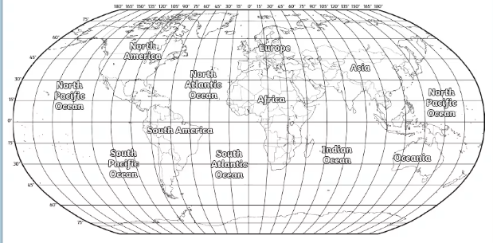
The Prime Meridian is located at 0°

Task 1: Using the map above answer the following questions:

On what continent would you find each of the following locations?
a. 60°N, 100°W __________________________________
b. 60°N, 100°E __________________________________
c. 20°S, 60°W __________________________________
d. 20°N, 20°E __________________________________
e. 20°S, 140°E __________________________________
Part 2: Use the map above to identify and select the correct answer.
1. In what ocean does the Prime Meridian cross the equator?
a. Atlantic b. Pacific c. Indian d. Arctic

2. What two continents does the equator cross?
a. North America and South America c. Africa and Europe
b. Africa and South America d. Australia

3. Which one of these continents lies completely in the Southern Hemisphere?
a. North America c. South America
b. Asia d. Australia

4. What ocean lies completely in the Eastern Hemisphere?
a. Atlantic b. Indian c. Pacific d. Arctic

Peer-assessment:
What went well:
Even better if:

