Year 7 Home Learning Project
Autumn term: Medieval Jobs

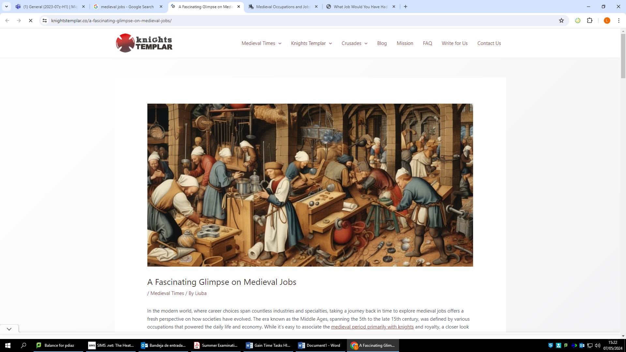

Homework expectations
-Written by yourself, in your own words.
-Completed by the due date.
-Finished to the best of your ability.
-Closely followed the instructions.
-Green penned and improved when needed.
-Peer or self-assessed when asked to.
-Presented so it is clear and neat
-Proof read the work to ensure spelling, punctuation and grammar is to the best of your ability.

Task one- Medieval Jobs
Due Date:

Instructions: Refer to the Task 1 research folder in teams.

Gong farmer-Write one positive point about that line of work
1. _____________________________________________________________________________________

Gong farmer-Write one negative point about that line of work
1. _____________________________________________________________________________________

Barber surgeon -Write one positive point about that line of work
1. _____________________________________________________________________________________

Barber surgeon -Write one negative point about that line of work
1. _____________________________________________________________________________________

Teacher assessed
Positive points:
How to improve further:

Task two- Retrieval questions
Due Date:

Write down 2 examples of what life was like in England:
-

-
- What jobs did most people do in England during the 11thcentury?

- What was the Bayeux Tapestry?
The Bayeux Tapestry was ________________________________________________________________________________________________________________________________________________________________________

- What important event did the Bayeux Tapestry show in 1066?
A) World War 1 B) The Battle of Hastings C) Henry VIII being crowned king

- Who were the three claimants to the throne?
-

-

-

- Who won the battle of Stamford Bridge?
____________________________________________________________________________________

Task three- Medieval job advert
Due Date:

Instructions: Pick one of the medieval jobs from Task One and design an advert encouraging people to take that job. Include at least 2 positive points about why. Compare to other medieval jobs and explaining why that job is better

Self assessed
Positive points:
How to improve further:

Task four – Retrieval questions
Due Date:

When was the Battle of Hastings?
_________________________________________________________________________________
- Who were the two leaders fighting for the throne?
_________________________________________________________________________________
- What was the tactic called where William and his men ran up the hill and back down to capture the Anglo-saxons?

F__________d R__________t

- Who won the Battle of Hastings?
_________________________________________________________________________________
- What was the name of the castles created by William I?
_________________________________________________________________________________
- Name two features of these types of castles (for example it had a moat):
-

-

- Fill in the feudal system triangle in the correct order:
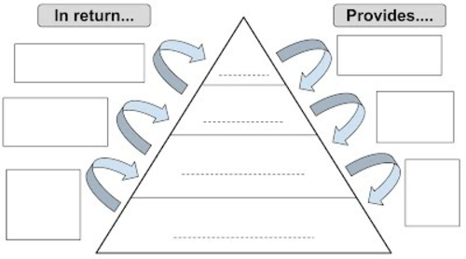

Task five –Medieval Diary
Due Date:

Instructions: Refer to the Task 3 research folder in teams.

Pick one of the medieval jobs and write a diary entry from the perspective of someone doing that job. Think about 1. Good things/bad things 2. What your job is like, day to day tasks etc. (remember to use all your senses –see, hear, smell, touch, taste) 3. What you would like to change about your job.
_____________________________________________________________________________________
_____________________________________________________________________________________
_____________________________________________________________________________________
_____________________________________________________________________________________
_____________________________________________________________________________________
_____________________________________________________________________________________
___________________________________________________________________________________
_____________________________________________________________________________________
_____________________________________________________________________________________
_____________________________________________________________________________________
_____________________________________________________________________________________
_____________________________________________________________________________________
_____________________________________________________________________________________
_____________________________________________________________________________________
_____________________________________________________________________________________
_____________________________________________________________________________________
_____________________________________________________________________________________
_____________________________________________________________________________________
_____________________________________________________________________________________
Self assessed
Positive points:
How to improve further:

Task 6 – Retrieval questions
Due Date:

Do you think the Feudal System was good or bad and why?
__________________________________________________________________________________________________________________________________________________________________
- What was the Domesday Book?
__________________________________________________________________________________________________________________________________________________________________
- Name 2 things that would have been recorded in the Domesday book?

-
-

- How did the Domesday book help William I control England?
___________________________________________________________________________________________________________________________________________________________________________________________________________________________________________________
- Why is the Baeyux Tapestry useful for learning about England in the 1000’s?
___________________________________________________________________________________________________________________________________________________________________________________________________________________________________________________
- Why is the Bayeux tapestry not useful for learning about England in the 1000s
___________________________________________________________________________________________________________________________________________________________________________________________________________________________________________________

Task seven - Medieval Job comparison
Due Date:

Instructions: Refer to the Task 3 research folder in teams.

Treadmill Operator -Write down an interesting fact about this job
1. _____________________________________________________________________________________

Lime Burner -Write down an interesting fact about this job
1. _____________________________________________________________________________________

Tanner -Write down an interesting fact about this job
1. _____________________________________________________________________________________

Which job would like to do (if you had to pick one from the above) Explain why you would pick that job.
_____________________________________________________________________________________
_____________________________________________________________________________________
_____________________________________________________________________________________
_____________________________________________________________________________________
_____________________________________________________________________________________

Task eight – Retrieval questions
Due Date:

Name two things you’d find in a medieval village:
__________________________________________________________________________________________________________________________________________________________________
- What are two jobs that would be needed for a medieval village to run well:
__________________________________________________________________________________________________________________________________________________________________
- Name 3 things that medieval people believed in:
-
-

- What are doom paintings
___________________________________________________________________________________________________________________________________________________________________________________________________________________________________________________
- What is the definition of a monk?
__________________________________________________________________________________________________________________________________________________________________

Task nine –Medieval Job Ranking
Due Date:

Instructions: Refer to the Task 3 research folder in teams.

Create a Diamond 4 pyramid and place the worst job at the top and least worst at the bottom. Explain why you have placed your worst job at the top and the best job at the bottom.

Task ten –Medieval Conversation
Due Date:

Instructions: Refer to the Task folder in teams.

Pick 2 of the worst medieval jobs that you have researched. Create a script of a conversation between the 2 characters. Create and interesting conversation about their jobs.

Person 1:
_____________________________________________________________________________________
Person 2:
_____________________________________________________________________________________
Person 1:
_____________________________________________________________________________________
Person 2:
_____________________________________________________________________________________
Person 1:
_____________________________________________________________________________________
Person 2:
_____________________________________________________________________________________

