Mathematics Home Learning
AUTUMN TERM 1 – Year 7
Aspiration
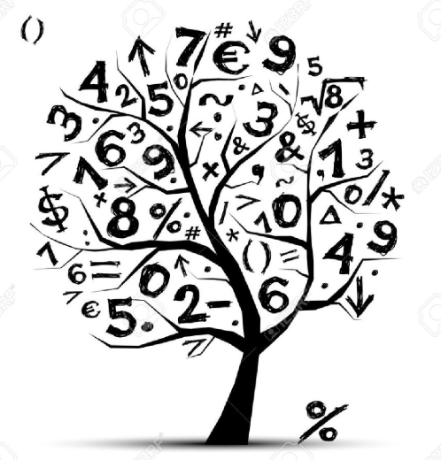
Home Learning Expectations

SPARX Login Details

All students can access SPARX from home by going to https://sparxmaths.com and using their school Microsoft login details.

SPARX expectations:
- All students must complete Home Learning work in the BLUE exercise book provided
- Divide your page in half
- Draw margins using a ruler and a pencil
- Use blue or black ink
- The title should be the date the homework is due
- Write SPARX question codes for all questions
- Show working out for each question where applicable
- Once you have completed a question, mark you answer with a green pen
- When all questions have been completed write down the percentage you achieved
- If you get a question wrong, reattempt the question using a green pen
- Make sure all your working out is neat and legible.

EXAMINATION questions expectations:
- Use blue or black ink
- If the question is 2 or more marks you must show working out in the spaces provided
- Make sure all your working out is neat and legible
- Write final answer on the dotted line

HOME LEARNING SCHEDULE – Autumn Term

Homework is set on: | Date Completed
Week beginning 7th Sept 26 – No home learning this week
Week beginning 14th Sept 26 – No home learning this week
TASK 1: Week beginning 21st Sept 26 – Complete SPARX in BLUE homework books
TASK 2: Week beginning 28th Sept 26 – Complete SPARX in BLUE homework books
TASK 3: Week beginning 5th Oct 26 – Complete SPARX in BLUE homework books
TASK 4: Week beginning 12th Oct 26 – Complete EXAM questions on Sequences on pages 3 and 4
TASK 5: Week beginning 19th Oct 26 - Complete SPARX in BLUE homework books
HALF TERM

TASK 6: Week beginning 2nd Nov 26 – Complete EXAM questions on Algebraic Expressions and Equations and Substitution on pages 5 and 6
TASK 7: Week beginning 9th Nov 26 – Complete SPARX in BLUE homework books

TASK 8: Week beginning 16th Nov 26 – Complete SPARX in BLUE homework books

TASK 9: Week beginning 23rd Nov 26 – Complete EXAM questions on Averages and Range on pages 7 and 8

TASK 10: Week beginning 30th Nov 26 - Complete SPARX in BLUE homework books

TASK 11: Week beginning 7th Dec 26 - Complete EXAM questions on Place Value, Ordering and Rounding on pages 9 and 10

Week beginning 14th Dec 26 - No home learning this week

CHRISTMAS HOLIDAYS

Sequences
1.
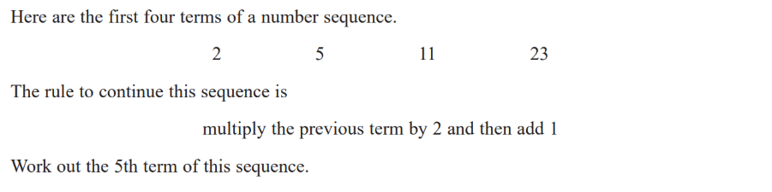

1 mark

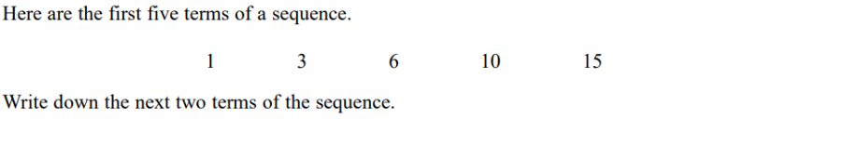
2.

2 marks

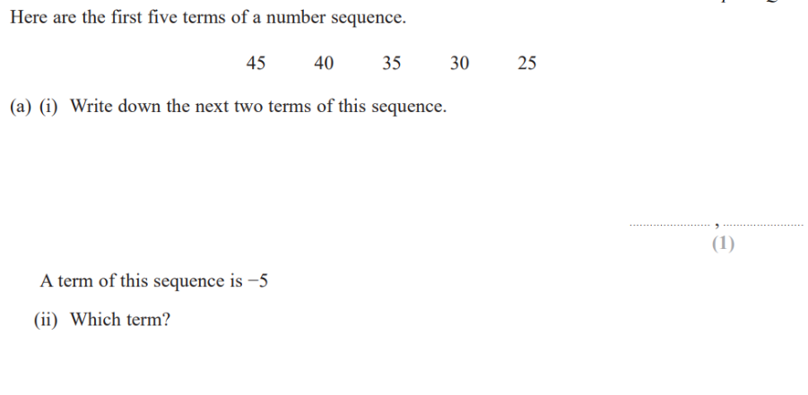
3.

Total 2 marks

1 mark

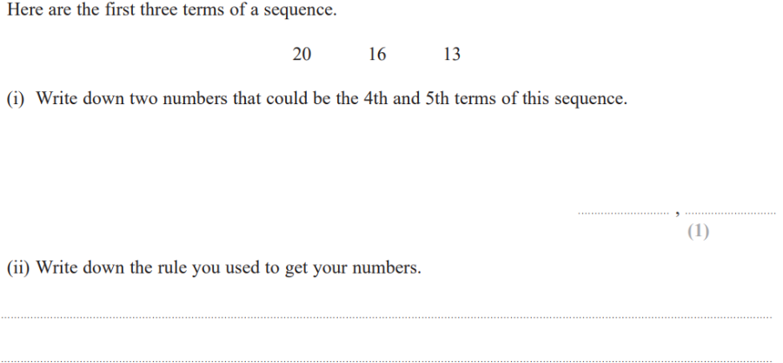
4.

2 marks

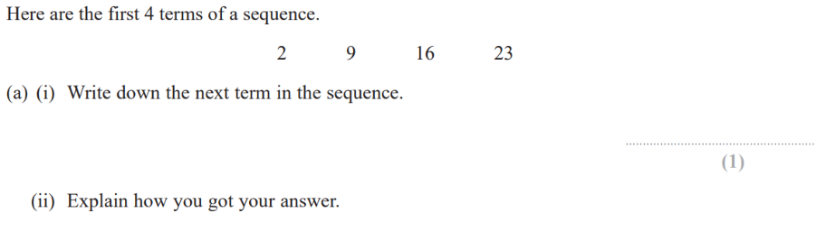
5.

2 marks

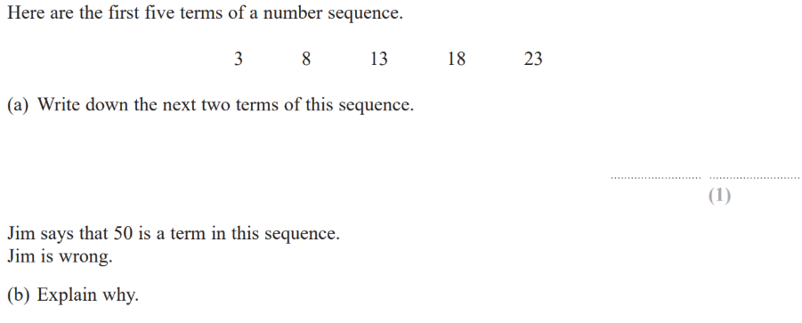
6.

2 marks

Algebraic Expressions and Equations and Substitution

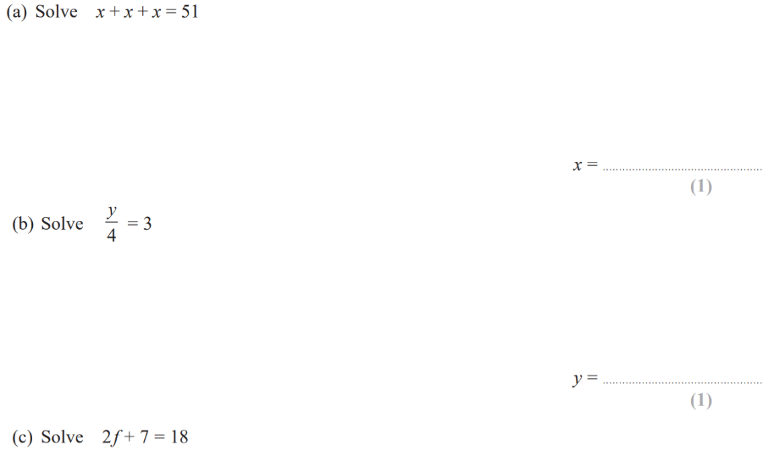
1.
Total 3 marks

1 mark

2.
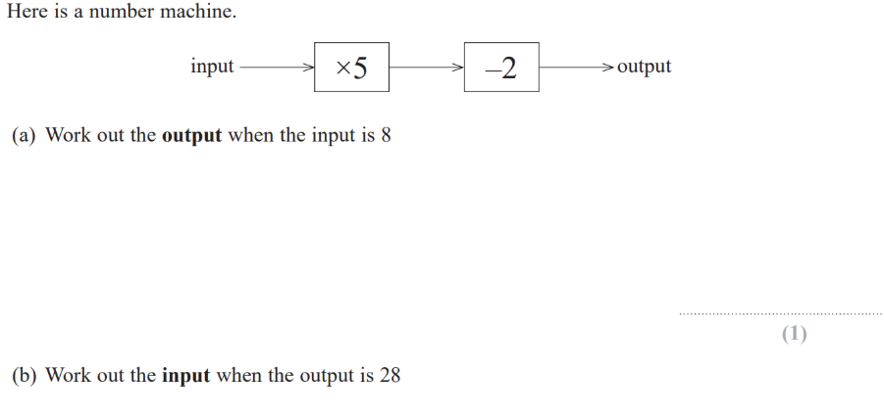

2 marks

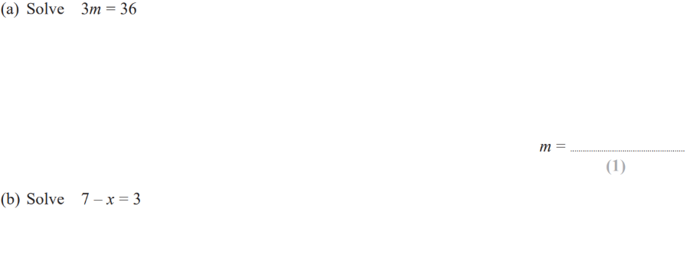
3.
Total 2 marks

1 mark

4.
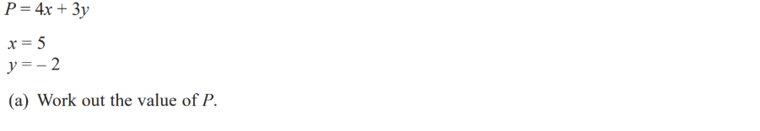

2 marks

Averages and Range

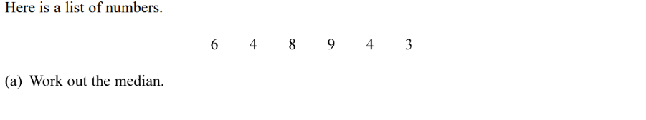
1.

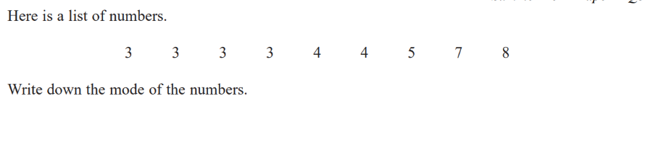
2.
2 marks

1 mark

3.

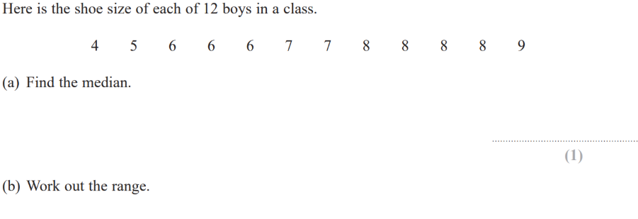

1 mark

4.
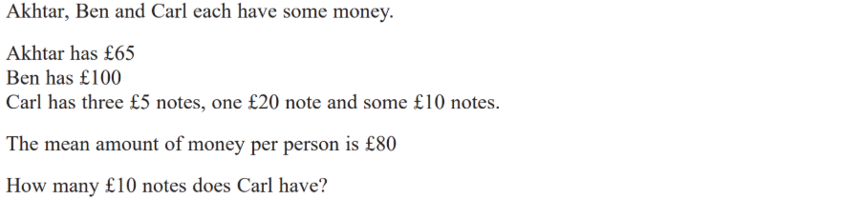

4 marks

5.
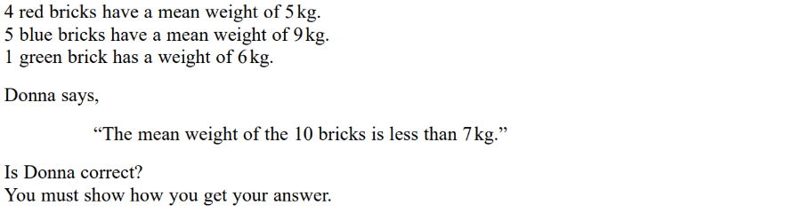

3 marks

Place value, Ordering and Rounding
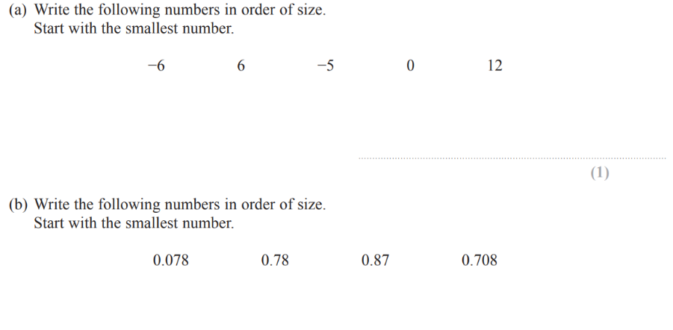
1.
Total 2 marks

1 mark

2.

1 mark

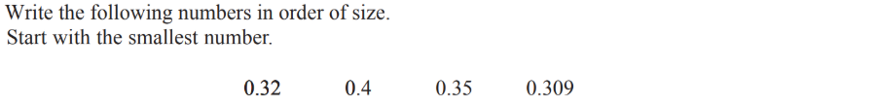
3.

1 mark

4.
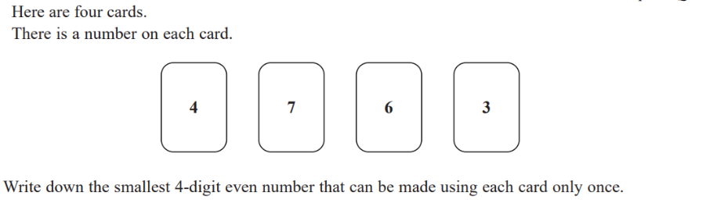

1 mark

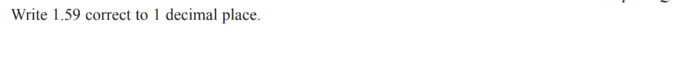
5.
Total 1 mark

6.
1 mark

Total 1 mark

1 mark

7.
1 mark

8.
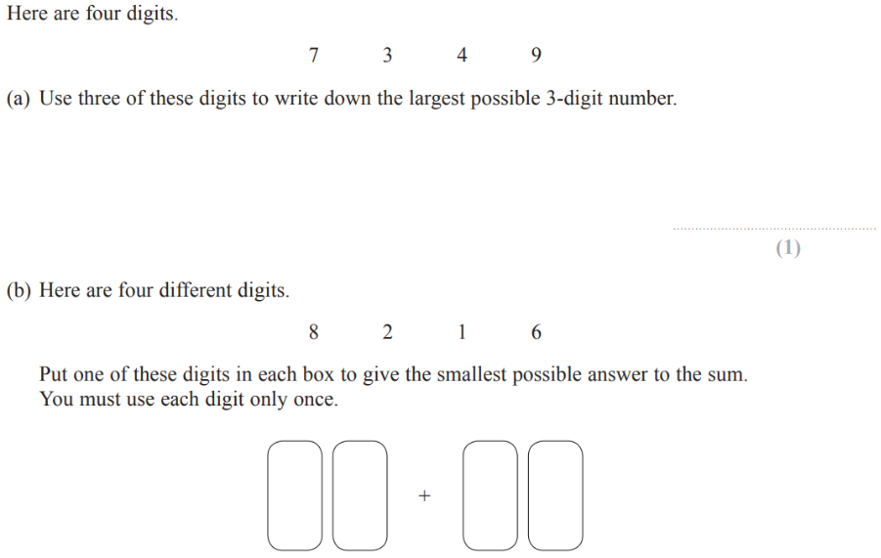
1 mark

