Year 7 Home Learning
-Dedication-
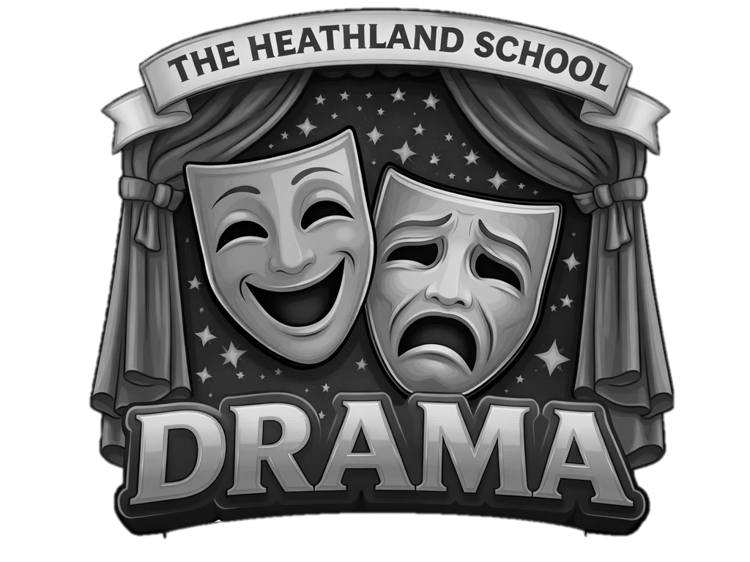
Name:
_________________________
Class:
_________________________
Teacher:
_________________________
Home Learning expectations
- All work is written by yourself, in your own words.
- Completed by the due date.
- Finished to the best of your ability.
- Clearly read and followed the instructions.
- Green penned and improved where needed.
- Peer or self-assessed when asked to.
- Presented so it is clear and neat.
- Work has been proof read to ensure spelling, punctuation and grammar is to the best of your ability.

TOPIC 1
INTRODUCTION TO DRAMA

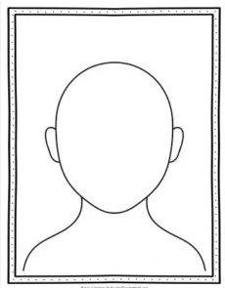
Due date:
ANGRY
GRUMPY
SAD
HAPPY
Task one - Introduction to Drama Poster 1: Complete task here

Task one - Introduction to Drama Poster

Draw a face for each of the emotions, you should think about the below
Eyes, Mouth, Nose, Eyebrows

- Facial Expression – Using your face to show emotion.
Task one - Introduction to Drama Poster Feedback

Students to complete:
I have drawn all parts of the face
I have changed my drawing to show the correct emotion
I have included colour in my drawing
Positive points:

How to improve further:

Self-assessed

Teacher to complete:
On your work you will find different letters, use the below key to see what your teacher feedback is. You must now green pen your work in full sentences next to the letter.
Teacher assessed
A | You haven’t drawn a piece of the face
B | You haven’t drawn the correct emotion try again
C | Include more colour in your drawing.

Q1. What is POSTURE in drama? | The way an actor stands or holds their body on stage.
Q1. What is POSTURE in drama? | The speed at which an actor speaks
Q1. What is POSTURE in drama? | The level of volume used in a performance
Q2. Why is POSTURE important in a performance? | It helps actors remember their lines
Q2. Why is POSTURE important in a performance? | It can communicate a character's emotions or status
Q2. Why is POSTURE important in a performance? | It makes the actor louder
Q3. What is GESTURE in drama? | A small hand movement used to communicate something
Q3. What is GESTURE in drama? | The loudness of a performance
Q3. What is GESTURE in drama? | The tone of voice used
Q4. Which of the following is an example of GESTURE? | Pointing
Q4. Which of the following is an example of GESTURE? | Running
Q4. Which of the following is an example of GESTURE? | Speaking in a low voice
Q5. What is BODY LANGUAGE? | The tone of speech
Q5. What is BODY LANGUAGE? | The volume of speech
Q5. What is BODY LANGUAGE? | Communication through physical movements and posture
Q6. How does BODY LANGUAGE help in drama? | It helps actors deliver their lines faster
Q6. How does BODY LANGUAGE help in drama? | It allows non-verbal communication of a character’s emotions and intentions
Q6. How does BODY LANGUAGE help in drama? | It makes the scene more humorous
Q7. What is the difference between GESTURE and BODY LANGUAGE? | Gestures are verbal, while body language is non-verbal
 | Gesture refers to individual movements, while body language involves the whole body
 | Body language involves voice, while gesture doesn't
Q8. What does FACIAL EXPRESSION convey in drama? | The volume of speech
Q8. What does FACIAL EXPRESSION convey in drama? | The pace of speech
Q8. What does FACIAL EXPRESSION convey in drama? | Emotions and reactions
Q9. Which of these is an example of FACIAL EXPRESSION? | Yelling
Q9. Which of these is an example of FACIAL EXPRESSION? | Pointing a finger
Q9. Which of these is an example of FACIAL EXPRESSION? | Frowning
Q10. Why is FACIAL EXPRESSION important in acting? | It makes the actor louder
Q10. Why is FACIAL EXPRESSION important in acting? | It adds depth to the character by showing emotions
Q10. Why is FACIAL EXPRESSION important in acting? | It helps the actor move faster
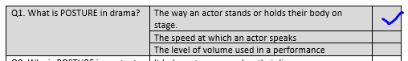
Score: ______ / 10
Due date:
Task two - Introduction to Drama Quiz:
Tick the box that you believe is the correct answer.
Peer assessed
Due date:
Task three- Introduction to Drama Written
Describe and Explain how you would use your vocal and physical skills to perform the following line.
“Why did you do that? You can see that she is upset.”
- What emotion does the character have?
____________________________________________________________________________________________________________________________________________________________________________________________________________________________________
- Name and define a physical skill.
____________________________________________________________________________________________________________________________________________________________________________________________________________________________________
- Describe how you will use that physical skills to show the emotion of the line.
____________________________________________________________________________________________________________________________________________________________________________________________________________________________________
- Explain what effect this will have on the audience?
____________________________________________________________________________________________________________________________________________________________________________________________________________________________________

KEY TERMS

Facial expression – Using your face to show emotion.
Body language – Using your body to show emotion.
Gesture – Using your hands to communicate meaning.
Posture – How tall or bent your back is to show the power or age of your character.
Task three- Introduction to Drama Written Feedback
Students to complete:
Self-assessed
I have described how I will use my key skills.
I have explained the reason behind my choices.
I have checked my spelling and punctuation.
Positive points:

How to improve further:

Mark Scheme | Band | Key words used correctly: | Description | Explanation | Overall score  /5
Mark Scheme | Top (5pts) | 6+ | Almost all skills described in impressive detail. | Effects of almost all skills explained impressively.
Mark Scheme | Middle (3pts) | 4-5 | +2 skills described simply, or 1 described in detail. | +2 effects simply explained, or 1 described in detail
Mark Scheme | Bottom (1pt) | 1-3 | Some attempt is made to describe skills. | Some attempt is made to explain effects of skills.
Mark Scheme | None (0pt) | 0 | No description | No explanation
Teacher feedback:
Teacher assessed

A | You have not described how you will use your skills.
B | You have not explained the reason behind your choice. Why will you do this?
C | You need to link to the audience and the impact it will have on them.
Due date:
- Work as a team
- Go for it!
- Accept successes and failures.
The rules of Improvisation
- Listen
- Don’t say ‘no’

Task four: Introduction to Drama Poster:
Complete task here

Task four - Introduction to Drama Poster:
Re-create your own poster using the rules of improvisation below.

Task four - Introduction to Drama Poster: Feedback
Students to complete:
Self-assessed
I have made clear description of the rules of improvisation.
I have used colour well and included images.
I have checked my spelling and punctuation.
Positive points:

How to improve further:

Teacher to complete:
On your work you will find different letters, use the below key to see what your teacher feedback is. You must now green pen your work in full sentences next to the letter.
Teacher assessed
A | You have not described the key term.
B | You have not included an image to link to the key word.
C | You need to expand on your definition and include more detail.

Task 5 Introduction to Drama Quiz
Tick the box that you believe is the correct answer.

Due date:
Score: ______ / 10
Q1. What is it called when an actor laughs when they are not supposed to, killing the performance of their character? | Stage Laugh
 | Killer Laugh
 | Corpsing
Q2. Which Physical Skill describes how straight or slouched an actor’s back is? | Body Language
 | Posture
 | Status
Q3. Which Physical skill is used to communicate emotions with the shape of your body? | Facial Expressions
 | Gesture
 | Body Language
Q4. What is it called when actors involve people watching the play in the performance, usually by getting them to call out or sing along? | Audience Game
 | Audience Participation
 | Pick on the Audience
Q5. What is it called when you use your gestures and vocal skills in an over-the-top manner? | Exaggeration
 | Melodrama
 | Pantomime
Q6. Which Physical Skill is used to communicate emotions with the shape and movement of your face? | Facial Expression
 | Face Emotions
 | Face Movements
Q7. What is Eye Contact? | Where you're looking
Q7. What is Eye Contact? | When you look at someone in the eye
Q7. What is Eye Contact? | When you communicate with your eyes
Q8. What is Eye Line? | Where you're looking
Q8. What is Eye Line? | When you look at someone in the eye
Q8. What is Eye Line? | When you communicate with your eyes
Q9. What is Gait? | The way you sound is based on where you're from
Q9. What is Gait? | The distance between your legs when you walk
Q9. What is Gait? | Using your arms to communicate
Q10. What is blocking? | The set movement of an actor on the stage
Q10. What is blocking? | The way an actor uses their body
Q10. What is blocking? | How high or low your voice is
Peer assessed
Due date:
KEY TERMS

Volume – How loud or soft your voice is
Tone – The emotion of your voice
Pitch – How high or low your voice is
Pace – How quick or slow you speak
- What emotion does the character have?
____________________________________________________________________________________________________________________________________________________________________________________________________________________________________
- Name and define a vocal skill.
____________________________________________________________________________________________________________________________________________________________________________________________________________________________________
- Describe how you will use that vocal skill to show the emotion of the character
____________________________________________________________________________________________________________________________________________________________________________________________________________________________________
- Explain what effect this will have on the audience?
____________________________________________________________________________________________________________________________________________________________________________________________________________________________________

Task 6 - Introduction to Drama Written
Describe and Explain how you would use your vocal and physical skills to perform the following line.

“I can’t wait to go to the party. It’s going to be great!”

“Why did you do that?
________________________________________________________________________________________________________________________________________________________________________________________________________________________________________________________________
Can’t you see she is upset?
_______________________________________________________________________________________________________________________________________________________________________________________________________________________________________________________________

Task 6 - Introduction to Drama Written Feedback
Students to complete:
Self-assessed
I have described how I will use my key skills.
I have explained the reason behind my choices.
I have checked my spelling and punctuation.
Positive points:

How to improve further:

Mark Scheme | Band | Key words used correctly: | Description | Explanation | Overall score  /5
Mark Scheme | Top (5pts) | 6+ | Almost all skills described in impressive detail. | Effects of almost all skills explained impressively.
Mark Scheme | Middle (3pts) | 4-5 | +2 skills described simply, or 1 described in detail. | +2 effects simply explained, or 1 described in detail
Mark Scheme | Bottom (1pt) | 1-3 | Some attempt is made to describe skills. | Some attempt is made to explain effects of skills.
Mark Scheme | None (0pt) | 0 | No description | No explanation
Teacher feedback:
Teacher assessed

A | You have not described how you will use your skills.
B | You have not explained the reason behind your choice. Why will you do this?
C | You need to link to the audience and the impact it will have on them.

TOPIC 2
EPIC
THEATRE

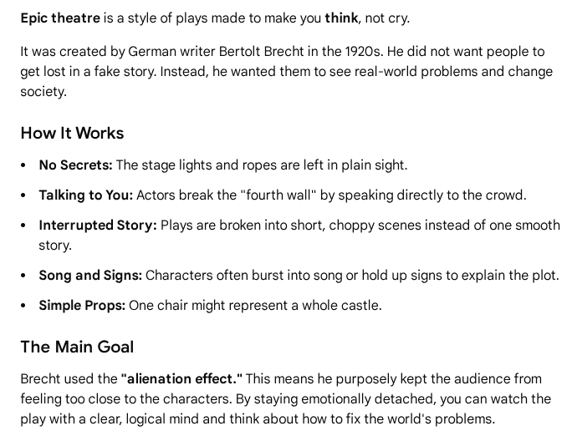
Due date:
Task one - Epic theatre poster
Re-create your own poster in the style of Epic theatre you should use the below picture as inspiration.

Task one - Epic theatre poster. complete task here

Task one - Epic theatre poster Feedback
Students to complete:
Self-assessed
I have made clear description of the style of Epic theatre
I have used colour well and included images.
I have checked my spelling and punctuation.
Positive points:

How to improve further:

Teacher to complete:
On your work you will find different letters, use the below key to see what your teacher feedback is. You must now green pen your work in full sentences next to the letter.
Teacher assessed
A | You have not described the key term.
B | You have not included an image to link to the key word.
C | You need to expand on your definition and include more detail.

Q1. Who created Epic Theatre? | Bertolt Brecht
Q1. Who created Epic Theatre? | Constantin Stanislavski
Q1. Who created Epic Theatre? | Mischief Theatre
Q2. Which Staging Skill is used to show a character’s rank in society? | Proxemics
 | Status
 | Levels
Q3. Which best describes the intention of Epic Theatre? | A style of theatre which aims to educate the audience about a social or political issue.
Q3. Which best describes the intention of Epic Theatre? | An Epic Play
Q3. Which best describes the intention of Epic Theatre? | A funny style of theatre based on fairytales
Q4. What are placards? | Costumes
Q4. What are placards? | Signs with words or messages
Q4. What are placards? | Musical instruments
Q5. What is Epic Theatre trying to do? | Make the audience forget real life
Q5. What is Epic Theatre trying to do? | Make the audience think about the message
Q5. What is Epic Theatre trying to do? | Make the audience feel very sad
Q6. What does “breaking the fourth wall” mean? | Actors break the stage
Q6. What does “breaking the fourth wall” mean? | Actors talk directly to the audience
Q6. What does “breaking the fourth wall” mean? | Actors forget their lines
Q7. What is “Spass”? | A type of costume
Q7. What is “Spass”? | A German word meaning fun
Q7. What is “Spass”? | A stage light
Q8. What is multi-rolling? | When an actor plays more than one character in the same performance.
Q8. What is multi-rolling? | When actors swap roles halfway through a scene.
Q8. What is multi-rolling? | When a group of actors all play the same character at the same time.
Q9. What does Epic Theatre want the audience to do after the play? | Think about the message and make changes in the real world
 | Forget the story and focus only on the actors’ skills
 | Leave feeling emotional and attached to the characters
Q10. Why does Epic Theatre use techniques like placards, narration, or breaking the fourth wall? | To remind the audience they are watching a play so they think about the message
 | To make the story feel more realistic and emotional
 | To help the audience forget the actors and get lost in the characters
Peer assessed
/10
Due date:
Task 2 - Epic Theatre Quiz
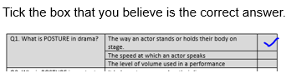
KEY TERMS

Facial expression – Using your face to show emotion.
Body language – Using your body to show emotion.
Gesture – Using your hands to communicate meaning.
Posture – How tall or bent your back is to show the power or age of your character.

Task three - Epic theatre Written
Describe and Explain how yo
How would use your vocal and physical skills to perform the following line.
“ Someday I will show them that I can do anything”

“Why did you do that?
________________________________________________________________________________________________________________________________________________________________________________________________________________________________________________________________
Can’t you see she is upset?
_______________________________________________________________________________________________________________________________________________________________________________________________________________________________________________________________

- What emotion does the character have?
____________________________________________________________________________________________________________________________________________________________________________________________________________________________________
- Name and define a physical skill.
____________________________________________________________________________________________________________________________________________________________________________________________________________________________________
- Describe how you will use that physical skill to show the emotion of the character
____________________________________________________________________________________________________________________________________________________________________________________________________________________________________
- Explain what effect this will have on the audience?
____________________________________________________________________________________________________________________________________________________________________________________________________________________________________

Due date:
Task three - Epic theatre Written feedback
Students to complete:
Self-assessed
I have described how I will use my key skills.
I have explained the reason behind my choices.
I have checked my spelling and punctuation.
Positive points:

How to improve further:

Mark Scheme | Band | Key words used correctly: | Description | Explanation | Overall score  /5
Mark Scheme | Top (5pts) | 6+ | Almost all skills described in impressive detail. | Effects of almost all skills explained impressively.
Mark Scheme | Middle (3pts) | 4-5 | +2 skills described simply, or 1 described in detail. | +2 effects simply explained, or 1 described in detail
Mark Scheme | Bottom (1pt) | 1-3 | Some attempt is made to describe skills. | Some attempt is made to explain effects of skills.
Mark Scheme | None (0pt) | 0 | No description | No explanation
Teacher feedback:
Teacher assessed

A | You have not described how you will use your skills.
B | You have not explained the reason behind your choice. Why will you do this?
C | You need to link to the audience and the impact it will have on them.
Task four – Epic theatre poster: Create an A4 poster detailing the below Epic theatre techniques. You should include a clear definition and an image to go with the technique.
- Placards
- Multi-rolling

Placards
- What it is: A placard is a sign held up on stage by an actor.
- What it does: It tells the audience facts about the story.
- Example: A sign might say, "Two years later" or "This character is going to make a bad choice."
- Why we use it: It stops the story to make the audience think instead of just getting lost in the play.

Multi-rolling
- What it is: Multi-rolling is when one actor plays more than one character in the same play.
- What it does: The actor changes their voice, jacket, or how they walk to quickly become a new person.
- Example: An actor plays a king in Scene 1, puts on a hat, and plays a poor farmer in Scene 2.
- Why we use it: It reminds the audience that they are watching a fake play, not real life.

Task four – Epic theatre poster: Complete task here

Due date:
Task four – Epic theatre poster: Feedback
Students to complete:
Self-assessed
I have made clear description of the style of Epic theatre
I have used colour well and included images.
I have checked my spelling and punctuation.
Positive points:

How to improve further:

Teacher to complete:
On your work you will find different letters, use the below key to see what your teacher feedback is. You must now green pen your work in full sentences next to the letter.
Teacher assessed
A | You have not described the key term.
B | You have not included an image to link to the key word.
C | You need to expand on your definition and include more detail.

Due date:
Task five – Epic theatre Quiz
/10
Q1. What does Epic Theatre try to avoid? | - Emotional realism
Q1. What does Epic Theatre try to avoid? | - Clear storytelling
Q1. What does Epic Theatre try to avoid? | - Actors speaking on stage
Q2. Which of these would Brecht MOST likely use in a performance? | - A realistic kitchen set
 | - A narrator explaining events
 | - Hidden microphones
Q3. Why might actors show scene changes openly? | - To save time backstage
Q3. Why might actors show scene changes openly? | - To remind the audience the play is constructed
Q3. Why might actors show scene changes openly? | - To make the play look more realistic
Q4. Why might an actor step out of character during a scene? | - To correct another actor
Q4. Why might an actor step out of character during a scene? | - To comment on the action or message
Q4. Why might an actor step out of character during a scene? | - To take a break
Q5. What is the purpose of using simple, non-realistic props? | Make the audience forget real life
 | Make the audience think about the message
 | Make the audience feel very sad
Q6. Which of these best describes the audience’s role in Epic Theatre? | - To relax and enjoy the story
 | - To think critically about what they are watching
 | - To believe the characters are real
Q7. What is the purpose of using simple, non‑realistic props? | - To save money
 | - To keep the focus on ideas rather than realism
 | - To make the stage look empty
Q8. Why might a scene be shown out of chronological order? | - To confuse the audience
Q8. Why might a scene be shown out of chronological order? | - To highlight themes instead of plot
Q8. Why might a scene be shown out of chronological order? | - To make the play shorter
Q9. Which statement best fits Brecht’s beliefs about theatre | - Theatre should entertain but not teach
Q9. Which statement best fits Brecht’s beliefs about theatre | - Theatre should help audiences question the world
Q9. Which statement best fits Brecht’s beliefs about theatre | - Theatre should always feel realistic
Q10. Why does Epic Theatre use techniques like placards, narration, or breaking the fourth wall? | To remind the audience they are watching a play so they think about the message
 | To make the story feel more realistic and emotional
 | To help the audience forget the actors and get lost in the characters
Peer assessed
KEY TERMS

Volume – How loud or soft your voice is
Tone – The emotion of your voice
Pitch – How high or low your voice is
Pace – How quick or slow you speak
- What emotion does the character have?
____________________________________________________________________________________________________________________________________________________________________________________________________________________________________
- Name and define a vocal skill.
____________________________________________________________________________________________________________________________________________________________________________________________________________________________________
- Describe how you will use that vocal skill to show the emotion of the character
____________________________________________________________________________________________________________________________________________________________________________________________________________________________________
- Explain what effect this will have on the audience?
____________________________________________________________________________________________________________________________________________________________________________________________________________________________________

Due date:
Task six – Epic theatre Written: Describe and Explain how you would use your vocal and physical skills to perform the following line.

“You are unbelievable, how could you do this to me?”

“Why did you do that?
________________________________________________________________________________________________________________________________________________________________________________________________________________________________________________________________
Can’t you see she is upset?
_______________________________________________________________________________________________________________________________________________________________________________________________________________________________________________________________

- What emotion does the character have?
____________________________________________________________________________________________________________________________________________________________________________________________________________________________________
- Name and define a vocal skill.
____________________________________________________________________________________________________________________________________________________________________________________________________________________________________
- Describe how you will use that vocal skill to show the emotion of the character
____________________________________________________________________________________________________________________________________________________________________________________________________________________________________
- Explain what effect this will have on the audience?
____________________________________________________________________________________________________________________________________________________________________________________________________________________________________

KEY TERMS

Volume – How loud or soft your voice is
Tone – The emotion of your voice
Pitch – How high or low your voice is
Pace – How quick or slow you speak
Task six – Epic theatre Written: Feedback
Students to complete:
Self-assessed
I have described how I will use my key skills.
I have explained the reason behind my choices.
I have checked my spelling and punctuation.
Positive points:

How to improve further:

Mark Scheme | Band | Key words used correctly: | Description | Explanation | Overall score  /5
Mark Scheme | Top (5pts) | 6+ | Almost all skills described in impressive detail. | Effects of almost all skills explained impressively.
Mark Scheme | Middle (3pts) | 4-5 | +2 skills described simply, or 1 described in detail. | +2 effects simply explained, or 1 described in detail
Mark Scheme | Bottom (1pt) | 1-3 | Some attempt is made to describe skills. | Some attempt is made to explain effects of skills.
Mark Scheme | None (0pt) | 0 | No description | No explanation
Teacher feedback:
Teacher assessed

A | You have not described how you will use your skills.
B | You have not explained the reason behind your choice. Why will you do this?
C | You need to link to the audience and the impact it will have on them.

TOPIC 3
Scripted & Set Design

Due date:
Task one - Scripted & Set Design Poster: Complete task here

Task one - Scripted & Set Design Poster
Create a poster about William Shakespeare. You should consider the below questions when making your poster.
1. Who was William Shakespeare?
William Shakespeare was a famous English writer from Stratford-upon-Avon who lived over 450 years ago and invented more than 1,700 words.
2. What are some of Shakespeare's most famous plays?
His most famous plays include Romeo and Juliet (a sad story about young love), Macbeth (a dark story about a greedy king), and A Midsummer Night's Dream (a funny story about magic fairies).
3. What was the Globe Theatre and why is it important?
The Globe Theatre was a massive, round, open-air playhouse in London where both rich and poor people watched Shakespeare's greatest plays come to life.

Due date:
Epic Theatre Written Home Learning 2: Describe and Explain how you would use your vocal and physical skills to perform the following line.
You must use all the following Key Terms in your writing at least once:
Highlight every key term that you use.
Pause | Pace | Emphasis | Body language | Eye Contact

“Why did you do that?
________________________________________________________________________________________________________________________________________________________________________________________________________________________________________________________________
Can’t you see she is upset?
_______________________________________________________________________________________________________________________________________________________________________________________________________________________________________________________________

Task one - Scripted & Set Design Poster: Feedback

Students to complete:
Self-assessed
I have made links the facts about Shakespeare.
I have used colour well and included images.
I have checked my spelling and punctuation.
Positive points:

How to improve further:

Teacher to complete:
On your work you will find different letters, use the below key to see what your teacher feedback is. You must now green pen your work in full sentences next to the letter.
Teacher assessed
A | You have not described the key term.
B | You have not included an image to link to the key word.
C | You need to expand on your definition and include more detail.

Q1. Who wrote Romeo and Juliet? | - William Shakespeare
Q1. Who wrote Romeo and Juliet? | - Charles Dickens
Q1. Who wrote Romeo and Juliet? | - JK Rowling
Q2. What type of play is Romeo and Juliet | - Comedy
Q2. What type of play is Romeo and Juliet | - Tragedy
Q2. What type of play is Romeo and Juliet | - Mystery
Q3. Why can’t Romeo and Juliet be together? | - They are from rival families
Q3. Why can’t Romeo and Juliet be together? | - They live far apart
Q3. Why can’t Romeo and Juliet be together? | - They don’t like each other
Q4. What is the name of the theatre Shakespeare worked in? | - The Globe
Q4. What is the name of the theatre Shakespeare worked in? | - The Royal Court
Q4. What is the name of the theatre Shakespeare worked in? | - The National Theatre
Q5. Which of these is a vocal skill? | - Gesture
Q5. Which of these is a vocal skill? | - Tone
Q5. Which of these is a vocal skill? | - Levels
Q6. Why do actors use facial expressions? | - To show emotion
Q6. Why do actors use facial expressions? | - To remember lines
Q6. Why do actors use facial expressions? | - To change scenes
Q7. What is “pace” in vocal skills? | - How fast or slow you speak
Q7. What is “pace” in vocal skills? | - How loudly you shout
Q7. What is “pace” in vocal skills? | - How high or low your voice is
Q8. What does “volume” refer to in drama? | - How fast you speak
Q8. What does “volume” refer to in drama? | - How loud or quiet your voice is
Q8. What does “volume” refer to in drama? | - How emotional your voice sounds
Q9. What does “tone” help an actor show? | - Emotion or attitude
Q9. What does “tone” help an actor show? | - Costume choices
Q9. What does “tone” help an actor show? | - Stage directions
Q10. Which of these is an example of body language? | - Whispering
Q10. Which of these is an example of body language? | - Standing with crossed arms
Q10. Which of these is an example of body language? | - Changing pitch
Peer assessed
/10
Due date:
Task two- Scripted & Set Design Quiz:
Due date:
KEY TERMS

Facial expression – Using your face to show emotion.
Body language – Using your body to show emotion.
Gesture – Using your hands to communicate meaning.
Posture – How tall or bent your back is to show the power or age of your character.

- What emotion does the character have?
____________________________________________________________________________________________________________________________________________________________________________________________________________________________________
- Name and define a physical skill.
____________________________________________________________________________________________________________________________________________________________________________________________________________________________________
- Describe how you will use that physical skill to show the emotion of the character
____________________________________________________________________________________________________________________________________________________________________________________________________________________________________
- Explain what effect this will have on the audience?
____________________________________________________________________________________________________________________________________________________________________________________________________________________________________

Task three - Scripted & Set Design Written:
Describe and Explain how you would use your vocal and physical skills to perform the following line.

“ Where is your Home Learning? You are in so much trouble”

“Why did you do that?
________________________________________________________________________________________________________________________________________________________________________________________________________________________________________________________________
Can’t you see she is upset?
_______________________________________________________________________________________________________________________________________________________________________________________________________________________________________________________________

Task three - Scripted & Set Design Written: Feedback
Students to complete:
Self-assessed
I have described how I will use my key skills.
I have explained the reason behind my choices.
I have checked my spelling and punctuation.
Positive points:

How to improve further:

Mark Scheme | Band | Key words used correctly: | Description | Explanation | Overall score  /5
Mark Scheme | Top (5pts) | 6+ | Almost all skills described in impressive detail. | Effects of almost all skills explained impressively.
Mark Scheme | Middle (3pts) | 4-5 | +2 skills described simply, or 1 described in detail. | +2 effects simply explained, or 1 described in detail
Mark Scheme | Bottom (1pt) | 1-3 | Some attempt is made to describe skills. | Some attempt is made to explain effects of skills.
Mark Scheme | None (0pt) | 0 | No description | No explanation
Teacher feedback:
Teacher assessed

A | You have not described how you will use your skills.
B | You have not explained the reason behind your choice. Why will you do this?
C | You need to link to the audience and the impact it will have on them.

Task four - Scripted & Set Design Poster:: Complete task here

Due date:
Task four - Scripted & Set Design Poster
Create a poster all about Romeo& Juliet.
Who are the main characters in "Romeo and Juliet"?
Romeo Montague: He quickly falls in love with Juliet.
Juliet Capulet: The headstrong and intelligent 13-year-old daughter of the Capulet family.
Plot of "Romeo and Juliet"?
Romeo and Juliet is a famous, tragic story about two teens from rival families—the Montagues and the Capulets—who fall in love. Because their families are sworn enemies, they marry in secret. A series of sad mistakes causes the lovers to lose their lives
Task four - Scripted & Set Design Poster: Feedback

Students to complete:
Self-assessed
I have made links the facts about Romeo and Juliet
I have used colour well and included images.
I have checked my spelling and punctuation.
Positive points:

How to improve further:

Teacher to complete:
On your work you will find different letters, use the below key to see what your teacher feedback is. You must now green pen your work in full sentences next to the letter.
Teacher assessed
A | You have not described the key term.
B | You have not included an image to link to the key word.
C | You need to expand on your definition and include more detail.

Due date:
/10
Q1. What does “volume” mean in drama? | - How loud or quiet your voice is
Q1. What does “volume” mean in drama? | - How fast you move
Q1. What does “volume” mean in drama? | - How emotional you feel
Q2. What is “pitch”? | - How high or low your voice sounds
Q2. What is “pitch”? | - How long you speak for
Q2. What is “pitch”? | - How clearly you pronounce words
Q3. What is “pace” in vocal skills? | - How fast or slow you speak
Q3. What is “pace” in vocal skills? | - How loudly you shout
Q3. What is “pace” in vocal skills? | - How many lines you have
Q4. What does a frown usually show in a performance? | - Happiness
Q4. What does a frown usually show in a performance? | - Confusion or anger
Q4. What does a frown usually show in a performance? | - Excitement
Q5. What does a fast pace in movement suggest? | - Calmness
Q5. What does a fast pace in movement suggest? | - Panic or excitement
Q5. What does a fast pace in movement suggest? | - Sleepiness
Q6. What does “accent” refer to in vocal skills? | - The rhythm of your steps
Q6. What does “accent” refer to in vocal skills? | - The way words sound depending on where someone is from
Q6. What does “accent” refer to in vocal skills? | - The shape of your facial expression
Q7. What does a shaky voice often suggest? | - Confidence
Q7. What does a shaky voice often suggest? | - Nervousness or fear
Q7. What does a shaky voice often suggest? | - Anger
Q8. What does “levels” mean in physical performance? | - How high or low your body is positioned
Q8. What does “levels” mean in physical performance? | - How loud you speak
Q8. What does “levels” mean in physical performance? | - How many props you use
Q9. Why is facial expression important in drama? | - It helps show a character’s emotions
Q9. Why is facial expression important in drama? | - It helps actors move faster
Q9. Why is facial expression important in drama? | - It helps change the lighting
Q10. What does a firm, steady tone usually show in a performance? | - Confidence
 | - Confusion
 | - Shyness
Peer assessed
Peer assessed
Task five -Scripted & Set Design quiz:
Due date:
KEY TERMS

Volume – How loud or soft your voice is
Tone – The emotion of your voice
Pitch – How high or low your voice is
Pace – How quick or slow you speak
- What emotion does the character have?
____________________________________________________________________________________________________________________________________________________________________________________________________________________________________
- Name and define a vocal skill.
____________________________________________________________________________________________________________________________________________________________________________________________________________________________________
- Describe how you will use that vocal skill to show the emotion of the character
____________________________________________________________________________________________________________________________________________________________________________________________________________________________________
- Explain what effect this will have on the audience?
____________________________________________________________________________________________________________________________________________________________________________________________________________________________________

Task six -Scripted & Set Design Written:

Describe and Explain how you would use your vocal and physical skills to perform the following line.
“You are unbelievable, how could you do this to me?”

“Why did you do that?
________________________________________________________________________________________________________________________________________________________________________________________________________________________________________________________________
Can’t you see she is upset?
_______________________________________________________________________________________________________________________________________________________________________________________________________________________________________________________________

- What emotion does the character have?
____________________________________________________________________________________________________________________________________________________________________________________________________________________________________
- Name and define a vocal skill.
____________________________________________________________________________________________________________________________________________________________________________________________________________________________________
- Describe how you will use that vocal skill to show the emotion of the character
____________________________________________________________________________________________________________________________________________________________________________________________________________________________________
- Explain what effect this will have on the audience?
____________________________________________________________________________________________________________________________________________________________________________________________________________________________________

KEY TERMS

Volume – How loud or soft your voice is
Tone – The emotion of your voice
Pitch – How high or low your voice is
Pace – How quick or slow you speak
Task six -Scripted & Set Design Written: Feedback
Students to complete:
Self-assessed
I have described how I will use my key skills.
I have explained the reason behind my choices.
I have checked my spelling and punctuation.
Positive points:

How to improve further:

Mark Scheme | Band | Key words used correctly: | Description | Explanation | Overall score  /5
Mark Scheme | Top (5pts) | 6+ | Almost all skills described in impressive detail. | Effects of almost all skills explained impressively.
Mark Scheme | Middle (3pts) | 4-5 | +2 skills described simply, or 1 described in detail. | +2 effects simply explained, or 1 described in detail
Mark Scheme | Bottom (1pt) | 1-3 | Some attempt is made to describe skills. | Some attempt is made to explain effects of skills.
Mark Scheme | None (0pt) | 0 | No description | No explanation
Teacher feedback:
Teacher assessed

A | You have not described how you will use your skills.
B | You have not explained the reason behind your choice. Why will you do this?
C | You need to link to the audience and the impact it will have on them.

