  - Year 7
  - Español
  - cuaderno de deberes
  - Topic 1 + 2 : HOLA + MI VIDA
  - Autumn Term
  - Aspiration


Home Learning expectations
-Written by yourself, in your own words.
-Completed by the due date.
-Finished to the best of your ability.
-Instructions to be read carefully.
-Green pen and improve when needed.
-Peer or self-assess when asked to.
-Presented so your work is clear and neat.
-Proof read your work to ensure spelling, punctuation and grammar is to the best of your ability.

El Alcázar - Sevilla

Use your Knowledge Organisers to support with your Home Learning Tasks

Contents
Topic 1 and 2
Topic 1 Task 1: Linguascope : Números (1-31) 2
TOPIC 1 TASK 2: Vocabulary: Meses 3
Topic 1 Task 3: Grammar : Adjectival Agreement 4
Topic 1 Task 4: Vocabulary: Animales 5
Topic 2 task 1: Vocabulary: La familia 6
Topic 2 task 2: Linguascope: La familia 7
Topic 2 TAsk 3: Vocabulary: Describing people 8
Topic 2 Task 4: Grammar – TENER and SER 9


Topic 1 Task 1: Linguascope : NUMEROS (1-31)
Login into Linguascope

Username: Heathland
Password: _________________________________
Instruction:
- Click on the Spanish flag and select ‘Elementary’ section
- On the right side click on ‘Números (1-31) from the list of topics
- Select ‘Introducción´.
- Spend 20 minutes practising the new vocab.
Extension: Practice two more games of your choice.
Exercise: Calculate the number. Write the number in the box following the example.
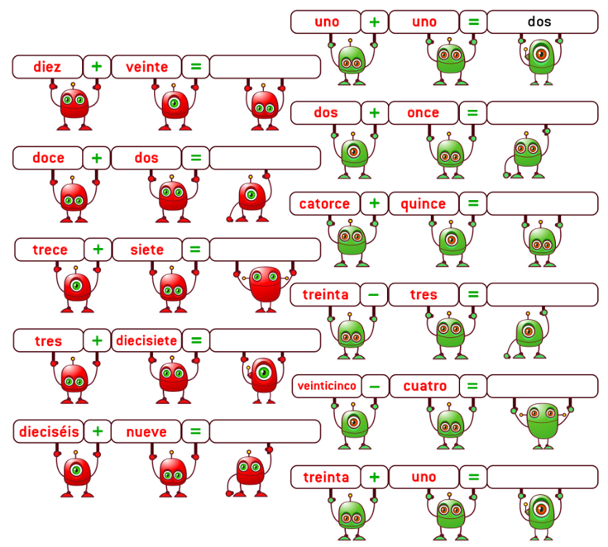
Write your score here: ________
Do you think you can do it better? Try again and write your best score _____

Write with your green pen
-How confident do you feel about it from 1 to 5 (1 is not confident at all, and 5 is very confident)? _____
-How to improve further:

Self-assessed


TOPIC 1 TASK 2: VOCABULARY: MESES
Due: ______________________
Use the Knowledge Organiser 1 (Hola) at the back of your booklet.
Choose 15 words from the box ‘meses’ and practice using the grid below.

Spanish Vocabulary | English Translation | Look and Say (tick) | Look, Say and Write in Spanish | Look, Say and Write in Spanish | Look, Say and Write in Spanish
Extension: Write three sentences using the vocabulary that you’ve learned
- __________________________________________________________
- __________________________________________________________
- __________________________________________________________
Peer-assessed
Write with your green pen
-How confident do you feel about it from 1 to 5 (1 is not confident at all, and 5 is very confident)? _____
-How to improve further:

Topic 1 Task 3: GRAMMAR ADJECTIVAL AGREEMENT
Due: ______________________
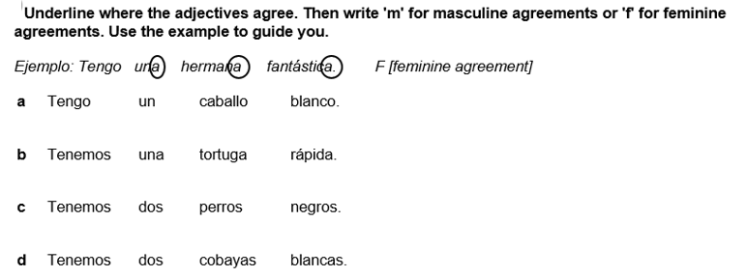
Learning Intentions: I can use adjective and noun agreement correctly.
1
2
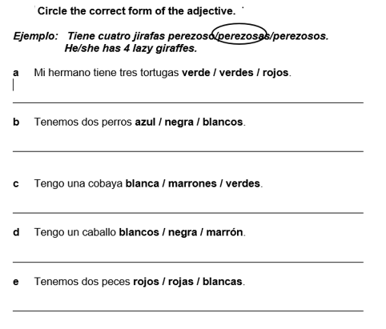
Extension: Translate all sentences.
Teacher-assessed
Write with your green pen
-How confident do you feel about it from 1 to 5 (1 is not confident at all, and 5 is very confident)? _____
-How to improve further:

Topic 1 Task 4: VOCABULARY: ANIMALES
Due: ______________________

Use the Knowledge Organiser 1 (Hola).
Choose 15 words from the box ‘Animales’ and practice using the vocab grid.
Spanish Vocabulary | English Translation | Look and Say (tick) | Look, Say and Write in Spanish | Look, Say and Write in Spanish | Look, Say and Write in Spanish

Extension: Write three sentences using the vocab that you’ve learned
- __________________________________________________________
- __________________________________________________________
- __________________________________________________________
Peer-assessed
Write with your green pen
-How confident do you feel about it from 1 to 5 (1 is not confident at all, and 5 is very confident)? _____
-How to improve further:

Topic 2 task 1: VOCABULARY LA FAMILIA
Due: ______________________
Use the Knowledge Organiser 2 (Mi vida) at the back of your booklet.
Choose 15 words from the box ‘La familia’ and practice using the vocab grid.
Spanish Vocabulary | English Translation | Look and Say (tick) | Look, Say and Write in Spanish | Look, Say and Write in Spanish | Look, Say and Write in Spanish

Extension: Write three sentences using the vocab that you’ve learned
- __________________________________________________________
- __________________________________________________________
- __________________________________________________________

Peer-assessed
Write with your green pen
-How confident do you feel about it from 1 to 5 (1 is not confident at all, and 5 is very confident)? _____
-How to improve further:

Topic 2 task 2: LINGUASCOPE - LA FAMILIA
Due: ______________________
Login into Linguascope
Username: Heathland
Password: _________________________________

Instruction:
- Click on the Spanish flag and select ‘Beginner’ section.

- On the left side select ‘Mi familia y yo’ from the list of topics.
- Select ‘Los miembros de mi familia’.
- Spend 20 minutes practicing the new vocab in the following sections





Extension: Practice two more sections of your choice

Write your score here for the Examen Final: ________
Do you think you can do it better? Try again and write your best score _____

Self-assessed
Write with your green pen
-How confident do you feel about it from 1 to 5 (1 is not confident at all, and 5 is very confident)? _____
-How to improve further:

Peer assessed
Positive points:
How to improve further:

Topic 2 TAsk 3: Vocabulary: DESCRIBING PEOPLE
Due: ______________________
Use the Knowledge Organiser Autumn Term 2 (Mi vida)
Choose 15 words from the box 2 ‘Descripción física’ and practice using the vocab grid.
Spanish Vocabulary | English Translation | Look and Say (tick) | Look, Say and Write in Spanish | Look, Say and Write in Spanish | Look, Say and Write in Spanish

Extension: Write three sentences using the vocab that you’ve learned
- __________________________________________________________
- __________________________________________________________
- __________________________________________________________
Peer-assessed
Write with your green pen
-How confident do you feel about it from 1 to 5 (1 is not confident at all, and 5 is very confident)? _____
-How to improve further:

Peer assessed
Positive points:
How to improve further:

Topic 2 Task 4: GRAMMAR – TENER and ser
Due: ______________________
Learning Intentions: I can use the verbs ‘tener’ and ‘ser’ correctly.
Use the Knowledge Organiser Autumn Term 2 (Mi vida).
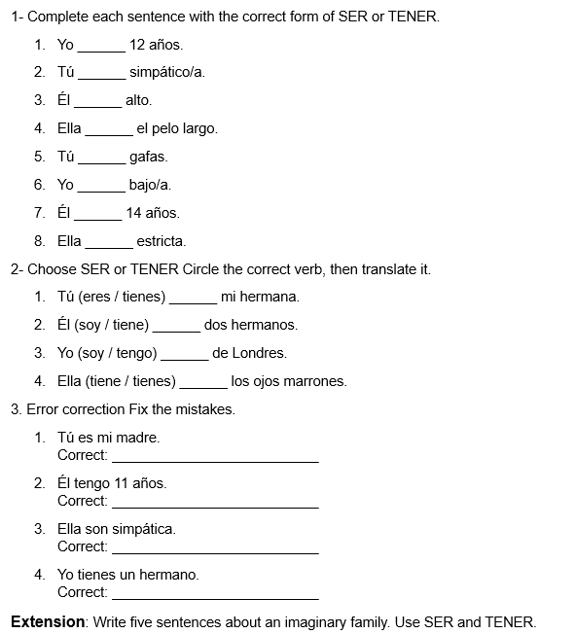
- __________________________________________________________
- __________________________________________________________
- __________________________________________________________
- __________________________________________________________
- ______________________________________________________
Teacher-assessed
Write with your green pen
-How confident do you feel about it from 1 to 5 (1 is not confident at all, and 5 is very confident)? _____
-How to improve further:

